Decision No. C24-0050
BEFORE THE PUBLIC UTILITIES COMMISSION OF THE STATE OF COLORADO
PROCEEDING NO. 23M-0217R
REPOSITORY PROCEEDING FOR THREE-YEAR SAFETY OVERSIGHT AUDIT AND INVESTIGATIONS OF THE REGIONAL TRANSPORTATION DISTRICT.
COMMISSION DECISION APPROVING
CORRECTIVE ACTION PLANS
Mailed Date: January 25, 2024
Adopted Date: January 24, 2024

BY THE COMMISSION

Statement
- This matter comes before the Commission for consideration of approval of three Corrective Action Plans (CAP or CAPs) that was submitted by the Denver Metro area Regional Transportation District light rail operation that occurred between July 1, 2023, and
September 30, 2023. A report summarizing the CAP was filed by Staff of the Public Utilities Commission (Staff) on January 16, 2024.
- The CAPs to be reviewed by the Commission are: CAP1-08162023, CAP1-08212023 and CAP1-09292023 for final approval and monitoring to closure.
- This matter also comes before the Commission for consideration of two CAPs that Staff has monitored and verified that all CAP elements have been completed as outlined in the CAPs and as discussed in the report summarizing the CAPs filed by Staff on
January 16, 2024. The CAP numbers reviewed by the Commission for closure are: CAP1-01232022 and CAP5-07272022.
- The Commission has reviewed the summary report filed by Staff and concurs with Staff’s review of the CAPs and recommendations for final approval and monitoring to closure of the three new CAPs, and for closure of two existing open CAPs.
- The Commission has jurisdiction in this matter under § 40-18-103, C.R.S., and Rule 7347 of the Rules Regulating Railroads, Rail Fixed Guideways, Transportation by Rail, and Rail Crossings, 4 Code of Colorado Regulations 723-7.

ORDER

The Commission Orders That:
- The Commission provides final approval of and monitoring to closure CAP-08162023, CAP1-08212022 and CAP1-09292023 submitted by the Denver Metro area Regional Transportation District light rail operations and closure of CAP1-01232022 and CAP5-07272022.
- This Decision is effective on its Mailed Date.

ADOPTED IN COMMISSIONERS’ WEEKLY MEETING
January 24, 2024
(S E A L)    ATTEST: A TRUE COPY  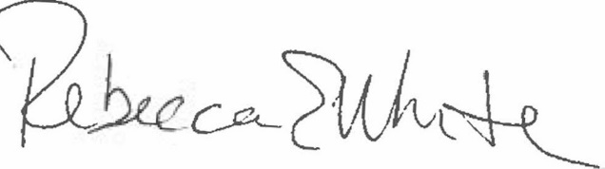  Rebecca E. White,  Director | THE PUBLIC UTILITIES COMMISSION  OF THE STATE OF COLORADO  ERIC BLANK  ________________________________  MEGAN M. GILMAN  ________________________________  TOM PLANT  ________________________________  Commissioners

