Decision No. C24-0045-E
BEFORE THE PUBLIC UTILITIES COMMISSION OF THE STATE OF COLORADO
PROCEEDING NO. 23A-0617FG
IN THE MATTER OF THE VERIFIED APPLICATION OF BLACK HILLS COLORADO GAS, INC. D/B/A BLACK HILLS ENERGY FOR AN ORDER GRANTING TO IT A CERTIFICATE OF PUBLIC CONVENIENCE AND NECESSITY TO EXERCISE NATURAL GAS FRANCHISE RIGHTS IN THE TOWN OF MONUMENT, COLORADO.
ERRATA NOTICE FOR
commission decision DEEMING APPLICATION COMPLETE AND GRANTING APPLICATION
Errata mailed January 26, 2024
Original Decision No. C24-0045 mailed January 24, 2024

- Statement Paragraph No. 9 currently reads as follows:
According to the franchise agreement, as consideration for the franchise rights granted and in recognition of Black Hills’ right to use the Town streets, the Town requires Black Hills to collect and remit to the Town a franchise fee equal to three percent of all revenues received from the sale of natural gas service within the Town, excluding revenues received from the Town for the sale of natural gas service to the Town.
Statement Paragraph No. 9 is Amended to read as follows:
According to the franchise agreement, as consideration for the franchise rights granted, and in recognition of Black Hills’ right to use the Town streets, the Town requires Black Hills to collect and remit to the Town a franchise fee equal to three percent of all revenues from the sale, distribution, or transportation of natural gas delivered within the Town, excluding revenues received from the Town for the delivery of natural gas to the Town.
(S E A L)    ATTEST: A TRUE COPY  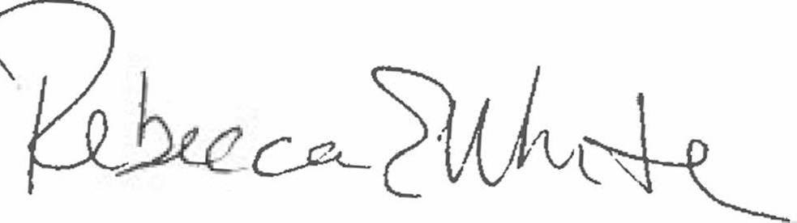  Rebecca E. White,  Director | THE PUBLIC UTILITIES COMMISSION  OF THE STATE OF COLORADO  REBECCA E. WHITE  ________________________________  Director

