Decision No. R23-0439-I
BEFORE THE PUBLIC UTILITIES COMMISSION OF THE STATE OF COLORADO
PROCEEDING NO. 23A-0128W
IN THE MATTER OF THE APPLICATION OF PAPASON LLC DBA BAXTER WATER AND SERVICES FOR AUTHORITY TO TRANSFER ALL ASSETS, CERTIFICATE OF PUBLIC CONVENIENCE AND NECESSITY AND ACCOMPANYING WATER AND WELL RIGHTS FROM GREENWELL ENERGY INC AKA GREENWELL ENERGY LLC AKA OCTAL RESOURCES INC DBA ONEAL WATER WORKS AKA ONEAL WATER INC AKA ONEAL WATER TO PAPASON LLC DBA BAXTER WATER AND Services.
INTERIM DECISION OF
ADMINISTRATIVE LAW JUDGE
Aviv Segev
Granting uNOPPOSED mOTION TO Extend Deadline for Filing Direct Testimony
Mailed Date: July 5, 2023

STATEMENT

Procedural Background
      - On March 16, 2023, Papason LLC, doing business as Baxter Water & Services (Applicant) filed with the Commission its Application (Application), seeking approval of the transfer of Greenwell Energy Inc, doing business as O’Neal Water’s (O’Neal Water) Certificate of Public Convenience and Necessity, and related assets and rights, to Applicant. This filing commenced Proceeding No. 23A-0128W.
      - On March 17, 2023, the Commission issued its Notice of Application Filed (Notice). The Notice established a 30-day intervention period for intervenors to file appropriate pleadings to become parties in this Proceeding.
      - On April 6, 2023, the Staff of the Public Utilities Commission (Staff) timely noticed its intervention of right.
      - On April 19, 2023, the Commission deemed the Application complete and referred this matter to an Administrative Law Judge (ALJ) by minute entry.
      - By Decision No., R23-0329-I, issued May 17, 2023, the ALJ adopted a procedural schedule, pursuant to which Applicant was to submit its direct testimony by June 21, 2023.
      - On June 21, 2023, Applicant’s Unopposed Motion to Extend Deadline for Filing of Direct Testimony was filed by Applicant (Motion to Extend Filing Deadline). Applicant is seeking an extension of the deadline for the filing of Applicant’s direct testimony, through July 5, 2023, due to Applicant’s co-owner recently having undergone a heart surgery. This delayed the process of obtaining documents and information required for the submission of Applicant’s direct testimony. The Motion to Extend Filing Deadline is unopposed.
      - The ALJ finds that Applicant has stated good cause for its requested extension of time. The due date for Applicant’s direct testimony will be extended, as ordered below.
      - Because the relief sought by Applicant is unopposed, response time to the Motion to Extend Filing Deadline will be waived, as ordered below.

ORDER

It Is Ordered That:
      - Response time to Applicant’s Unopposed Motion to Extend Deadline for Filing of Direct Testimony was filed by Applicant (Motion to Extend Filing Deadline), filed June 21, 2023, by Papason LLC, doing business as Baxter Water & Services (Applicant), is waived.
      - The Motion to Extend Filing Deadline is granted.
      - Applicant shall file its direct testimony by July 5, 2023.
      - The remaining requirements set forth in Decision No. R23-0329-I shall remain in effect.
      - This Decision shall be effective immediately.

(S E A L)    ATTEST: A TRUE COPY  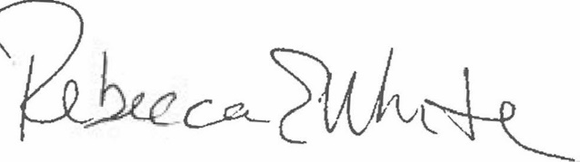  Rebecca E. White,  Director | THE PUBLIC UTILITIES COMMISSION  OF THE STATE OF COLORADO  AVIV SEGEV  ________________________________  Administrative Law Judge

