USING GOTOMEETING
TO ATTEND HEARING BY VIDEO CONFERENCE
______________________________________________________________________________
- This Attachment is intended to provide information to aid parties in joining a remote hearing by video conference using GoToMeeting, but is not intended to provide full and complete instructions on how to do so.
- Information and tutorials on using GoToMeeting are available at:
https://www.gotomeeting.com/meeting/resources/gotomeeting-quick-and-helpful-guide-for-attendees.

This link is provided for the parties’ convenience and does not warrant that the information on the link is accurate or that it provides all the information the parties may need in order to use GoToMeeting. The parties are encouraged to review tutorials about presenting documents using GoToMeeting; this may become useful should the parties need to present evidence or other materials during a GoToMeeting hearing.
2. Parties planning to participate in a GoToMeeting hearing by video conference should use a computer connected to the internet with an operational microphone and a speaker. To participate by computer, at the date and time of the hearing, parties must enter the link provided to them for the GoToMeeting hearing in their internet browser. The link is provided either in the Decision scheduling the hearing, or by separate email to the parties.
3. Parties will then be taken to the screen where they may join the hearing, as shown in the below image.
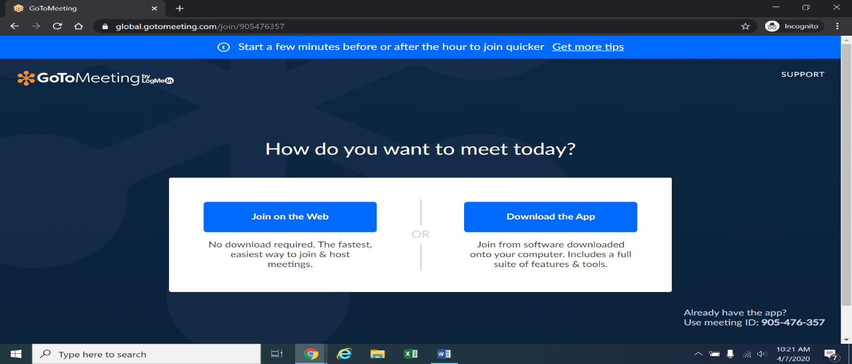
4. Once parties are at the above page, they should select “Join on the Web,” which is the blue box on the left side of the screen. The webpage below will appear.
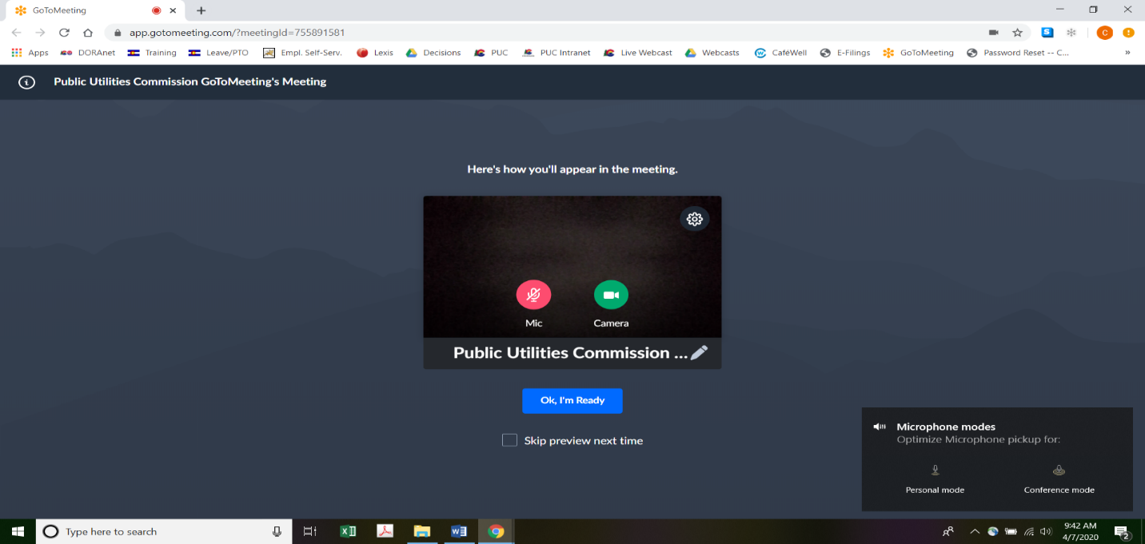
5. Parties experiencing difficulties with the link provided for the hearing, should enter https://app.gotomeeting.com/home.html in their internet browser, and use the meeting access or ID code provided to them to join the hearing. Parties may be directed to download a plug-in in order to join the meeting. If so, parties should download the plug-in; this should take only a few moments.
6. Parties who do not wish their image to be displayed during the hearing may turn off their computer’s video camera icon by clicking on the video camera icon image contained in the green circle at the bottom of the video screen. A slash will appear over the video camera icon to indicate that the video camera is off. Parties may turn off their microphones in a similar way by clicking on the microphone icon at the bottom of the video screen. Demonstratively, the image in ⁋4 above shows the microphone turned off and the video camera turned on; the image below shows the microphone and video camera turned on.
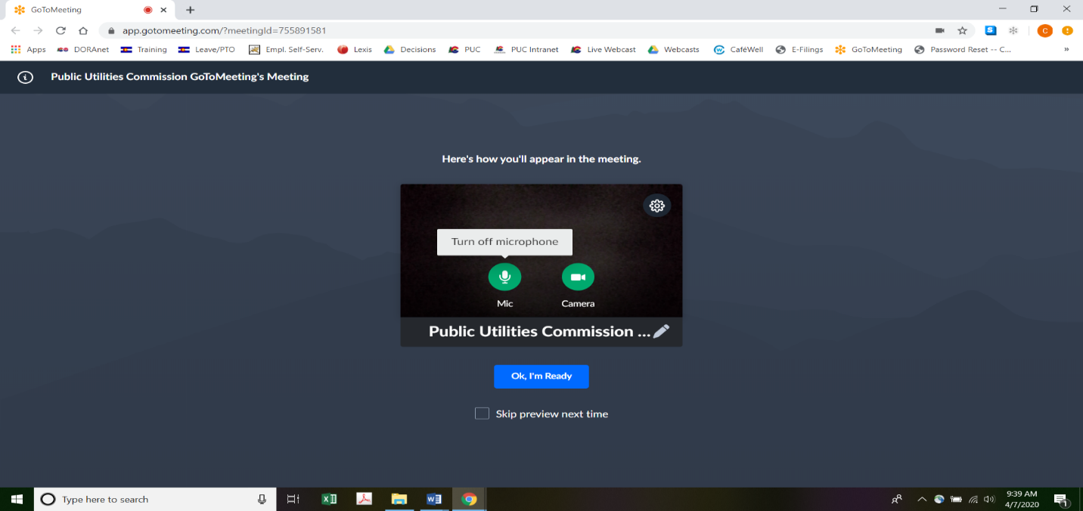
7. When parties have set their video camera and microphone preferences, parties must next select the “Ok, I’m Ready” icon shown above in the blue box to join the meeting.
8. To minimize background noise, parties should turn off (or mute) their microphones during the hearing when not speaking. Parties may manage their audio volume using volume controls on their computers.
9. To terminate participation in the hearing, parties should click on the telephone handset icon with the word “Leave” underneath it and then select “Yes” in the pop-up box, as shown below. A party who inadvertently selects the handset icon may select “Not now” instead of “Yes” to stay in the meeting, as shown below.
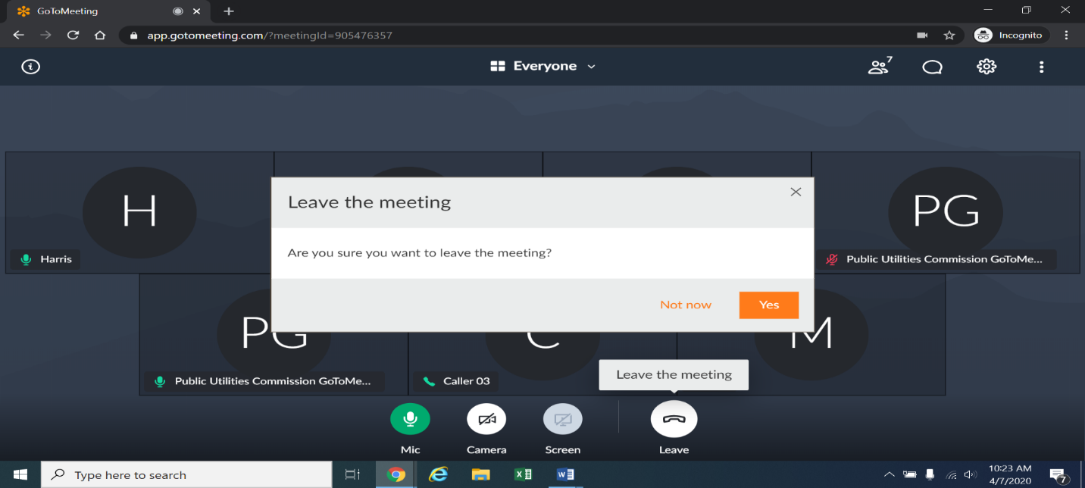

These instructions are not directed at using a tablet or smartphone to participate in a GoToMeeting video conference.
To minimize audio feedback, parties are encouraged to listen using headphones connected to the audio or headset jack on their computers.

