Decision No. R20-0258-I
BEFORE THE PUBLIC UTILITIES COMMISSION OF THE STATE OF COLORADO
PROCEEDING NO. 20C-0091-INS
IN THE MATTER OF COMMISSION ACTION AGAINST THE CERTIFICATE(S) AND PERMIT(S) OF MOTOR CARRIERS CONCERNING FINANCIAL RESPONSIBILITY PURSUANT TO § 40-10.1-112, C.R.S., AND RULE 4 CCR 723-6-6008 OF THE RULES REGULATING TRANSPORTATION BY MOTOR VEHICLES.
INTERIM DECISION OF
ADMINISTRATIVE LAW JUDGE
Melody Mirbaba
addressing motion to dismiss and converting april 22, 2020 hearing to remote hearing
Mailed Date: April 15, 2020

TABLE OF CONTENTS
I. STATEMENT, Background, Findings, and conclusions 1
II. ORDER 8
A. It Is Ordered That: 8

STATEMENT, Background, Findings, and conclusions
- Only the procedural history relevant to understand this Decision is included. On March 6, 2020, Commission Staff (Staff) instituted the cases against the motor-carrier Respondents by issuing and filing the “Order[s] of Summary Suspension and Complaint[s] and Notice of Hearing” (Complaints) and other documents in this proceeding. The Complaints
- against each of the Respondents in this proceeding allege that the Commission received notice from the Respondents’ insurance or surety carriers that the Respondents’ insurance or surety coverage has been or will be cancelled, as specifically identified in each Complaint.
- The Complaints further notify Respondents that their authorities or permits have been, or will be summarily suspended on the date specified in each Complaint, and that a hearing will take place on March 25, 2020 at 12:00 p.m. at the Commission’s office to determine whether their authorities or permits should be permanently revoked for failing to maintain proper evidence of insurance or surety coverage on file with the Commission. Based on Staff’s Motion to Continue Insurance Show Cause Hearing to April 22, 2020, the Administrative Law Judge (ALJ) continued the March 25, 2020 hearing to April 22, 2020. Decision No. R20-0190-I issued March 20, 2020. The hearing is scheduled to take place at a hearing room at the Commission’s office in Denver, Colorado. Id.
- On April 13, 2020, Staff filed a Motion to Dismiss Insurance Show Cause Hearing Set for April 22, 2020 (Motion). The Motion clarifies that Staff seeks to dismiss this proceeding, currently set for a hearing on April 22, 2020. Staff requests a waiver of the response time to the Motion. Staff argues that the novel coronavirus COVID-19 pandemic has disrupted normal routines, including the Governor’s extension of the statewide stay-at-home order through April 26, 2020. Based on this, Staff submits that it is appropriate to dismiss this proceeding without prejudice. But, at the same time, Staff also requests that summary suspension continue for Respondent-motor carriers who have not filed appropriate proof of financial responsibility. Also on April 13, 2020, Staff separately filed an unmarked list of carriers whose summary suspension it seeks to remain in place. That list is attached to this Decision as Attachment A.
- The April 22, 2020 hearing is closely approaching, leaving little time for parties to respond to the Motion and for the ALJ to rule on it before the hearing. Based on this, the ALJ finds that good cause exists to waive the response time to the Motion, as permitted under Rule 1400(b) of the Commission’s Rules of Practice and Procedure, 4 Code of Colorado Regulations (CCR) 723-1. As such, the ALJ waives the response time to the Motion.
- In effect, if this proceeding is dismissed, the Complaints against each of the Respondent-motor carriers in this proceeding are dismissed. That includes carriers who remain out of compliance with financial responsibility requirements. Staff fails to provide a legal basis that would allow the ALJ to both dismiss the Complaints in this proceeding while also continuing the summary suspensions against Respondent-motor carriers who remain out of compliance with the Commission’s financial responsibility requirements. And, even if such authority does exist, continuing the summary suspensions as requested results in indefinite summary suspensions without an opportunity for a hearing. This is untenable, as it potentially creates due process problems. See e.g., § 24-4-104(4), C.R.S. For these reasons, the ALJ denies Staff’s request to dismiss Complaints against Respondent-motor carriers who remain out of compliance with the Commission’s financial responsibility requirements while extending their summary suspensions. Those carriers are listed in Attachment A to this Decision.
- Given that there is no further relief which Staff seeks against Respondent-motor carriers who have come into compliance with the financial responsibility requirements, the ALJ grants Staff’s request to dismiss the Complaints against such carriers.
- Based on the foregoing, the only Complaints that remain at issue are those against carriers who remain out of compliance with their financial responsibility requirements. See Attachment A. Current conditions relating to COVID-19 render an in-person hearing on those Complaints impracticable. Indeed, Colorado is under a stay-at-home order until April 26, 2020, and the City of Denver is under a similar order until April 30, 2020. This presents extraordinary circumstances which warrant either a different hearing date at which parties may appear in person, or converting the April 22, 2020 hearing to a remote hearing at which parties may appear via video conference or telephone.
- Under the circumstances, the ALJ finds it is more appropriate to convert
the current hearing date to a remote hearing rather than continuing it. The hearing will be
held as scheduled on April 22, 2020 at 12:00 p.m., using the web-hosted video conferencing service, GoToMeeting. This service allows attendees to participate by computer, or telephone. Attending the hearing by computer allows for video-conference participation in the hearing; video-conference participation allows parties wishing to present evidence to display exhibits on the video-conference screen where others participating by video-conference may view them in a manner most similar to that which occurs during in-person hearings.
- Staff carries the burden of proof in this proceeding per Rule 1500, 4 CCR 723-1. As such, the ALJ anticipates that Staff will present exhibits during the hearing. To facilitate the presentation of exhibits during the remote hearing, Staff will be required to: (a) participate in the hearing by video conference; and (b) file an electronic copy of its pre-marked hearing exhibits using the Commission’s E-filing System on or by 10:00 a.m. on April 22, 2020.
- The ALJ strongly encourages Respondents to also participate in the hearing using a computer, especially any Respondent wishing to present documents for consideration during the hearing. Respondents who are unable to participate by computer may participate by telephone. Parties joining the hearing by telephone may view exhibits by either providing an email address where the exhibits may be sent at the time of the hearing, or by accessing the exhibits within the administrative record for this proceeding through the Commission’s free
E-Filing System. Parties may register for the Commission’s E-Filing System at no charge at the following website: https://www.dora.state.co.us/pls/efi/EFI.homepage.
- The following are general instructions for how to participate by telephone and computer. Parties wishing to participate by telephone must call 224-501-3412 at the date and time of the hearing. When prompted, parties must input 619-949-285# to join the hearing.
- Parties participating by computer must use a computer that is connected to the
internet with an operational microphone and a speaker. To participate by computer, at the date and time of the hearing, parties must enter the following link in their internet browser:
https://global.gotomeeting.com/join/619949285.
13. Parties will then be taken to the screen where they may join the meeting, as shown in the below image.
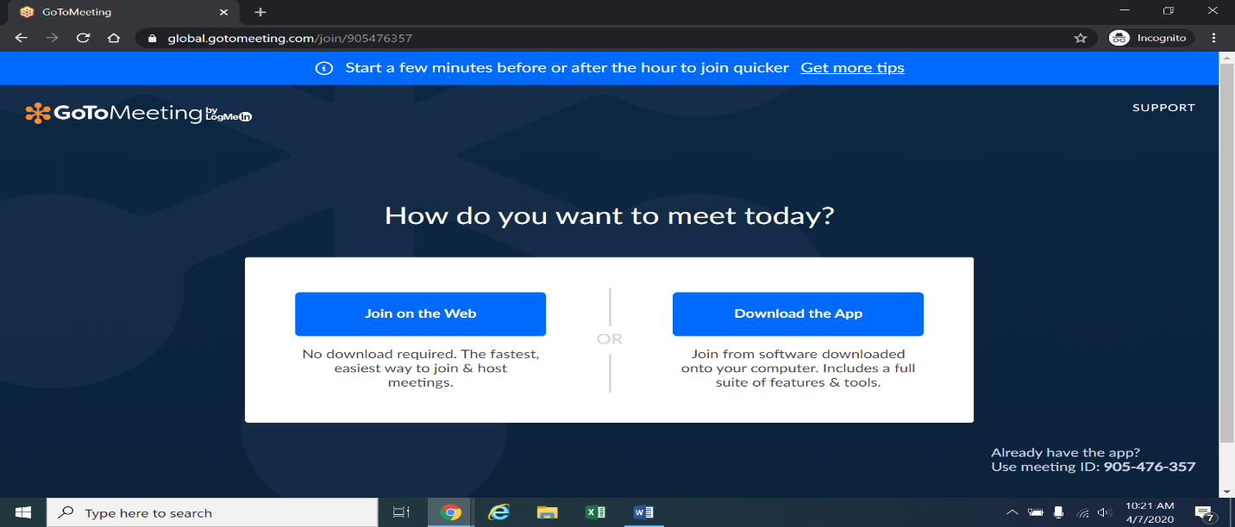
14. Once parties are at the above page, they must select “Join on the Web” in the blue box on the left. The webpage below will appear.
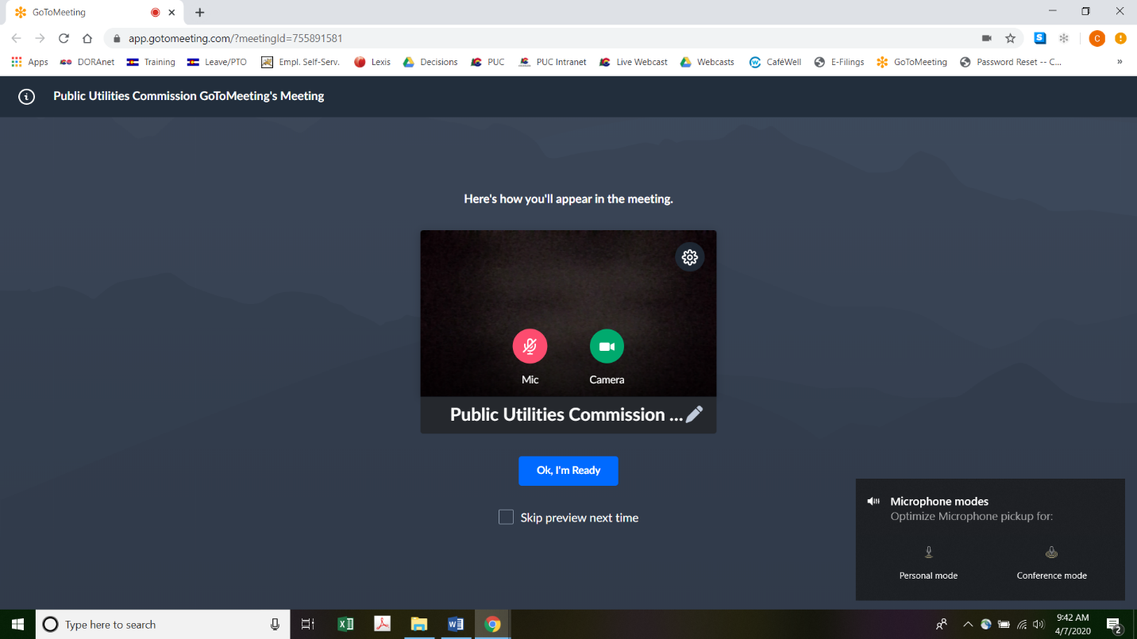
15. Parties experiencing difficulties with the link provided above, should instead go to https://app.gotomeeting.com/home.html and enter 619949285 to join the meeting.
16. Parties participating by computer who do not wish their image to be displayed during the hearing may turn off their computer’s video camera icon by clicking on the video camera icon image contained in the green circle at the bottom of the video screen. A slash will appear over the video camera icon to indicate that the video camera is off. Parties may turn off their microphones in a similar way by clicking on the microphone icon at the bottom of the video
- screen. Demonstratively, the image above shows the microphone turned off and the video camera turned on; the image below shows the microphone and video camera turned on.
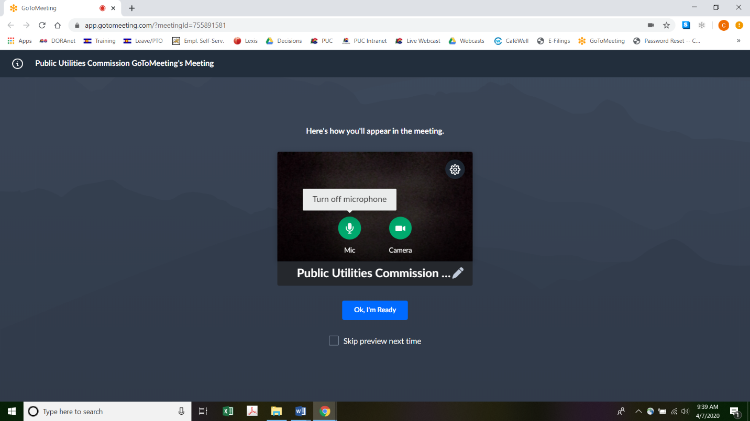
17. When parties have set their video camera and microphone preferences, parties must next select the “Ok, I’m Ready” icon shown above in the blue box to join the meeting.
18. To minimize background noise, parties should turn off (or mute) their microphones during the hearing when not speaking. Parties may manage their audio volume using volume controls on their computers.
19. To terminate participation in the hearing, parties should click on the telephone handset icon with the word “Leave” underneath it and then click the “Yes” button in the pop-up
- box (as shown below). A party who inadvertently clicks on the handset icon may select
“Not now” instead of “Yes” to stay in the meeting, as shown below.
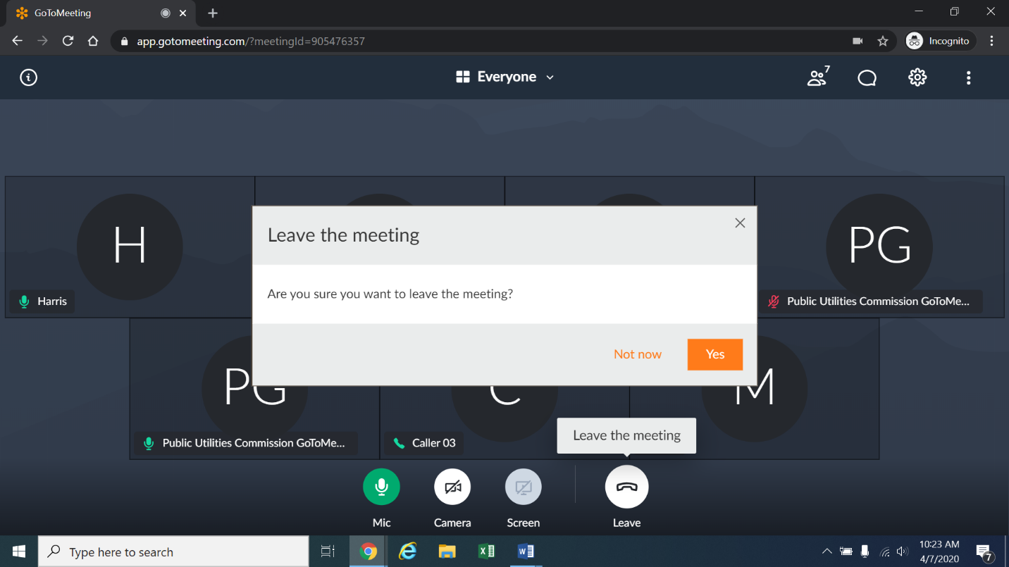
20. Additional information and tutorials for using GoToMeeting are available at: https://www.gotomeeting.com/meeting/resources/gotomeeting-quick-and-helpful-guide-for-attendees.
21. The above link is only provided for the parties’ convenience and is not intended to guarantee that the information on the link is accurate or that it provides all the information the parties may need in order to use GoToMeeting. Parties who plan to participate in the remote hearing by computer are strongly advised to familiarize themselves with GoToMeeting before the hearing.

ORDER

It Is Ordered That:
- Commission Staff’s (Staff) Motion to Dismiss Insurance Show Cause Hearing
Set for April 22, 2020 filed on April 13, 2020 is granted and denied in part consistent with the above discussion. Respondent-motor carriers against whom Complaints are still pending in this proceeding are listed in Attachment A to this Decision. Complaints against Respondent-motor carriers in this proceeding who are not included in Attachment A are dismissed without prejudice.
- Consistent with the above discussion, the hearing scheduled to take place at the Commission’s office on April 22, 2020 at 12:00 p.m. on the Order[s] of Summary Suspension and Complaint[s] and Notice of Hearing against each Respondent-motor carrier listed in Attachment A to this Decision is converted to a remote hearing. Parties may not appear in person at the Commission’s Office for the hearing, and instead will appear remotely.
- Staff must participate in the April 22, 2020 12:00 p.m. hearing by video conference using a computer. Respondents may appear by computer or telephone. Parties must follow the instructions provided in this Decision to participate in the April 22, 2020 12:00 p.m. remote hearing by computer or telephone.
- Staff must file its pre-marked hearing exhibits on or by April 22, 2020 at 10:00 a.m.

- This Decision is effective immediately.

(S E A L)    ATTEST: A TRUE COPY  Doug Dean,  Director | THE PUBLIC UTILITIES COMMISSION  OF THE STATE OF COLORADO  MELODY MIRBABA  ________________________________  Administrative Law Judge

As referenced in this Decision, motor carriers are carriers who hold a Commission permit, authority, or certificate.
This proceeding involves numerous Respondents against whom the Commission initiated Complaints by sending them each an Order of Summary Suspension and Complaint and Notice of Hearing.
To minimize audio feedback, parties are encouraged to listen using headphones connected to the audio/headset jack on their computers.

