Decision No. R20-0202-I
BEFORE THE PUBLIC UTILITIES COMMISSION OF THE STATE OF COLORADO
PROCEEding NO. 19AL-0687E
IN THE MATTER OF ADVICE LETTER NO. 1814 filed by PUBLIC SERVICE COMPANY OF COLORADO TO implement the modified residential
energy time-of-use schedule to become effective january 2, 2020.
interim decision OF
ADMINISTRATIVE LAW JUDGE
CONOR F. FARLEY
CONSOLIDATING APRIL 8, 2020 AND APRIL 16, 2020 PUBLIC COMMENT HEARINGS TO TAKE PLACE ON APRIL 16, 2020, CONVERTING the APRIL 16, 2020 CONSOLIDATED PUBLIC COMMENT HEARING
TO A REMOTE PUBLIC COMMENT HEARING,
AND PROVIDING INSTRUCTIONS FOR
PARTICIPATION IN THE APRIL 16, 2020
REMOTE PUBLIC COMMENT HEARING
Mailed Date: March 27, 2020

TABLE OF CONTENTS
I. BY THE COMMISSION 2
A. Statement 2
B. Impact of Subsequent Developments on Public Comment Hearings 4
C. Instructions for Participating in Remote Public Comment Hearing 5
1. Instructions for Participating by Telephone 5
2. Instructions for Participating by Computer 6
3. General Instructions 8
4. Written Comments 8
II. ORDER 9
A. It Is Ordered That: 9

BY THE COMMISSION

Statement
- On December 2, 2019, Public Service Company of Colorado (PSCo) filed Advice Letter No. 1814-Electric with tariff sheets (Advice Letter and Tariff Sheets) implementing a Modified Residential Energy Time-of-Use Schedule and related tariff changes. PSCo states that the filing of the Advice Letter and Tariff Sheets is made pursuant to the Non-Unanimous Comprehensive Settlement Agreement (Three Case Settlement) approved by Decision
No. C16-1075. The Three Case Settlement required PSCo to file the Advice Letter and Tariff Sheets by December 2, 2019.
- PSCo proposes an effective date of January 2, 2020 for the Advice Letter and Tariff Sheets, as required by the Three Case Settlement. PSCo further requests that the Commission suspend the tariffs, and set the tariffs for hearing, with an effective date of January 1, 2021.
- By Decision No. C19-1015 issued December 18, 2019, the Commission referred this proceeding to an Administrative Law Judge (ALJ) for disposition. The proceeding was subsequently assigned to the undersigned ALJ.
- The following entities filed Notices of Interventions as of Right before the deadline established in Decision No. C19-1015: Trial Staff of the Commission (Staff) and the Office of Consumer Counsel (OCC) on December 18, 2019, and Colorado Energy Office (CEO) on January 16, 2020.
- In addition, the following entities filed Motions or Petitions to Intervene in this proceeding before the deadline: Energy Outreach Colorado (EOC) on January 15, 2020; the City of Boulder (Boulder), Southwest Energy Efficiency Project (SWEEP), and Vote Solar on January 16, 2020; and Colorado Solar and Storage Association (COSSA), the Solar Energy Industries Association (SEIA), and Western Resource Advocates (WRA) on January 17, 2020.
- On December 27, 2019, PSCo filed a Motion for Extraordinary Protection seeking highly confidential protection for “proprietary system hourly marginal costs information.” PSCo seeks to seeks to limit disclosure of this information to Staff, the OCC, the Commission (Commissioners, advisors, and the ALJ), and a “reasonable number” of attorneys and subject-matter experts. The Motion for Extraordinary Protection is unopposed.
- On January 28, 2020, Decision No. R20-0062-I issued that, among other things, scheduled a prehearing conference in this proceeding for February 11, 2020.
- On February 11, 2020, the prehearing conference took place. PSCo and the entities that filed Motions or Petitions to Intervene appeared at the prehearing conference. Among the topics discussed at the prehearing conference were the Motions and Petitions to Intervene, the Motion for Extraordinary Protection, suspension of the effective date of the Advice Letter and Tariff Sheets, a procedural schedule, the scheduling of the hearing in this proceeding, and the scheduling of public comment hearings.
- On February 21, 2020, the ALJ issued Decision No. R20-0121-I that, among other things, granted the Motions and Petitions to Intervene, established a prehearing schedule, and scheduled the hearing June 16 through 19, 2020. Included in the prehearing schedule are public comment hearings on April 8, 2020 in Grand Junction and April 16, 2020 in Denver, Colorado. As noted in that decision, public comment hearings allow ratepayers to provide comment to the Commission on PSCo’s proposal that will inform the decision in this proceeding.

Impact of Subsequent Developments on Public Comment Hearings
- Subsequently, on March 10, 2020, Colorado Governor Jared Polis declared a state of emergency over the novel coronavirus pandemic (COVID-19). Since then, Colorado State government and the Commission have been working diligently to address how to safely and effectively manage the challenges presented by COVID-19. These efforts have focused on limiting the disruption to the services delivered by the Commission (and other State agencies), while attempting to mitigate the risks to State employees and the public. For example, the Commission has been conducting its Weekly Meetings remotely, and the Commission has asked members of the public not to attend meetings in person, but to view them by webcast. More recently, public access to the building containing the Commission’s offices and hearing rooms has been restricted and it is unclear when the restriction will be lifted.
- Under these circumstances, the ALJ will consolidate the April 8 and 16, 2020 public comment hearings. The consolidated public comment hearing shall take place on April 16, 2020 as a remote hearing in which the participants will appear from remote locations. Any interested persons (including corporate entities) who desire to provide comments in this proceeding should NOT attend the April 16, 2020 hearing in-person. Instead, those interested persons may provide comments remotely, as provided below. The ALJ finds that holding a remote public comment hearing is consistent with current public health advisories to prevent the spread of COVID-19. The ALJ concludes that it is in the parties’ and the public interest to hold the public comment hearing in this proceeding as a remote hearing.

Instructions for Participating in Remote Public Comment Hearing
- The Commission prefers written comments over oral comments. As a result, the Commission urges individuals to provide their comments in written form via the methods described in more detail below on pages 8 through 9.
- For those individuals who nevertheless want to provide oral comments, the Commission uses Google’s platform for video conferencing to hold video conferences, and in this case, a remote public comment hearing. Individuals who wish to provide public comments during the public comment hearing can participate and provide their comments either by telephone or computer. The following are general instructions for how to participate by telephone or by computer.
- Additional information and tutorials on the Google tool used by the Commission are available at: https://support.google.com/a/users/answer/9282720?hl=en. This link is only provided for the convenience of the individuals who plan to participate in the remote public comment hearing, and is not intended to guarantee that the information on the link is accurate or that it provides all the information the parties may need in order to use the relevant Google tool. Those individuals who plan to participate in the remote public comment hearing by computer are strongly advised to familiarize themselves with the Google tool before the hearing.

Instructions for Participating by Telephone
- Any member of the public or party who wishes to provide comments by telephone during the remote hearing must call 413-366-1096 when the hearing takes place. When prompted, input 577181939#. You will then be placed into the hearing.
- During the hearing, each individual participating by telephone must mute their telephones during all times when they are not speaking. To mute the telephone, press “*6” on the telephone’s keypad. To unmute the telephone, press “*6” again. To terminate your participation in the hearing, hang up the telephone.

Instructions for Participating by Computer
- Any member of the public or party who wishes to participate in the
public comment hearing by computer must use a computer that is connected to the
internet and has a microphone and a speaker. At the time of the hearing, go to https://meet.google.com/grb-qftq-vhx. The webpage below will appear.
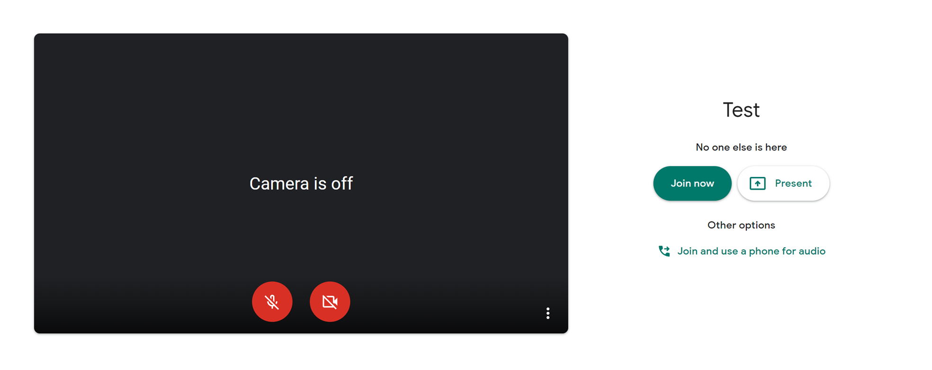
If you do not want others participating in the hearing to see you, click on the camera icon contained in the circle at the bottom of the video screen. The icon will turn red and a slash will be placed over the icon indicating that your camera has been turned off. Likewise, if you do not want others participating in the hearing to hear you, click on the microphone icon contained in the circle at the bottom of the video screen. In the screenshot of the webpage above, both the
- camera and microphone have been turned off. Conversely, the screenshot of the webpage below shows the microphone and video icons turned on and ready to transmit video and audio when you join the hearing.
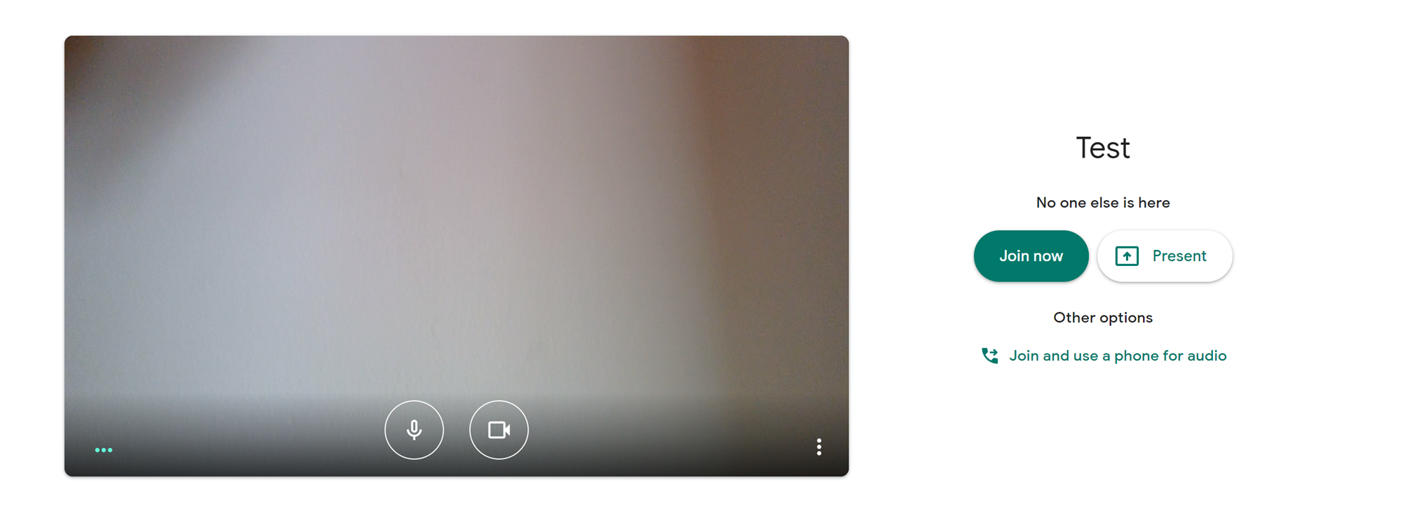
- When you have the video and microphone settings the way you want them, click on the “Join Now” button shown in green in the screenshots above. You can control the volume of the audio through the volume controls on your computer. The screenshot below shows the screen after joining the hearing with both the microphone and camera turned off.
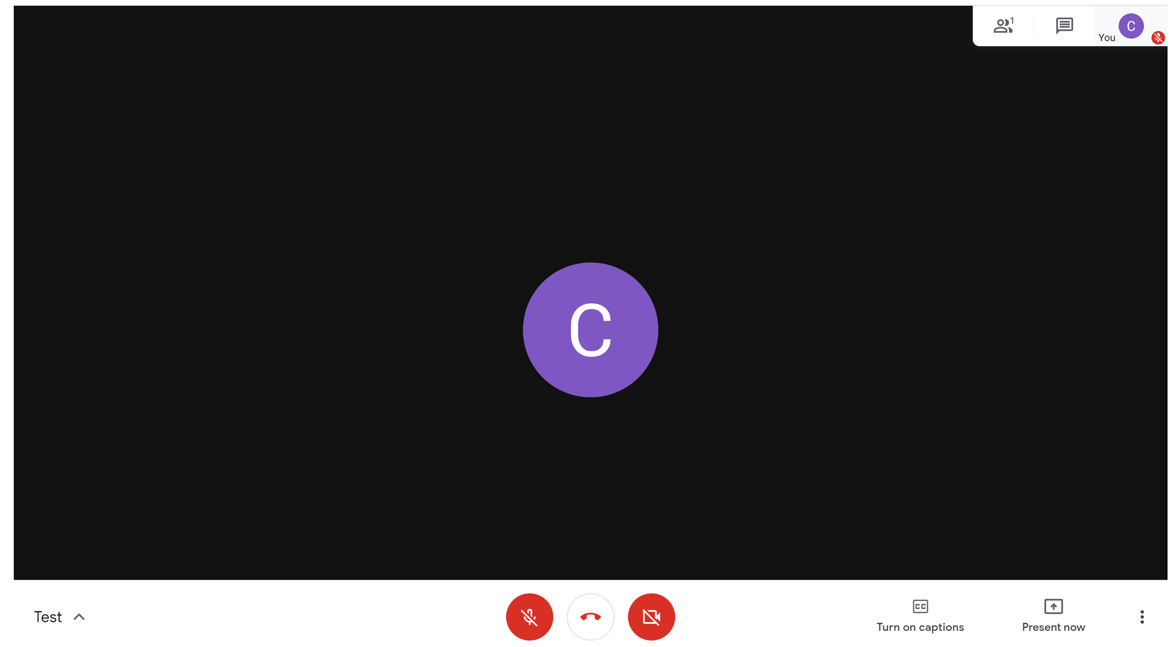
- All participants in the hearing should turn off their microphones during the hearing until called upon by the ALJ to provide comments. When prompted by the ALJ to provide comments, please click on the microphone icon to turn on your microphone and then commence speaking. While you are speaking, please listen for any direction you are given by the ALJ.
- To terminate your participation in the hearing, click on the telephone handset icon between the microphone and camera icons shown on the screenshot above.

General Instructions
- The following are the procedures for the public comment hearings:
a) An individual who is a party or who is a representative of a party will not be permitted to present comments at the remote public comment hearings. Parties will present their positions and will make their comments through testimony at the evidentiary hearing.
b) The remote public comment hearing will be transcribed.
c) The remote public comment hearing will begin at 4:00 p.m. and will continue until concluded, but in no event later than 6:00 p.m.
d) At the outset of the remote public comment hearing, the ALJ will ask for those members of the public who wish to provide public comments to identify themselves. The ALJ will then call on each individual to provide his/her comments. Generally, the ALJ will permit each individual to speak for five minutes, but the length of time allotted to each speaker will depend on the number of persons who wish to speak.
e) The ALJ may ask clarifying questions of an individual who makes a comment at the public comment hearings.

Written Comments
- The Commission prefers written comments over oral comments. As a result, interested persons are encouraged to submit written comments through either: (a) the Commission’s Electronic Filing System at https://www.dora.state.co.us/pls/efi/EFI.homepage in this proceeding; or (b) the Commission’s website at https://puc.colorado.gov/ by clicking on the “FILE A COMMENT OR COMPLAINT” link. Both oral and written comments will be given the same weight in this proceeding.

ORDER

It Is Ordered That:
- The public comment hearings scheduled for April 8, 2020 in Grand Junction, Colorado and April 16, 2020 in Denver, Colorado are consolidated.
- The consolidated public comment hearing shall take place from 4:00 p.m. until it is concluded, but not later than 6:00 p.m. on April 16, 2020. The consolidated public comment hearing is converted into a remote public comment hearing, as described above. Members of the public who wish to participate in, and/or to provide public comments at the remote public comment hearing, must follow the instructions stated above. Members of the public should not attend the public comment hearing in-person.
- This Decision is effective immediately.
(S E A L)    ATTEST: A TRUE COPY  Doug Dean,  Director | THE PUBLIC UTILITIES COMMISSION  OF THE STATE OF COLORADO  CONOR F. FARLEY  ________________________________  Administrative Law Judge

The Three Case Settlement was filed in Consolidated Proceeding Nos. 16AL-0048E, 16A-0139E, and (16A-0055E and approved by Decision No. C16-1075 on November 23, 2016.
Staff, OCC, CEO, EOC, Boulder, SWEEP, Vote Solar, COSSA, SEIA, and WRA are referred to as Intervenors in this Decision.
Motion for Extraordinary Protection at 1.
Id. at 5.

