Decision No. C23-0792-I-E
BEFORE THE PUBLIC UTILITIES COMMISSION OF THE STATE OF COLORADO
PROCEEDING NO. 23D-0547E
IN THE MATTER OF Colorado energy office’s petition for declaratory order to clarify public service company of colorado’s administration of the income-qualified electric vehicle rebate program under its 2021-2023 transportation electrification plan (PROCEEDING nO. 20a-0204e).
ERRATA NOTICE FOR
interim COMMISSION decision accepting petition for declaratory order, issuing notice, and establishing 14-day INTERVENTION period
Errata Mailed: November 30, 2023
Original Decision No. C23-0792-I mailed: November 30, 2023

- Paragraph 4 of this Decision reads as follows:
This Decision also establishes a deadline for initial comments to the Petition of December 14, 2023, at 5:00 p.m. Any responsive comments to the Initial Comments shall be filed no later than December 14, 2023, at 5:00 p.m.
Paragraph 4 is amended to read as follows:
This Decision also establishes a deadline for initial comments to the Petition of December 14, 2023, at 5:00 p.m. Any responsive comments to the Initial Comments shall be filed no later than December 21, 2023, at 5:00 p.m.

- Paragraph 16 of this Decision reads as follows:
Any responsive comments to the Initial Comments shall be filed no later than December 14, 2023, at 5:00 p.m.
Paragraph 16 is amended to read as follows:
Any responsive comments to the Initial Comments shall be filed no later than December 21, 2023, at 5:00 p.m.
- Ordering Paragraph 6 of this Decision reads as follows:
Initial Comments to the Petition shall be filed no later than December 14, 2023, at 5:00 p.m. Any responsive comments to the Initial Comments shall be filed no later than December 14, 2023, at 5:00 p.m.
Ordering Paragraph 6 is amended to read as follows:
Initial Comments to the Petition shall be filed no later than December 14, 2023, at 5:00 p.m. Any responsive comments to the Initial Comments shall be filed no later than December 21, 2023, at 5:00 p.m.
(S E A L)    ATTEST: A TRUE COPY  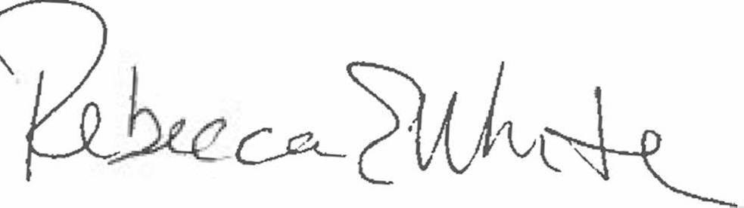  Rebecca E. White,  Director | THE PUBLIC UTILITIES COMMISSION  OF THE STATE OF COLORADO  REBECCA E. WHITE  ________________________________  Director

