Decision No. C23-0689-E
BEFORE THE PUBLIC UTILITIES COMMISSION OF THE STATE OF COLORADO
PROCEEDING NO. 23M-0005E
IN THE MATTER OF THE YEAR 2023 FILINGS BY COLORADO ELECTRIC UTILITIES IN ACCORDANCE WITH 4 CCR 723-3-3206 FOR THE DESIGNATION OF ELECTRIC UTILITY TRANSMISSION FACILITIES WHETHER THE FACILITIES ARE IN THE NORMAL COURSE OF BUSINESS OR AN APPLICATION TO OBTAIN A CERTIFICATE OF PUBLIC CONVENIENCE AND NECESSITY IS REQUIRED.
ERRATA NOTICE FOR
COMMISSION DECISION SETTING RESPONSE DEADLINE TO STAFF RECOMMENDATIONS
Errata mailed October 16, 2023
Original Decision No. R23-0689 mailed October 13, 2023

- Ordering Paragraph No. 1 states Responses to the Recommendation of Commission Staff are due by October 20, 2023, this date is incorrect.
Ordering Paragraph No. 1 is amended to read as follows:
Responses to the Recommendations of Commission Staff, filed on September 27, 2023, and re-filed on September 29, 2023, are due by October 19, 2023.
(S E A L)    ATTEST: A TRUE COPY  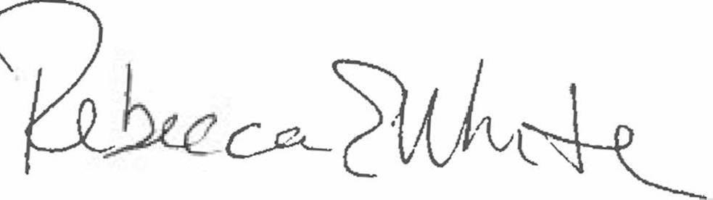  Rebecca E. White,  Director | THE PUBLIC UTILITIES COMMISSION  OF THE STATE OF COLORADO  REBECCA E. WHITE  ________________________________  Director

