Decision No. C23-0621-I-E
BEFORE THE PUBLIC UTILITIES COMMISSION OF THE STATE OF COLORADO
PROCEEDING NO. 19A-0209W
iN THE MATTER OF THE APPLICATION OF DANIEL HEPNER, CHAPTER 7 TRUSTEE FOR THE PROSPECT MOUNTAIN WATER COMPANY, INC. AND THE TOWN OF ESTES PARK, BY AND THROUGH ITS WATER ACTIVITY ENTERPRISE, FOR APPROVAL OF TRANSFER OF ASSETS, TO SURRENDER AND RELINQUISH CERTIFICATE OF PUBLIC CONVENIENCE AND NECESSITY, FOR APPROVAL OF CHARGE PURSUANT TO C.R.S. §40-3.5-102, FOR DECLARATORY ORDER, AND FOR CERTAIN VARIANCES AND WAIVERS
ERRATA NOTICE FOR
INTERIM cOMMISSION DECISION
GRANTING FUND DISBURSAL REQUESTS
Errata Mailed: September 20, 2023
Original Decision No. C23-0621-I mailed: September 15, 2023

- Ordering Paragraph 1 of this Decision reads as follows:
1. The Motion for Final Approval of Disbursements from Capital Improvement Fund (Motion) filed on April 26, 2018 by Prospect Mountain Water Company (Prospect Mountain) is granted, consistent with the above discussion.
Paragraph 1 is amended to read as follows:
1. The Capital Improvement Fund disbursement requested by Prospect Mountain Water Company (Prospect Mountain) is granted, consistent with the above discussion.

(S E A L)    ATTEST: A TRUE COPY  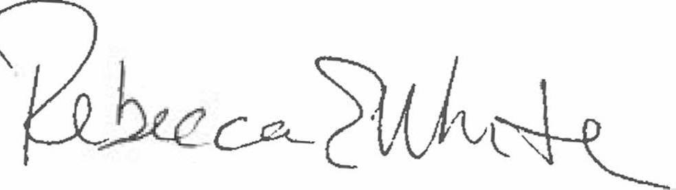  Rebecca E. White,  Director | THE PUBLIC UTILITIES COMMISSION  OF THE STATE OF COLORADO  REBECCA E. WHITE  ________________________________  Director

