Decision No. C23-0561-E
BEFORE THE PUBLIC UTILITIES COMMISSION OF THE STATE OF COLORADO
PROCEEDING NO. 23A-0373FG
IN THE MATTER OF THE APPLICATION OF black hills colorado gas, inc. FOR AN order granting to it a CERTIFICATE OF PUBLIC CONVENIENCE AND NECESSITY to EXERCISE NATURAL GAS FRANCHISE RIGHTS in the town of FREDERICK, COLORADO.
ERRATA NOTICE FOR
COMMISSION decision DEEMING
APPLICATION COMPLETE and GRANTING THE APPLICATION
Second Errata Mailed: September 25, 2023
First Errata Mailed:
Original Decision No. C23-0561 mailed: September 1, 2023

- Paragraph 10 of this Decision reads as follows:
10. According to the franchise agreement, as consideration for the franchise rights granted and in recognition of Black Hills’ right to use the Town streets, the Town requires Black Hills to collect and remit to the Town a franchise fee equal to three percent of all revenues received from the sale of natural gas service within the Town, excluding revenues received from the Town for the sale of natural gas service to the Town.
The previous Errata for this decision requires further defining and clarification to the gross revenues subject to the franchise agreement. Paragraph 10 is amended to read as follows:
10. According to the franchise agreement, as consideration for the franchise rights granted and in recognition of Black Hills’ right to use the Town streets, the Town requires Black Hills to collect and remit to the Town a franchise fee equal to three percent of all gross revenues received from the sale, distribution, and transportation of natural gas service within the Town, excluding revenues received from the Town for the sale of natural gas service to the Town.

(S E A L)    ATTEST: A TRUE COPY  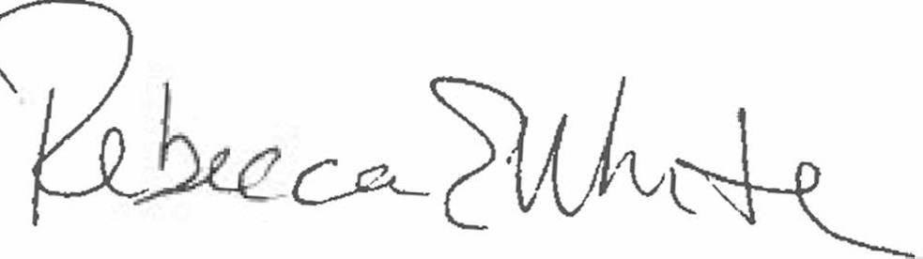  Rebecca E. White,  Director | THE PUBLIC UTILITIES COMMISSION  OF THE STATE OF COLORADO  REBECCA E. WHITE  ________________________________  Director

