Decision No. C23-0175-E
BEFORE THE PUBLIC UTILITIES COMMISSION OF THE STATE OF COLORADO
PROCEEDING NO. 23A-0049R
IN THE MATTER OF THE APPLICATION OF THE CITY OF LONGMONT, COLORADO FOR AUTHORITY TO INSTALL GRADE SEPARATED CROSSINGS TO ACCOMMODATE A PEDESTRIAN UNDERPASS UNDER GREAT WESTERN RAILWAY OF COLORADO RAIL FACILITIES, OMNITRAX, IN THE CITY OF LONGMONT, WELD COUNTY, STATE OF COLORADO.
Errata Notice for
COMMISSION DECISION DEEMING APPLICATION COMPLETE AND GRANTING APPLICATION
Errata mailed March 20, 2023
Original Decision No. C23-0175 mailed March 17, 2023

- Paragraph 8 on page 2 of this Decision reads as:
The proposed new grade separation railroad bridge pedestrian pathway is designed as a single span 78-foot box culvert structure 217 feet by 9 inches long bridge structure to connect trail connections near the Spring from Midway Boulevard and Industrial Lane. The underpass pedestrian and bikeway are proposed to have 13 feet of vertical clearance and 16 feet of clear width along the bridge structure. The proposed minimum clearances meet or exceed the minimum requirements found in Ruled 7375 and 7327 of the Commission Rules Regulating Railroads, Rail Fixed Guideways, Transportation by Rail and Rail Crossings, 4 Code of Colorado Regulations (CCR) 723-7.
- Paragraph 7 states that this project connects a trail between Midway Boulevard and Industrial Lane. That is incorrect. Paragraph 8 also references Rule 7375. That is incorrect. The correct rule reference is Rule 7325. Paragraph 7 shall be amended to read as follows:
The proposed new grade separation railroad bridge pedestrian pathway is designed as a single span 78-foot box culvert structure 217 feet by 9 inches long bridge structure to connect trail connections from Weld County Road 1 near railroad milepost 2.08. The underpass pedestrian and bikeway are proposed to have 13 feet of vertical clearance and 16 feet of clear width along the bridge structure. The proposed minimum clearances meet or exceed the minimum requirements found in Ruled 7325 and 7327 of the Commission Rules Regulating Railroads, Rail Fixed Guideways, Transportation by Rail and Rail Crossings, 4 Code of Colorado Regulations (CCR) 723-7.
(S E A L)    ATTEST: A TRUE COPY  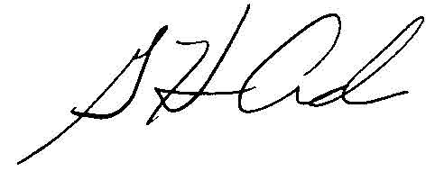  G. Harris Adams,  Interim Director | THE PUBLIC UTILITIES COMMISSION  OF THE STATE OF COLORADO  G. HARRIS ADAMS  ________________________________  Interim Director

