Decision No. C22-0767
BEFORE THE PUBLIC UTILITIES COMMISSION OF THE STATE OF COLORADO
PROCEEDING NO. 20A-0236R
IN THE MATTER OF THE APPLICATION OF CITY OF THORNTON FOR AUTHORITY TO WIDEN 144TH AVENUE CROSSING FOR ROADWAY AND PEDESTRIAN IMPROVEMENTS; REMOVAL OF ACTIVE CROSSING WARNING DEVICES; INSTALLATION OF PASSIVE WARNING DEVICES AT REGIONAL TRANSIT DISTRICT (US DOT 804303G) IN CITY OF THORNTON, ADAMS COUNTY, STATE OF COLORADO.
commission decision granting motion
for extension of time
Mailed Date: December 5, 2022
Adopted Date: November 30, 2022

by the commission

Statement
- This matter comes before the Commission for consideration of a Request for Modifications to City’s Application and Commission’s Decision C20-0552 (Motion) filed by the City of Thornton (Thornton) on November 10, 2022 requesting an extension of time to
July 26, 2021, requesting an extension of time to July 31, 2023 to complete the approved project.
- As grounds for this Motion, Thornton states they continue to experience ongoing delays in construction which will push this project into the 2023 paving season in order to complete the project. Thornton believes that it can complete construction of the project by
July 31, 2023.
- No responses were filed to the Motions.
- Now being fully advised in the matter, we grant the Motion.

ORDER

The Commission Orders That:
- The Request for Modifications to City’s Application and Commission’s Decision C20-0552 (Motion) filed by the City of Thornton (Thornton) on November 10, 2022, requesting an extension of time to July 31, 2023 to complete the approved project is granted.
- Thornton shall provide a letter of completion in this matter by July 31, 2023.
- The Commission retains jurisdiction to enter further decisions, as necessary.
- This Decision is effective on its Mailed Date.

ADOPTED IN COMMISSIONERS’ WEEKLY MEETING
November 30, 2022.
(S E A L)    ATTEST: A TRUE COPY  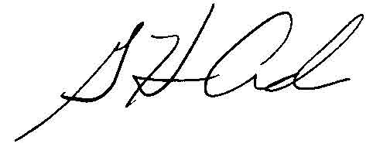  G. Harris Adams,  Interim Director | - THE PUBLIC UTILITIES COMMISSION  OF THE STATE OF COLORADO  ERIC BLANK  ________________________________  JOHN GAVAN  ________________________________  MEGAN M. GILMAN  ________________________________  Commissioners

