Decision No. R23-0519-I
BEFORE THE PUBLIC UTILITIES COMMISSION OF THE STATE OF COLORADO
PROCEEDING NO. 23V-0274T
IN THE MATTER OF THE PETITION OF THE NORTH AMERICAN NUMBERING PLAN ADMINISTRATION ON BEHALF OF THE COLORADO TELECOMMUNICATIONS INDUSTRY FOR RELIEF FOR THE 970 AREA CODE.
INTERIM DECISION OF
ADMINISTRATIVE LAW JUDGE
Aviv segev
sCHeDULING rEMOTE pREHeARING cONFERENCE
Mailed Date: August 4, 2023

STATEMENT
- On May 31, 2023, the North American Numbering Planning Administrator (NANPA), filed its Petition (Petition) on behalf of the Colorado telecommunications industry for the approval of an overlay relief plan to address the anticipated exhaustion of available telephone numbers in the 970 Numbering Plan Area (NPA).
- During the Commission’s weekly meeting, held July 16, 2023, the matter involving the Petition was referred to an administrative law judge (ALJ) for disposition.
- In anticipation of an evidentiary hearing, the undersigned ALJ is setting a prehearing conference in accordance with Rule 1409(a) of the Rules of Practice and Procedure, 4 Code of Colorado Regulations 723-1. Accordingly, a remote prehearing conference will be scheduled, as ordered below, and will be conducted using the Zoom videoconferencing platform. The ALJ, or a member of Commission Staff, will email the parties the log-in information in advance of the hearing.
- The parties are advised that failure to attend or to participate in the remote prehearing conference may be construed as a waiver of any objection to the rulings made, the procedural schedule established, or the hearing date scheduled, during the remote prehearing conference.

ORDER

It Is Ordered That:
- A remote prehearing conference is scheduled as follows:
DATE: August 15, 2023
TIME: 09:30 a.m.
PLACE: Join by video conference using Zoom at the link to be provided in an email from the Administrative Law Judge
- No one should appear in-person for the remote prehearing conference or evidentiary hearing.
- Participants in the prehearing conference and evidentiary hearing may not distribute the Zoom link and access code to anyone not participating in the remote prehearing conference, or evidentiary hearing.
- Video-Conference Participation. Counsel for the parties, parties, and witnesses, as applicable, may attend the prehearing conference and the evidentiary hearing by videoconference using the Zoom platform.
- This Decision shall be effective immediately.
(S E A L)    ATTEST: A TRUE COPY  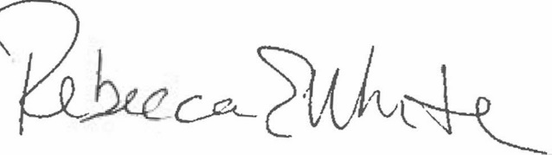  Rebecca E. White,  Director | THE PUBLIC UTILITIES COMMISSION  OF THE STATE OF COLORADO  AVIV SEGEV  ________________________________  Administrative Law Judge

Additional information about the Zoom platform and how to use the platform are available at: https://zoom.us/. The parties are strongly encouraged to participate in a test meeting prior to the scheduled prehearing conference. See https://zoom.us/test.

