Decision No. R23-0408-I
BEFORE THE PUBLIC UTILITIES COMMISSION OF THE STATE OF COLORADO
PROCEEDING NO. 22F-0263EG
OLSONS GREENHOUSES OF COLORADO, LLC,
COMPLAINANT,
V.
PUBLIC SERVICE COMPANY OF COLORADO,
RESPONDENT.
interim DECISION of
administrative law judge
Conor F. Farley
SETTING DEADLINE FOR STATEMENTS OF POSITION
Mailed Date: June 16, 2023

STATEMENT
- The hearing in this proceeding took place on June 8, 2023.
- At the conclusion of the hearing, the undersigned Administrative Law Judge set July 7, 2023, as the deadline for Statements of Position.

ORDER

The Commission Orders That:
- The deadline for the filing of Statements of Position is July 7, 2023.
- This Decision is effective immediately.
(S E A L)    ATTEST: A TRUE COPY  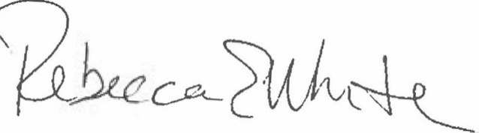  Rebecca E. White,  Director | THE PUBLIC UTILITIES COMMISSION  OF THE STATE OF COLORADO  CONOR F. FARLEY  ________________________________  Administrative Law Judge

