Decision No. R23-0394-I
BEFORE THE PUBLIC UTILITIES COMMISSION OF THE STATE OF COLORADO
PROCEEDING NO. 23A-0112CP-EXT
IN THE MATTER OF THE APPLICATION OF BOILESEN SHUTTLES LLC DOING BUSINESS AS SWEET PEA TOURS TO EXTEND OPERATIONS UNDER CERTIFICATE OF PUBLIC CONVENIENCE AND NECESSITY NO. 48202S.
INTERIM DECISION OF
ADMINISTRATIVE LAW JUDGE
G. Harris Adams
Scheduling hearing and
establishing procedurES
Mailed Date: June 12, 2023

STATEMENT
- On March 6, 2023, Boilesen Shuttles LLC, doing business as
Sweet Pea Tours (Sweet Pea) filed its Application for Permanent Authority to Extend Operations under Certificate of Public Convenience and Necessity No. 48202S. On March 17, 2023,
Sweet Pea filed an amendment to the application.
- The Commission gave notice of the application, as amended, on March 20, 2023. As originally noticed, the application sought the following authority:
For an order of the Commission authorizing the extension of Certificate of Public Convenience and Necessity (CPCN) No. 48202S.
Currently, CPCN No. 48202S authorizes the following:
Transportation of passengers in call-and-demand shuttle service, between all points in Steamboat Springs, Colorado, on the one hand, and the Strawberry Hot Springs, near Steamboat Springs, Colorado, on the other hand.
This authority is restricted to providing service only within the following time frames:
- Between the dates of June 1 and October 1, of the same year, inclusive; and
- Between the dates of November 15 and April 15 of the following year, inclusive.
If the extension is granted, CPCN No. 48202S will read:
Transportation of passengers in call-and-demand charter service and call-and-demand shuttle service between all points in Routt County, State of Colorado.
This authority is restricted:
- against providing any transportation service to or from the Yampa Valley Regional Airport; and
- to providing transportation service from June 1 through October 1 of the same year; and from November 15 through April 15 of the following year.
- On April 13, 2023, the Petition for Leave to Intervene NDW Enterprises LLC d/b/a Ski Town Transportation (Ski Town) was filed.
- The matter was referred to an Administrative Law Judge (ALJ) for resolution by minute entry during the Commission’s Weekly Meeting held April 26, 2023.
- In its petition, Ski Town argues that intervention is supported by having filed applications for temporary and permanent authority in Proceeding Nos. 22A-0131CP-TA and 22A-0132CP. By Decision No. C22-0215, issued April 7, 2022, the Commission granted Ski Town the following temporary authority to conduct the following operations as a common carrier for a period of 150 days commencing from the effective date of the Decision:
Transportation of passengers in call-and-demand shuttle service:
- between the Yampa Valley Regional Airport, Hayden, Colorado, on the one hand, and the town of Steamboat Springs, Colorado, including all points within one mile of the town limits of Steamboat Springs and the Steamboat Springs Ski Area, on the other hand; and
- between the Yampa Valley Regional Airport, Hayden, CO, on the one hand, and the town of Craig, Colorado, including all points within one mile of the town limits of Craig, Colorado, on the other hand.
- By Decision No. C22-0606, issued October 7, 2022, the Commission further extended that temporary authority granted by Decision C22-0215, nunc pro tunc, from September 5, 2022, through the date a recommended decision issued by the administrative law judge on the permanent authority application becomes a Commission decision.
- By Decision No. R23-0302, issued May 8, 2023, Ski Town was granted a Certificate of Public Convenience and Necessity to operate as a common carrier by motor vehicle for hire as follows:
for the transportation of passengers, in Shuttle service:
(1) between the Yampa Valley Regional Airport, Hayden, Colorado, on the one hand, and the town of Steamboat Springs, Colorado, including all points within one mile of the town limits of Steamboat Springs and the Steamboat Springs Ski Area, on the other hand;
(2) between the Yampa Valley Regional Airport, Hayden, Colorado, on the one hand, and the town of Craig, Colorado, including all points within one mile of the town limits of Craig, Colorado, on the other hand; and
(3) between all points within the town of Steamboat Springs, Colorado, including all points within one mile of the town limits of Steamboat Springs and the Steamboat Springs Ski Area.
Restrictions:
1. Operations under Items 1 through 3 are restricted to the use of vehicles with a seating capacity of 28 passengers or fewer plus the driver according to vehicle manufacturer specifications.
2. Until December 31, 2024, operations under Items 1 through 3 are restricted to the use of no more than 30 vehicles at any one point in time, and on and after January 1, 2025, operations under Items 1 through 3 are restricted to the use of no more than 35 vehicles at any one point in time.
- A movant who seeks to permissively intervene in a Commission proceeding “must demonstrate that the subject proceeding may substantially affect the pecuniary or tangible interests of the movant (or those it may represent) and that the movant’s interests would not otherwise be adequately represented.” Rule 1401(c), 4 CCR 723-1.
- The proponent of a Commission decision bears the burden of proof with respect to the relief sought. Rule 1500, 4 CCR 723-1.
- By Sweet Pea’s proposed extension overlapping the permanent authority granted Ski Town by the Commission, it is found that a specific interest has been shown to substantially affect their pecuniary or tangible interest. Permissive intervention will be granted.
- All parties are advised that this proceeding is governed by the Rules of Practice and Procedure found at 4 CCR 723-1. The ALJ expects the parties to comply with these rules. The rules are available on the Commission’s website (http://www.dora.colorado.gov/puc) and in hard copy from the Commission.
- Each party is specifically reminded that all filings with the Commission must also be served upon all other parties in accordance with Rule 1205 of the Rules of Practice and Procedure, 4 CCR 723-1.

Procedural schedule and evidentiary Hearing.
- The parties request that the evidentiary hearing in this matter be held in Steamboat Springs, Colorado.
- Based upon the scope of the proposed authority, an attempt will be made to accommodate the parties request, subject to travel authorization, scheduling availability, and facility availability.
- To facilitate the orderly and efficient litigation of this proceeding, each party is ordered to file (or supplement), and to serve on each other, a list of witnesses the party intends to call, a summary of the testimony of each witness, and copies of the exhibits the filing party intends to present at the hearing.
- Parties are advised that no witness will be permitted to testify, except in rebuttal, unless that witness is identified on a list of witnesses filed and served in accordance with the procedural schedule. Parties are advised further that no exhibit will be received in evidence, except in rebuttal, unless filed and served in accordance with the procedural schedule.

ORDER

It Is Ordered That:
- A hearing in this matter shall be conducted at the following dates, time, and place:
DATES: August 23 and 24, 2023
TIME: 8:30 a.m. daily
PLACE: Health and Human Services Building
Routt County Community Room
135 6th St.
Steamboat Springs, CO 80487
- No later than July 3, 2023, Boilesen Shuttles LLC, doing business as
Sweet Pea Tours (Sweet Pea) shall file (or supplement) and serve: (a) a list that identifies the witnesses Sweet Pea intends to call at the hearing, the last known address and telephone number of each witness, and summary of the anticipated testimony of each witness; and (b) copies of the exhibits Sweet Pea will present at the hearing.
- No later than July 24, 2023, NDW Enterprises LLC d/b/a Ski Town Transportation (Ski Town) shall file (or supplement) and serve: (a) a list that identifies the witnesses Ski Town intends to call at the hearing, including a summary of the anticipated testimony of each witness; and (b) copies of the exhibits Ski Town will present at the hearing.
- This Decision shall be effective immediately.
(S E A L)    ATTEST: A TRUE COPY  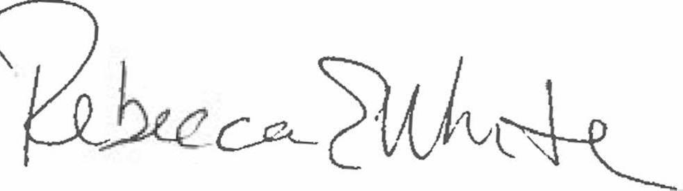  Rebecca E. White,  Director | THE PUBLIC UTILITIES COMMISSION  OF THE STATE OF COLORADO  G. HARRIS ADAMS  ________________________________  Administrative Law Judge

Service must be accomplished pursuant to Rule 1205 of the Commission’s Rules of Practice and Procedure, 4 CCR 723-1, including a certificate of service indicating how and when such documents were served on the other party.
Id.

