Decision No. C23-0640-E
BEFORE THE PUBLIC UTILITIES COMMISSION OF THE STATE OF COLORADO
PROCEEDING NO. 23M-0472E
IN THE MATTER OF THE COMMISSION'S REVIEW OF THE PROVISIONS ADDRESSING TRANSMISSION CERTIFICATES OF PUBLIC CONVENIENCE AND NECESSITY AND TRANSMISSION PLANNING IN THE RULES REGULATING ELECTRIC UTILITIES, 4 CODE OF COLORADO REGULATIONS (CCR) 723-3.
ERRATA NOTICE FOR
COMMISSION DECISION OPENING A REPOSITORY PROCEEDING AND SOLICITING INPUT FROM INTERESTED PARTICIPANTS
Errata mailed October 17, 2023
Original Decision No. C23-0640 mailed September 28, 2023

- Attachment A titled Questions For Colorado Transmission Utilities And Other Stakeholders requires revision to the questions set forth.
The revisions to those questions are attached to this Errata.

(S E A L)    ATTEST: A TRUE COPY  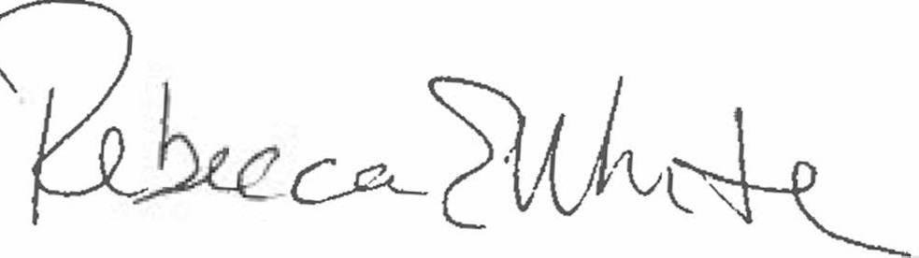  Rebecca E. White,  Director | THE PUBLIC UTILITIES COMMISSION  OF THE STATE OF COLORADO  REBECCA E. WHITE  ________________________________  Director

