Decision No. C23-0619E
BEFORE THE PUBLIC UTILITIES COMMISSION OF THE STATE OF COLORADO
PROCEEDING NO. 23M-0459EG
IN THE MATTER of ENERGY ASSISTANCE SYSTEM BENEFIT CHARGE FOR 2023-2024 PURSUANT TO 4 CCR 723-3-3412 AND 4 CCR 723-4-4412 TO BE EFFECTIVE OCTOBER 1, 2023.
Errata Notice for
COMMISSION DECISION SETTING AUTHORIZING REVISIONS TO THE ENERGY ASSISTANCE SYSTEM BENEFIT CHARGE RATES
Errata mailed September 20, 2023
Original Decision No. C23-0619 mailed September 15, 2023

- Decision No. C23-0619 issued on September 15, 2023, mistakenly included an incorrect version of “Commission Decision Setting Authorizing Revisions To The Energy Assistance System Benefit Charge Rates”.
The Decision attached to this notice is the correct Decision No. C23-0619, filed on September 15, 2023.
(S E A L)    ATTEST: A TRUE COPY  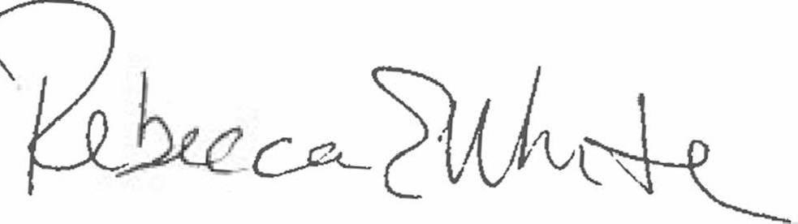  Rebecca E. White,  Director | THE PUBLIC UTILITIES COMMISSION  OF THE STATE OF COLORADO  REBECCA E. WHITE  ________________________________  Director

