Decision No. C23-0443
BEFORE THE PUBLIC UTILITIES COMMISSION OF THE STATE OF COLORADO
PROCEEDING NO. 22A-0181R
IN THE MATTER OF THE APPLICATION OF CITY AND COUNTY OF DENVER FOR AUTHORITY TO ALTER THE EXISTING AT-GRADE CROSSINGS OF THE REGIONAL TRANSPORTATION DISTRICT L LIGHT RAIL LINE IN THE VICINITY OF THE INTERSECTION OF 17TH STREET/ CALIFORNIA STREET, AND 17TH STREET/ STOUT STREET IN CITY AND COUNTY OF DENVER, STATE OF COLORADO.
commission decision granting motion
for extension of time
Mailed Date: July 7, 2023
Adopted Date: July 5, 2023

by the commission

Statement
- This matter comes before the Commission for consideration of an Unopposed Motion for Extension of Time (Motion) filed by the City and County of Denver (Denver) on
June 16, 2023 requesting an extension of time to September 30, 2023 to file the Notice of Completion of Work to the Commission.
- As grounds for this Motion, Denver states that it is still engaged in the alterations approved by the Commission in this proceeding. Denver believes that the alterations will be operational by September 30, 2023 and request an extension of time to this date to file the Notice of Completion of Work.
- There were no responses filed to this Motion.
- Now being fully advised in the matter, we grant the Motion.

ORDER

The Commission Orders That:
- The Unopposed Motion for Extension of Time filed by the City and County of Denver to file a signed Notice of Completion of Work in this matter is granted.
- Denver shall file the Notice of Completion of Work in this matter by September 30, 2023. However, we understand this notice may be provided earlier than this date depending on changes to the construction schedule.
- The Commission retains jurisdiction to enter further decisions, as necessary.
- This Decision is effective on its Mailed Date.

ADOPTED IN COMMISSIONERS’ WEEKLY MEETING
July 5, 2023.
(S E A L)    ATTEST: A TRUE COPY  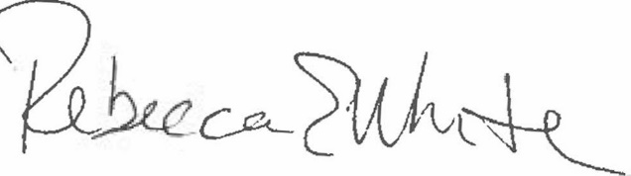  Rebecca E. White,  Director | THE PUBLIC UTILITIES COMMISSION  OF THE STATE OF COLORADO  ERIC BLANK  ________________________________  MEGAN M. GILMAN  ________________________________  TOM PLANT  ________________________________  Commissioners

