Decision No. C23-0305-I
BEFORE THE PUBLIC UTILITIES COMMISSION OF THE STATE OF COLORADO
PROCEEDING NO. 23M-0005E
IN THE MATTER OF THE YEAR 2023 FILINGS BY COLORADO ELECTRIC UTILITIES IN ACCORDANCE WITH RULE 4 CCR 723-3-3206 FOR THE DESIGNATION OF ELECTRIC UTILITY TRANSMISSION FACILITIES WHETHER THE FACILITIES ARE IN THE NORMAL COURSE OF BUSINESS OR AN APPLICATION TO OBTAIN A CERTIFICATE OF PUBLIC CONVENIENCE AND NECESSITY IS REQUIRED
interim commission decision
PROVIDING notice of filing
AND setting date for filing COMMENTS
Mailed Date: May 12, 2023
Adopted Date: May 10, 2023

BY THE COMMISSION

Statement
- Rule 3206(c) of the Commission’s Rules Regulating Electric Utilities, 4 Code of Colorado Regulations 723-3, requires each Colorado electric utility to file with the Commission, no later than April 30 of each year, information on its proposed new construction or extensions of transmission facilities for the next three calendar years.
- Rule 3206(d)(2)(A) provides that the Commission will give notice of the filing
of data to all those who, in the opinion of the Commission, are interested persons, firms, or corporations. Any interested person, firm, or corporation may file comments regarding the projects identified by the information filed with the Commission by June 15, 2023.
- The following utilities have filed information on proposed construction projects:
- Black Hills Colorado Electric, LLC
- CORE Electric Cooperative
- Public Service Company of Colorado
- Tri-State Generation and Transmission Association, Inc.
- Specific information may be found in each utility’s filing in this Proceeding on file with the Commission.

ORDER

It Is Ordered That:
- Notice is hereby given that the above investor-owned utilities and rural electric cooperative associations have submitted information concerning the proposed construction of transmission facilities in accordance with Rule 3206 of the Rules Regulating Electric Utilities, 4 Code of Colorado Regulations 723-3. Pursuant to that rule, the above-listed parties are notified that the information is available for inspection at the offices of the Commission during regular business hours or on the Commission’s online E-Filings system.
- On or before June 15, 2023, any interested person, firm, or corporation may file comments about the projects identified by the information now filed with the Commission. The Commission will consider any comments in determining which projects do not require a Certificate of Public Convenience and Necessity, which projects will require the utility to file an application for a Certificate of Public Convenience and Necessity, or which projects will require the utility to file for a formal determination that a Certificate is not required.
- This Decision is effective upon its Mailed Date.

ADOPTED IN COMMISSIONERS’ WEEKLY MEETING
May 10, 2023.
(S E A L)    ATTEST: A TRUE COPY  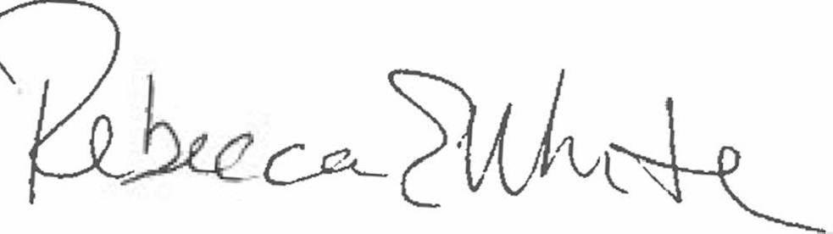  Rebecca E. White,  Director | THE PUBLIC UTILITIES COMMISSION  OF THE STATE OF COLORADO  ERIC BLANK  ________________________________  MEGAN M. GILMAN  ________________________________  TOM PLANT  ________________________________  Commissioners

