Decision No. C23-0217
BEFORE THE PUBLIC UTILITIES COMMISSION OF THE STATE OF COLORADO
PROCEEDING NO. 23I-0143R
IN THE MATTER OF THE REGIONAL TRANSPORTATION DISTRICT'S CORRECTIVE ACTION PLAN REGARDING THE jefferson county station dERAILMENT, RULE 4 CCR 723-7-7347.
COMMISSION DECISION OPENING
INVESTIGATION AND REQUIRING
FILING OF CORRECTIVE ACTION PLAN
Mailed Date: March 30, 2023
Adopted Date: March 29, 2023

by the commission

Statement
- On March 11, 2023, a Regional Transportation District (RTD) light-rail vehicle derailed at the Jefferson County end of line station in the City of Golden resulting in one light rail vehicle derailing, breaking through the bumper block and into the hillside before coming to a stop.
- RTD is still in the process of conducting the initial investigation of this derailment and will be providing a preliminary accident report to the Commission for initial review on
April 24, 2023, 45 days after the incident as required by the State Safety Oversight Program Standard, Commission Rule 4 Code of Colorado Regulations 723-7-7347.

Analysis
- While the Commission has not yet received the accident report for the
March 11, 2023, derailment, we are proactively opening this investigation so that RTD can file any corrective actions directly in this proceeding for our review.
- Pursuant to 4 CCR 723-7-7347 of the Commission’s Rules Regulating Railroads, Rail Fixed Guideways, Transportation by Rail and Rail Crossings, we are opening this investigation proceeding.
- RTD is required to file all Corrective Action Plans and corresponding hazard investigation reports in this proceeding on the same date that the accident investigation report is provided to the Commission.

ORDER

The Commission Orders That:
- An investigatory proceeding is opened to review and approve the Regional Transportation District’s (RTD) hazard investigations and Corrective Action Plan (CAP) for the March 11, 2023, derailment at the Jefferson County end of line station in Golden, Colorado.
- RTD shall file its preliminary CAP’s and hazard investigations in this proceeding to be publicly available on the same day it provided the preliminary accident report.
- This Decision is effective on its Mailed Date.

ADOPTED IN COMMISSIONERS’ WEEKLY MEETING
March 29, 2023.
(S E A L)    ATTEST: A TRUE COPY  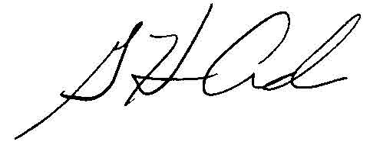  G. Harris Adams,  Interim Director | THE PUBLIC UTILITIES COMMISSION  OF THE STATE OF COLORADO  ERIC BLANK  ________________________________  MEGAN M. GILMAN  ________________________________  TOM PLANT  ________________________________  Commissioners

