Decision No. C23-0176
BEFORE THE PUBLIC UTILITIES COMMISSION OF THE STATE OF COLORADO
PROCEEDING NO. 20M-0109R
REPOSITORY DOCKET FOR THREE-YEAR STATE SAFETY OVERSIGHT AUDIT AND INVESTIGATIONS OF THE REGIONAL TRANSPORTATION DISTRICT.
Commission DECISION APPROVING
Semi-annual virtual AUDIT REPORT 6
Mailed Date: March 15, 2023
Adopted Date: March 15, 2023

BY THE COMMISSION

Statement
- This matter comes before the Commission for consideration of the Semi-Annual Virtual and On-Site Safety Audit 6 Report (Audit Report 6) of the metro Denver area Regional Transportation District (RTD) light rail operation filed on March 9, 2023.
- Audit Report 6, dated March 9, 2023, represents the sixth audit of a three-year on-site safety review of RTD’s Public Transportation Agency Safety Plan as required by Rule 7352 of the Rules Regulating Railroads, Rail Fixed Guideways, Transportation by Rail, and Rail Crossings, 4 Code of Colorado Regulations 723-7. Commission Safety Audit Rule 7352 was completed by Staff of the Commission (Staff). There are no findings made during the sixth audit of the cycle.
- As required by Rule 7352(c), RTD was provided the proposed checklist on January 23rd giving more than 30 days to review the draft checklists RTD did not have any immediate comments on the proposed checklists.
- The Commission has reviewed Audit Report 6 prepared by Staff and concurs with the contents of the report.
- With the changes that will continuously be occurring to RTD’s Public Transportation Agency Safety Plan, RTD documentation, and potentially Commission Rules in the future, we will allow Staff the flexibility to update these checklists throughout the audit cycle as needed to make required reference changes and to change questions as RTD documentation is developed and updated.
- The Commission has jurisdiction in this matter under § 40-18-103, C.R.S., and Rule 7352.

ORDER

The Commission Orders That:
- The Commission approves the Semi-Annual Virtual & On-Site Safety Audit 6 Report dated March 9, 2023.

- This Decision is effective on its Mailed Date.

ADOPTED IN COMMISSIONERS’ WEEKLY MEETING
March 15, 2023.
(S E A L)    ATTEST: A TRUE COPY  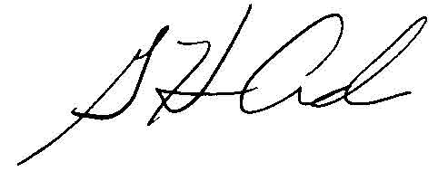  G. Harris Adams,  Interim Director | THE PUBLIC UTILITIES COMMISSION  OF THE STATE OF COLORADO  ERIC BLANK  ________________________________  MEGAN M. GILMAN  ________________________________  TOM PLANT  ________________________________  Commissioners

