Decision No. C23-0015
BEFORE THE PUBLIC UTILITIES COMMISSION OF THE STATE OF COLORADO
PROCEEDING NO. 21A-0575R
IN THE MATTER OF THE APPLICATION OF NEW ELK COAL CO., LLC FOR AUTHORITY TO REPAIR AND UPGRADE A COUNTY ROAD RAILROAD GRADE CROSSING AT COUNTY ROAD 47.3 AND NEW ELK COAL CO., LLC (COUNTY ROAD 47.3 IN VALDEZ, LAS ANIMAS COUNTY, STATE OF COLORADO).
commission decision granting motion
for extension of time to complete project CONSTRUCTION
Mailed Date: January 11, 2023
Adopted Date: January 11, 2023

by the commission

Statement
- This matter comes before the Commission for consideration of a letter requesting an extension of time to complete project construction (We will construe this letter as a Motion for Extension of Time To Complete Project Construction (Motion)) filed by New Elk Coal (New Elk) on December 27, 2022 requesting an extension of time to December 31, 2024 to complete the crossing improvement project approved by the Commission by Decision No. C22-0068 mailed January 31, 2022.
- As grounds for the Motion, New Elk states that due to unforeseen circumstances, New Elk would like to extend the date to complete the subject project to December 31, 2024.
- A crossing that trains could occupy currently does not exist, so there will be no highway-rail grade crossing safety issue by delaying completion of the project to
December 31, 2024.
- Now being fully advised in the matter, we grant the Motion.

ORDER

The Commission Orders That:
- The Motion for Extension of Time To Complete Project Construction filed by New Elk Coal on December 27, 2022 requesting an extension of time to December 31, 2024 to complete the project approved by the Commission by Decision No. C22-0068 mailed
January 31, 2022 is granted.
- New Elk Coal shall file a notice that the project has been completed in this matter shall be filed within ten days of December 31, 2024.
- The Commission retains jurisdiction to enter further decisions, as necessary.

- This Decision is effective on its Mailed Date.

ADOPTED IN COMMISSIONERS’ WEEKLY MEETING
January 11, 2023.

(S E A L)    ATTEST: A TRUE COPY  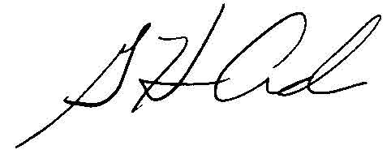  G. Harris Adams.,  Interim Director | THE PUBLIC UTILITIES COMMISSION  OF THE STATE OF COLORADO  ERIC BLANK  ________________________________  JOHN GAVAN  ________________________________  MEGAN M. GILMAN  ________________________________  Commissioners

