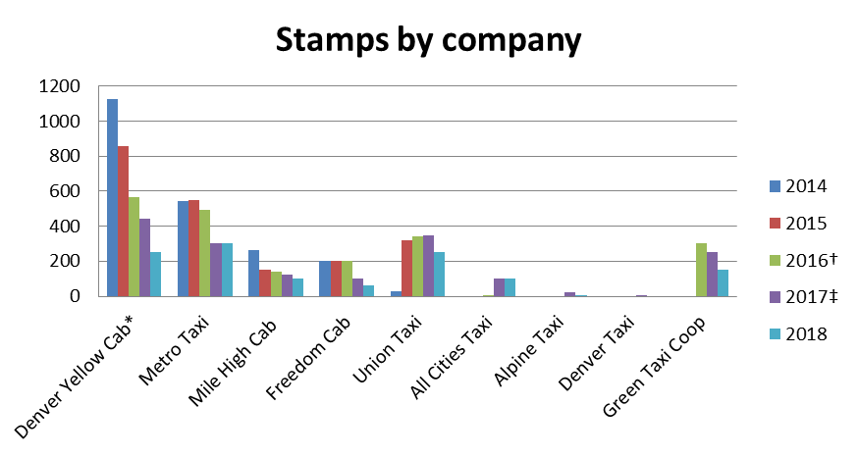
Source: Public Utilities Commission
* - Stamps purchased by Denver Yellow include stamps for Boulder Taxi and SuperShuttle
† - In 2016 the charge per stamp increased from $5 to $35
‡ - In 2017 the charge per stamp increased from $35 to $45

