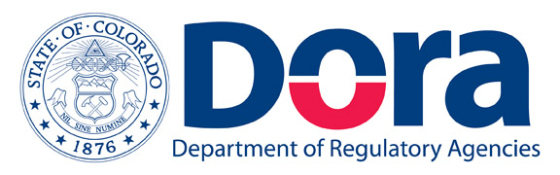 |  | Public Utilities Commission  Joshua B. Epel, Chairman  James K. Tarpey, Commissioner  Matt Baker, Commissioner  Doug Dean, Director
John W. Hickenlooper Governor
Barbara J. Kelley  Executive Director |  | November 10, 2011

MAY REQUIRE COMPANY ACTION

To: ALL TELECOMMUNICATIONS, ENERGY AND WATER PUBLIC UTILITIES IN THE STATE OF
COLORADO AND OTHER RELATED ENTITIES

RE: Interest Rate to be paid on Customer deposits for the year 2012.

Many public utilities offering telephone, energy and water services to residential and commercial customers in the State of Colorado have provisions in their tariffs that allow the utility to require customers to maintain a deposit with the utility to ensure payment of services. If the utility requires such deposits, it is required to pay simple interest on those customer deposits as prescribed by Commission rules.

For calendar year 2011, the rate was 0.34%.
For calendar year 2012 the rate will remain 0.34%.
(The basis point differential is less than 25 points)

Jurisdictional utilities are reminded that it might be necessary to file a compliance advice letter to amend their tariffs. If it is necessary to file a tariff change, the Commission expects the filing on or before December 30, 2011 with an effective date of January 1, 2012. Filing this compliance letter during the month of November would be greatly appreciated.

Failure to file the required compliance on or before December 30, 2011 will be viewed as an intentional violation of Commission fining Rules 2895, 3976, 4976, or 5420 and the company could be subject to a fine of up to $500.00.

For additional information and to facilitate any tariff changes, the Commission entered the corresponding Decisions.

Electric Utilities | Decision No. C11-1190
Gas Utilities | Decision No. C11-1191
Water Utilities | Decision No. C11-1193
Telecommunication Providers | Decision No. C11-1192

Please reference the respective Commission Decision Number on the tariffs accompanying your advice letter. The advice letter filing is a compliance filing.

Please submit your advice letter as a NEW Advice Letter filing. DO NOT file your advice letter in the docket associated with the above listed decisions.

If you have any questions regarding the applicability of the interest rate on deposits, the manner in which the rate is calculated, or any other issues relating to this web posting, please contact Michelle Franca, Financial Analyst, at 303-894-2828 or Michelle.Franca@dora.state.co.us.

Sincerely,
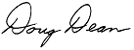
Doug Dean
Director

