Decision No. C04-1362
BEFORE THE PUBLIC UTILITIES COMMISSION OF THE STATE OF COLORADO
DOCKET NO. 03M-480T
IN THE MATTER OF THE VERIFIED PETITION OF STRASBURG TELEPHONE COMPANY FOR extension of VARIANCE OF COMMISSION RULE 4 CCR 723-1-10 REGARDING ELECTRONIC BILLING.
decision granting application
for EXTENSION of variance
Mailed Date: November 19, 2004
Adopted Date: November 17, 2004

BY THE COMMISSION

Statement
- This matter comes before the Commission for consideration of Strasburg Telephone Company's (Strasburg) application for an extension of a temporary variance from 4 Code of Colorado Regulations 723-2-10.1.1 (Rule 10). Rule 10 requires local exchange carriers to type or machine print their monthly bills to consumers. Strasburg requests the extension of the variance granted in Decision No. C03-1271 and be allowed to continue providing optional to the customer electronic billing (e-billing), for the period until the Commission modifies its rules to allow e-billing or December 31, 2005.
- We have initiated but have not yet completed revision of our telephone rules. Revisions to Rule 10.1.1, which would allow all local exchange carriers (LECs) to use e-billing are under consideration. Therefore, we grant Strasburg's request for a variance until Rule 10.1.1 is revised to allow e-billing by LECs in general, but, in any event, the variance shall not continue beyond December 31, 2005.

ORDER

The Commission Orders That:
- The application by Strasburg Telephone Company is deemed complete.
- Strasburg Telephone Company's application for an extension of variance from 4 Code of Colorado Regulations 723-2-10.1.1 is granted. The variance shall continue until that rule is revised in the Commission rulemaking docket but, in no event shall this variance continue beyond December 31, 2005.
- Strasburg Telephone Company shall file an Advice Letter with the Commission having an effective date of no less than 14 days from the date of filing to extend the termination date for optional e-billing for its customers. The tariff sheets shall include an expiration date of December 31, 2005, and the Number of this Decision as the authority that grants the ability to make the filing.
- This Order is effective on its Mailed Date.

ADOPTED IN COMMISSIONERS’ WEEKLY MEETING
November 17, 2004.

THE PUBLIC UTILITIES COMMISSION
OF THE STATE OF COLORADO
GREGORY E. SOPKIN
________________________________
POLLY PAGE
________________________________
CARL MILLER
________________________________
Commissioners
(S E A L)


ATTEST: A TRUE COPY
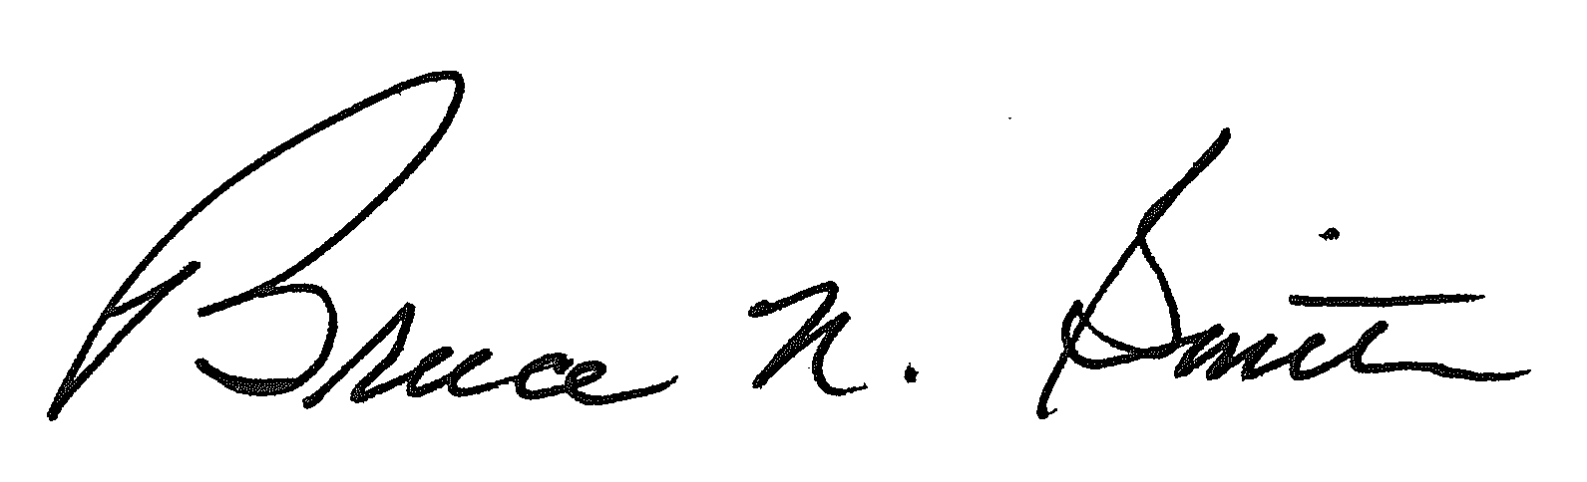
Bruce N. Smith
Director
/tmp/in/input.doc

