Decision No. R03-1332-I
BEFORE THE PUBLIC UTILITIES COMMISSION OF THE STATE OF COLORADO
DOCKET NO. 03A-204CP
in the matter of the application of norm’s transportation, service, l.l.c., for a certificate of public convenience and necessity to operate as a common carrier by motor VEHICLE for hire.
interim order of
administrative law judge
MANA L. JENNINGS-FADER
scheduling hearing
Mailed Date: November 26, 2003

statement
- On May 2, 2003, Applicant Norm’s Transportation Service, L.L.C. (Applicant) filed the Application for a Certificate of Public Convenience and Necessity to Operate as a Common Carrier by Motor Vehicle for Hire (Application) which commenced this docket.
- By Notice of Applications Filed (Notice), the Commission gave public notice of the filing of the Application. See Notice dated May 19, 2003, at 2. On June 18, 2003, Jose Arthur Martinez, doing business as Little Stinkers Taxi Cab Service, intervened in this proceeding. On June 19, 2003, Robert Noga of Twin Hearts Express & Transportation intervened in this proceeding. There are no other intervenors.
- On September 19, 2003, pursuant to Decision No. R03-0937-I, the Administrative Law Judge (ALJ) convened the hearing in this matter. The Parties were able to reach an agreement, which they reduced to writing and filed on October 10, 2003 (Stipulation). On November 18, 2003, for the reasons stated in Decision No. R03-1291-I, the undersigned ALJ rejected the Stipulation as submitted. In that Order, the ALJ required Applicant to file three proposed hearing dates, agreeable to the Parties, for this proceeding. Id. at ¶ 12.
- On November 25, 2003, Applicant filed the requested list of dates. Based on the filing, the ALJ will order the hearing in this matter to be held on January 13, 2004, in Alamosa, Colorado.
- In its filing, Applicant states that Applicant and the Intervenors are working to reach an agreement in this docket. Applicant requests on behalf of the Parties that, if such an agreement is filed, the hearing date be vacated. If the Parties file, on or before December 19, 2003, a stipulation which addresses the concerns identified in Decision No. R03-1291-I and otherwise is satisfactory, the ALJ will vacate the January 13, 2004, hearing.

ORDER

It Is Ordered That:
- Hearing shall be conducted in this matter at the following date, time, and place:
DATE: January 13, 2004
TIME: 9:00 a.m.
PLACE: Alamosa County Courthouse
702 4th Street - Upstairs Conference Room
Alamosa, Colorado
- This Order shall be effective immediately.

THE PUBLIC UTILITIES COMMISSION
OF THE STATE OF COLORADO
MANA L. JENNINGS-FADER
________________________________
Administrative Law Judge
(S E A L)

ATTEST: A TRUE COPY
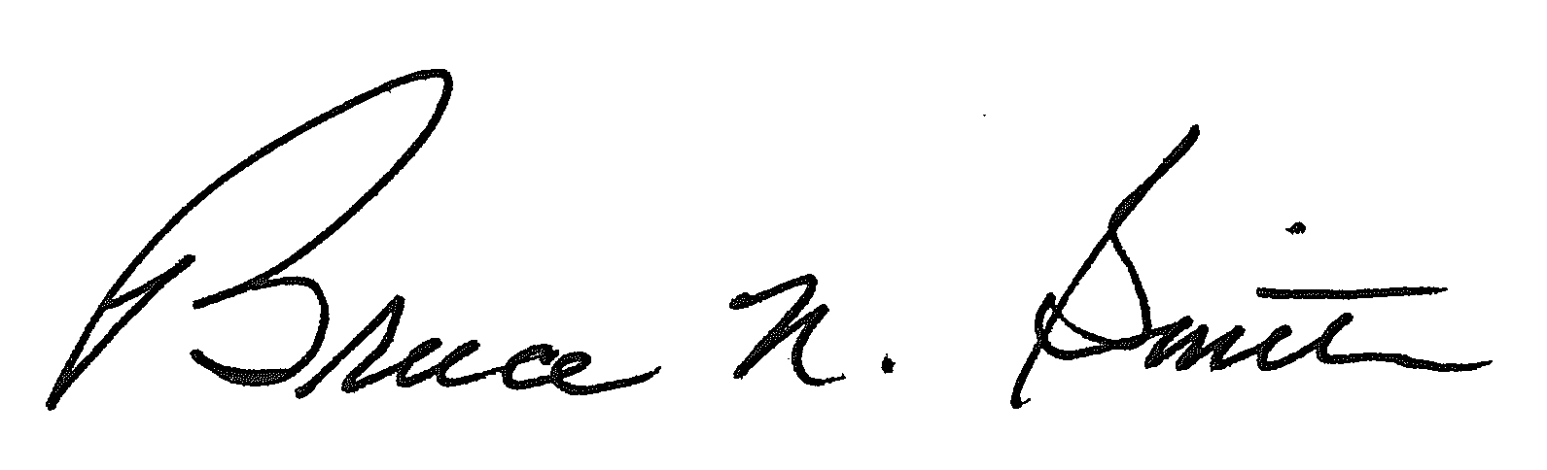
Bruce N. Smith
Director
/tmp/in/input.doc:srs

In this Order, Mr. Martinez and Mr. Noga are referred to collectively as the Intervenors; and Applicant and the Intervenors are referred to collectively as the Parties.

