Decision No. R03-1318-I
BEFORE THE PUBLIC UTILITIES COMMISSION OF THE STATE OF COLORADO
DOCKET NO. 03C-372T
IN THE MATTER OF THE TRANSFER OF ASSETS FROM FUTUREONE, INC. TO ON SYSTEMS TECHNOLOGY, LLC WITHOUT COMMISSION-APPROVED TRANSITION PLAN IN THE APPLICATION OF MILE HIGH TELECOM JOINT VENTURE TO DISCONTINUE PROVIDING REGULATED TELECOMMUNICATIONS SERVICES, AND THE ALLEGED SLAMMING OF CUSTOMERS FROM DMJ COMMUNICATIONS TO ON SYSTEMS TECHNOLOGY, LLC
Interim order of
administrative law judge
ken f. kirkpatrick
shortening response time
Mailed Date: November 24, 2003

statement
- On November 21, 2003, Staff of the Public Utilities Commission (Staff) filed its First Motion to Compel On Systems to Respond to Staff’s Audit Request; Motion to Modify Procedural Schedule; and Request to Shorten Response Time. In this motion Staff states that it has propounded two separate sets of audit questions, to which it has received no responses. It states that the current due date for Staff testimony is November 21, 2003. Staff seeks an order compelling responses to Staff’s audit questions, vacating the due date for Staff’s direct testimony, and shortening response time to the motion to one business day. Staff further states in its motion that it will serve a copy of the motion on an agent for On Systems Technology, LLC (On Systems) by electronic mail.
- The undersigned Administrative Law Judge (ALJ) has reviewed the file in this matter. There is no order in place allowing electronic service of pleadings. Further, the certificate of service does not say to what electronic address Staff would be notifying the agent for On Systems. The motion to shorten response time will be granted in part; response time will be shortened to seven days.

ORDER

It Is Ordered That:
- The Request to Shorten Response Time to Staff’s First Motion to Compel and Motion to Modify Procedural Schedule filed November 21, 2003 is granted in part. Respondents shall have until November 28, 2003 to respond to this motion.
- This Order shall be effective immediately.

THE PUBLIC UTILITIES COMMISSION
OF THE STATE OF COLORADO
KEN F. KIRKPATRICK
________________________________
Administrative Law Judge
(S E A L)

ATTEST: A TRUE COPY
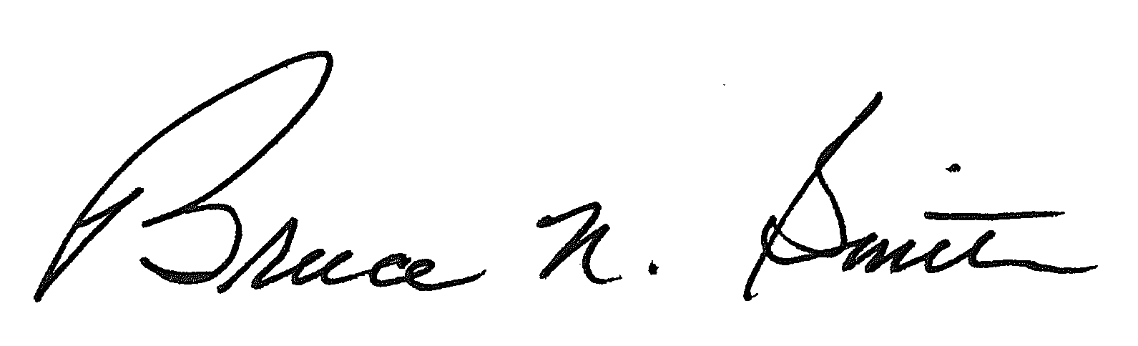
Bruce N. Smith
Director
/tmp/in/input.doc:srs

The ALJ to whom this matter has been assigned, ALJ William J. Fritzel, is unavailable to rule on this motion due to illness.

