Decision No. R03-1313-I
BEFORE THE PUBLIC UTILITIES COMMISSION OF THE STATE OF COLORADO
DOCKET NO. 03S-315T
Re: the investigation and suspension of tariff sheets filed by phillips county telephone company with advice letter no. 61.
interim order of
administrative law judge
dale e. isley
granting motion to vacate
procedural schedule and
setting hearing on stipulation
Mailed Date: November 24, 2003

statement
- On November 19, 2003, Phillips County Telephone Company (PCTC), filed a Motion to Vacate Procedural Schedule (Motion to Vacate) in the captioned proceeding. The Motion to Vacate also requests that the response time thereto be waived.
- The Motion to Vacate requests that the hearing dates and procedural schedule established by Decision No. C03-0806 be vacated. As grounds for that request, PCTC states that the parties have reached a tentative settlement resolving all disputed issues in this docket but that they need additional time to finalize and memorialize the same. They indicate that a written settlement agreement should be filed by early-December of this year.
- The Motion to Vacate indicates that neither the Staff of the Commission nor the Colorado Office of Consumer Counsel object to the relief requested therein. This underlies the request for waiver of response time to the Motion to Vacate.
- Good grounds having been shown, the Motion to Vacate will be granted. The parties will be required to file any desired settlement agreement on or before December 10, 2003, and a December 18, 2003, hearing date will be set in the event a hearing is required in connection with such settlement agreement.
- Since all parties have agreed that the current procedural schedule should be vacated, no party will be prejudiced thereby. As a result, the request to waive response time to the Motion to Vacate will be granted.

order

It Is Ordered That:
- The Motion to Vacate Procedural Schedule filed by Phillips County Telephone Company, is granted, consistent with the terms of this Order.
- The parties shall file any desired settlement agreement on or before December 10, 2003.
- The November 21, 2003, hearing date and the procedural schedule previously established in this matter by Decision No. C03-0806 are vacated.
- A hearing in connection with any settlement agreement filed in this matter is scheduled as follows:
DATE: December 18, 2003
TIME: 9:00 a.m.
PLACE: Commission Hearing Room
1580 Logan Street, OL2
Denver, Colorado
- This Order shall be effective immediately.

THE PUBLIC UTILITIES COMMISSION
OF THE STATE OF COLORADO
DALE E. ISLEY
________________________________
Administrative Law Judge
(S E A L)

ATTEST: A TRUE COPY
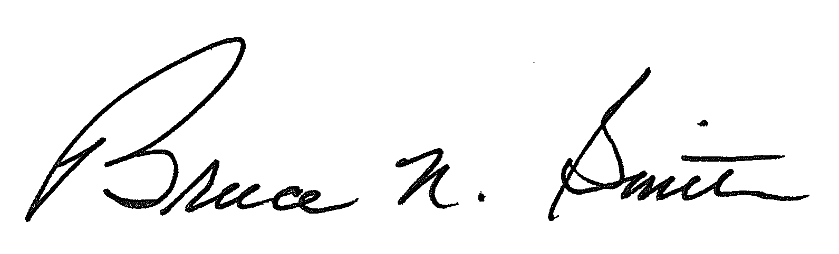
Bruce N. Smith
Director
/tmp/in/input.doc:srs

