Decision No. R03-1304
BEFORE THE PUBLIC UTILITIES COMMISSION OF THE STATE OF COLORADO
DOCKET NO. 03S-271E
re: the investigation and suspension of tariff sheets filed by public service company of colorado with advice letter no. 1394-electric.
recommended decision of
administrative law judge
mana l. jennings-fader
accepting settlement
agreement and closing docket
Mailed Date: November 20, 2003

STATEMENT
- On May 30, 2003, Public Service Company of Colorado (PSCo) filed Advice Letter No. 1394-Electric (Advice Letter) with accompanying tariffs. The purpose of the filing is to eliminate the Special Contract Service (Schedule SCS-8), applicable only to the University of Colorado at Boulder (University), from PSCo’s P.U.C. No. 7-Electric tariff.
- On June 26, 2003, the Commission suspended the effective date of the tariffs filed with the Advice Letter until October 29, 2003. See Decision No. C03-0704. That Decision initiated this docket. On October 16, 2003, the Commission issued Decision No. C03-1166, which extended the suspension period of the Advice Letter until February 26, 2004.
- On June 30, 2003, the University filed a timely intervention. On July 25, 2003, Staff of the Commission (Staff) filed a timely intervention. There are no other intervenors.
- On August 28, 2003, PSCo filed Amended Advice Letter No. 1394-Electric. On September 12, 2003, by Decision No. C03-1032, the Commission suspended the Amended Advice Letter until November 28, 2003, or until further order of the Commission.
- The undersigned Administrative Law Judge (ALJ) held a prehearing conference on August 21, 2003, following which she issued Decision No. R03-0966-I. That Order established the procedural schedule and the hearing dates in this proceeding.
- On October 22, 2003, PSCo filed a Motion to Vacate Procedural Schedule and Set this Matter for Hearing to Consider the Settlement Agreement. The Settlement Agreement accompanied the motion. On October 23, 2003, the ALJ vacated the procedural schedule and hearing dates. See Decision No. R03-1198-I.
- The Settlement Agreement as filed on October 22, 2003, did not contain signatures of the appropriate University official and of the University’s counsel. The University requested, and received, additional time to submit the signatures. On November 10, 2003, the University filed the Settlement Agreement with a page containing the signature of the University official and of counsel for the University. The Settlement Agreement, as filed, has been signed by all parties.
- The Settlement Agreement outlines the issues in this case; the positions of PSCo and the University with respect to those issues; and the resolution of this proceeding which is acceptable to PSCo, the University, and Staff (collectively, the Signatories). After review of the document, the ALJ has determined that a hearing on the Settlement Agreement is unnecessary.

FINDINGS AND CONCLUSION
- The tariffs accompanying the Advice Letter would have eliminated immediately Schedule SCS-8, which applies only to the University. PSCo would have provided electric service to the University under the terms of PSCo’s Primary Standby and Supplemental Service tariff, Schedule PSS. See Advice Letter at 1-2. The University opposed in toto PSCo’s proposed action. See generally Settlement Agreement at 2-3.
- The Settlement Agreement contains two substantive provisions.
- First, noting that PSCo expects to file its Electric Phase II rate case in early December, 2003, the Signatories agree that “they will address all issues relating to the proper standby service rate for [the University] as part of” that Phase II rate case. Settlement Agreement at 3.
- Second, the Settlement Agreement provides that PSCo will continue to provide service to the University under Schedule SCS-8 and the March 1, 1996, Electric Service Agreement between PSCo and the University. This provision of service will continue until PSCo puts into effect new rates following issuance of the Commission’s final decision in the Phase II rate case. The Settlement Agreement provides that, during the interim period, the University will nominate and pay for a minimum of seven megawatts (MW) of standby capacity from PSCo; that, under specified circumstances, that minimum standby capacity may increase; and that the maximum reservation of standby capacity shall not exceed 11 MW. Settlement Agreement at 3-4.
- Based on review of the Advice Letter, of the Settlement Agreement, and of the entire file in this matter, the ALJ finds that the Settlement Agreement is just, is reasonable, and is in the public interest.
- The Settlement Agreement will be accepted without modification.
- In accordance with § 40-6-109, C.R.S., the ALJ recommends that the Commission enter the following order.

ORDER

The Commission Orders That:
- The Settlement Agreement filed on October 22, 2003, is accepted without modification.
- The Settlement Agreement, a copy of which is attached as Appendix A, is incorporated by reference into this Order as if fully set forth.
- The parties shall comply with all terms of the Settlement Agreement.
- Docket No. 03S-271E is closed.
- This Recommended Decision shall be effective on the day it becomes the Decision of the Commission, if that is the case, and is entered as of the date above.
- As provided by § 40-6-109, C.R.S., copies of this Recommended Decision shall be served upon the parties, who may file exceptions to it.
a) If no exceptions are filed within 20 days after service or within any extended period of time authorized, or unless the decision is stayed by the Commission upon its own motion, the recommended decision shall become the decision of the Commission and subject to the provisions of § 40-6-114, C.R.S.
b) If a party seeks to amend, modify, annul, or reverse basic findings of fact in its exceptions, that party must request and pay for a transcript to be filed, or the parties may stipulate to portions of the transcript according to the procedure stated in § 40-6-113, C.R.S. If no transcript or stipulation is filed, the Commission is bound by the facts set out by the administrative law judge and the parties cannot challenge these facts. This will limit what the Commission can review if exceptions are filed.
- If exceptions to this Decision are filed, they shall not exceed 30 pages in length, unless the Commission for good cause shown permits this limit to be exceeded.

THE PUBLIC UTILITIES COMMISSION
OF THE STATE OF COLORADO
MANA L. JENNINGS-FADER
________________________________
Administrative Law Judge
(S E A L)

ATTEST: A TRUE COPY
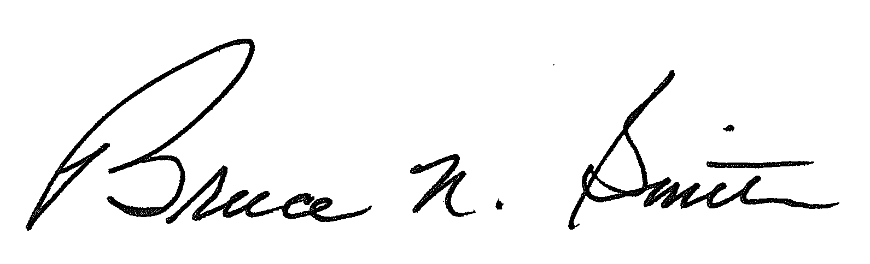
Bruce N. Smith
Director
/tmp/in/input.doc:srs

Each signatory specifically reserves its right to take any position in the Phase II proceeding. See Settlement Agreement at 3 and 4.

