Decision No. R03-1295-I
BEFORE THE PUBLIC UTILITIES COMMISSION OF THE STATE OF COLORADO
DOCKET NO. 03F-307R
city of greeley,
complainant,
v.
omnitrax, inc., and great western railway of colorado, LLC,
RESPONDENTS.
interim order of
administrative Law judge
william j. fritzel
granting Joint motion
for extension of time
to file motion to dismiss
or motion to reschedule
hearing, and granting
motion for waiver of response time
Mailed Date: November 18, 2003

statement
- On October 30, 2003, a joint motion to vacate the hearing scheduled for November 3, 2003 and motion to continue the matter filed by OmniTrax, Inc. and Great Western Railway of Colorado, LLC (OmniTRAX) and City of Greeley (Greeley) was orally granted. The parties stated that they had agreed in principal to settle the case and that they would file a motion to dismiss or motion to reschedule the hearing date by November 17, 2003.
- On November 17, 2003, OmniTRAX and Greeley filed a Joint Motion for Extension of Time to File a Motion to Dismiss or Motion to Reschedule the Hearing. The parties also requested that response time to the motion be waived.
- The parties state in the motion that they need additional time to and including November 20, 2003 to file an appropriate pleading in this matter either dismissing the action or a request to reschedule hearing.
- Counsel for OmniTRAX, Inc., states that Staff of the Commission does not oppose the motion.
- The Joint Motion for Extension of Time to File Motion to Dismiss or a Motion to Reschedule Hearing, and Motion for Waiver of Response Time will be granted.

ORDER

It Is Ordered That:
- The joint motion of OmniTRAX, Inc., and Great Western Railway of Colorado, LLC and the City of Greeley for an Extension of Time to file Motion to Dismiss or Motion to Reschedule Hearing to and including November 20, 2003 is granted.
- Response time to the motion is waived.
- This Order is effective immediately.

THE PUBLIC UTILITIES COMMISSION
OF THE STATE OF COLORADO
WILLIAM J. FRITZEL
________________________________
Administrative Law Judge
(S E A L)

ATTEST: A TRUE COPY
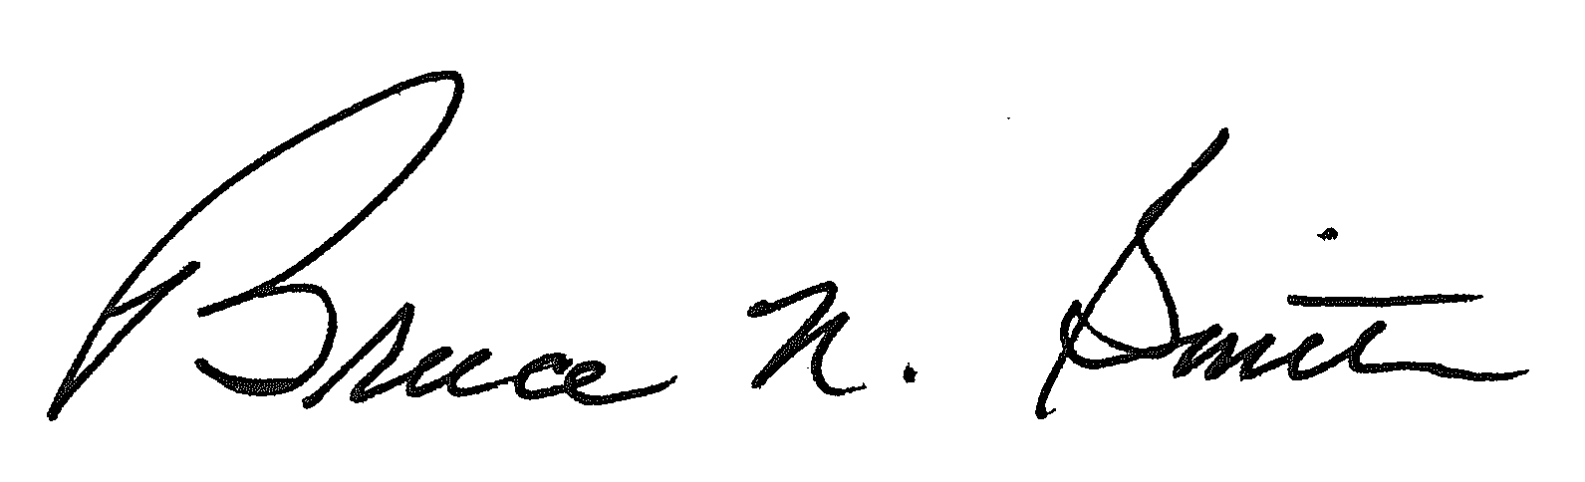
Bruce N. Smith
Director
/tmp/in/input.doc:srs

