Decision No. R03-1294-I
BEFORE THE PUBLIC UTILITIES COMMISSION OF THE STATE OF COLORADO
DOCKET NO. 03F-470W
cascade village condominium association, inc., and more
than 25 individual utility customers of mill creek water
sales & distribution, llc,
complainants,
v.
mill creek water sales & distribution, llc,
respondent.
interim order of
administrative law judge
MANA L. JENNINGS-FADER
granting unopposed motion,
vacating hearing, requiring filing,
and waiving response time
Mailed Date: November 18, 2003

statement
- On October 27, 2003, Cascade Village Condominium Association, Inc., and more than 25 individual customers of Mill Creek Water Sales & Distribution, LLC (Complainants), filed the Complaint which commenced this docket.
- On October 28, 2003, the Commission served on Mill Creek Water Sales & Distribution, LLC (Respondent), an Order to Satisfy or Answer. That Order required Respondent to file, within 20 days of service (i.e., on or before November 17, 2003), an answer or other pleading in response to the Complaint. That Order also established a procedural schedule which conforms to Rule 4 Code of Colorado Regulations (CCR) 723-1-72(a).
- On October 28, 2003, the Commission issued an Order Setting Hearing and Notice of Hearing in this proceeding. That Order established a hearing date of December 22, 2003, in this matter.
- On November 13, 2003, Staff of the Commission (Staff) filed a Petition for Leave to Intervene Pursuant to Rules 64(b) and 72(c)(2) (Petition) and its Notice of Intervention, Entry of Appearance, and Notice Pursuant to Rules 9(d) and 24(a)(1). On November 14, 2003, Staff filed a Notice of Filing Revised Certificates of Service for the two filings made on November 13, 2003. Response to the Petition is due on or before November 28, 2003; and a decision on the Petition will be made after expiration of the response time.
- On November 17, 2003, Respondent filed an Unopposed Motion for Extension of Time Within Which to Answer or Otherwise to Plead (Motion) and Request for Waiver of Response Time (Request). In the Motion Respondent requests that it be granted an extension of time, to and including December 2, 2003, within which to answer or to file a responsive pleading to the Complaint. Respondent represents that it has only recently retained counsel and that its counsel needs time to review the Complaint, to meet with his clients, and to formulate a response to the Complaint. Motion at ¶ 2. Respondent also represents that Complainants do not object to the granting of the Motion. Id. at ¶ 3.
- The Motion states good cause. Granting the Motion will not prejudice the Complainants, the only other parties in this proceeding at this time, as they do not oppose the granting of this Motion. The Motion will be granted; and Respondent will have the requested extension of time, to and including December 2, 2003.
- The procedural schedule in this case is calculated based on the answer to the Complaint. See Rule 4 CCR 723-1-72(a). Assuming Respondent files its answer on December 2, 2003, there is insufficient time to accommodate the other required filings before the December 22, 2003, hearing date. As a result, granting the requested extension of time necessitates vacating the hearing date of December 22, 2003; and the hearing will be vacated.
- It is now necessary to schedule a new hearing date. Complainants will be ordered to file, on or before December 16, 2003: (a) a list of three proposed hearing dates in February 2004; and (b) the name of the city in which the hearing should be held. This filing must be based on discussions held with counsel for Respondent and for Staff and must reflect dates and a city acceptable to all parties. If possible, the Administrative Law Judge (ALJ) will select a date and a location based on this filing. If the parties are unable to agree on proposed dates and/or city for the hearing, Applicant shall make a filing, on or before December 16, 2003, which informs the ALJ of this fact. In that event, the ALJ will select the hearing date and location.
- Pursuant to Rule 4 CCR 723-1-72(a), the procedural schedule in this proceeding is: (a) Complainants must certify in writing their desire to proceed with the Complaint, or their desire to withdraw the Complaint, no later than 15 calendar days after the date on which the answer is due; (b) Complainants must file and serve their list of witnesses and copies of their exhibits no later than ten working days after the date on which Respondent files and serves its answer; and (c) Respondent must file and serve its list of witnesses and copies of its exhibits no later than ten working days after the date on which Complainants file and serve their list of witnesses and copies of their exhibits. If the Petition is granted, Staff will be required to file and to serve its list of witnesses and copies of its exhibits no later than ten working days after the date on which Complainants file and serve their list of witnesses and copies of their exhibits.
- No witness will be permitted to testify, except in rebuttal, unless that witness has been identified on a witness list filed and served in accordance with Rule 4 CCR 723-1-72(a) and this Order. No document will be received in evidence, except in rebuttal, unless filed and served in accordance with Rule 4 CCR 723-1-72(a) and this Order.
- If a party fails to comply with the filing requirements of Rule 4 CCR 723-1-72(a) and of this Order, the Commission, upon the motion of any party or upon its own motion, may dismiss the Complaint; may dismiss the answer; may dismiss any intervention; or may take any other appropriate action.
- The Motion is unopposed. The Request will be granted, and response time to the Motion will be waived.

order

It Is Ordered That:
- The Unopposed Motion for Extension of Time Within Which to Answer or Otherwise to Plead is granted.
- On or before December 2, 2003, Mill Creek Water Sales & Distribution, LLC, shall file and serve its answer or other response to the Complaint.
- On or before December 16, 2003, Complainants Cascade Village Condominium Association, Inc., and more than 25 individual customers of Mill Creek Water Sales & Distribution, LLC, shall make the filing set out in ¶ I.8, supra.
- The Request for Waiver of Response Time is granted.
- Response time to the Unopposed Motion for Extension of Time Within Which to Answer or Otherwise to Plead is waived.
- Absent further order, the parties shall comply with the filing and service requirements set out in Rule 4 Code of Colorado Regulations 723-1-72(a) and ¶ I.9 of this Order.
- This Order shall be effective immediately.

THE PUBLIC UTILITIES COMMISSION
OF THE STATE OF COLORADO
MANA L. JENNINGS-FADER
________________________________
Administrative Law Judge
(S E A L)

ATTEST: A TRUE COPY
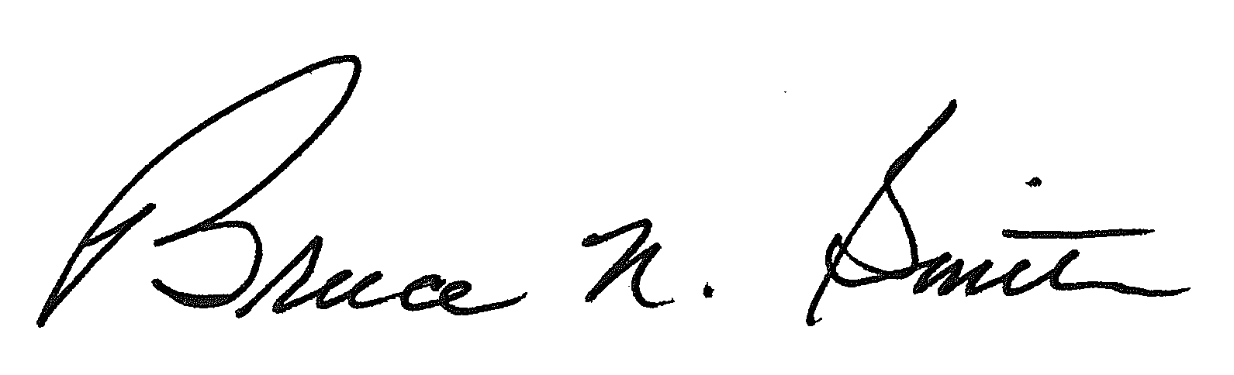
Bruce N. Smith
Director
/tmp/in/input.doc:srs

Respondent need not file its answer on December 2, 2003. Respondent may elect to file a motion to dismiss or other response to the Complaint. In that event, the answer will not be filed on December 2, 2003.
The ALJ is not available on February 16, 2004.
The ALJ expects the parties to cooperate in this matter.

