Decision No. R03-1291-I
BEFORE THE PUBLIC UTILITIES COMMISSION OF THE STATE OF COLORADO
DOCKET NO. 03A-204CP
in the matter of the application of norm’s transportation, service, l.l.c., for a certificate of public convenience and necessity to operate as a common carrier by motor VEHICLE for hire.
interim order of
administrative law judge
MANA L. JENNINGS-FADER
rejecting stipulation and
ordering filing
Mailed Date: November 18, 2003

statement
- On May 2, 2003, Norm’s Transportation Service, L.L.C. (Applicant),filed the Application for a Certificate of Public Convenience and Necessity to Operate as a Common Carrier by Motor Vehicle for Hire (Application) which commenced this docket.
- By Notice of Applications Filed (Notice), the Commission gave public notice of the filing of the Application. See Notice dated May 19, 2003, at 1. In the Notice the Commission, inter alia, scheduled a hearing and established a procedural schedule.
- Jose Arthur Martinez, doing business as Little Stinkers Taxi Cab Service, filed a timely intervention in this proceeding. Robert Noga of Twin Hearts Express & Transportation filed a timely intervention in this proceeding. These are the only interventions filed.
- On motion by Applicant, the undersigned Administrative Law Judge (ALJ) rescheduled the hearing to September 19, 2003. See Decisions No. R03-0776-I and No. R03-0937-I.
- On September 19, 2003, pursuant to Decision No. R03-0937-I, the ALJ convened the hearing in this matter. As a preliminary matter, the ALJ heard argument on Applicant’s oral motion to dismiss the interventions. For the reasons stated in the oral ruling, the ALJ denied the motion. Thereafter, the Parties were able to reach an agreement. The ALJ directed the Parties to reduce their agreement to writing and to file the written agreement. No testimony was taken, and no exhibits were admitted, at the hearing on September 19, 2003.
- On October 10, 2003, the Parties filed a Stipulation of Intervenors and Applicant (Stipulation). As relevant here, the Stipulation contains an agreement that, subject to conditions and restrictions stated in the Stipulation, Applicant should be granted common carrier by motor vehicle authority “to provide transportation services within the State of Colorado and originating in and/or returning to Saguache, Rio Grande, Mineral, Costilla, Conejos, or Alamosa County, Colorado, on a call-and-demand, scheduled, or charter basis[.]”
- Initially, Mr. Noga did not agree to the Stipulation provisions that stated that Applicant should be granted authority to offer on-schedule transportation services, subject to the specified conditions and restrictions. See Stipulation filed on October 10, 2003, as signed by Mr. Noga, at page 2, ¶ 1.B. On November 6, 2003, the Commission received a letter, dated October 23, 2003, from Mr. Noga. That letter stated that Mr. Noga has no objection to the entering of an order accepting the Stipulation as submitted on October 10, 2003. Based on the letter received by the Commission on November 6, 2003, the ALJ concludes that all Parties agree to all the terms and conditions of the Stipulation.
- The Commission-issued Notice serves several important purposes. As pertinent here, the Notice states the scope of the authority sought by an applicant; provides public notice of the authority sought; gives interested persons the opportunity to intervene based on the scope of the proceeding as identified by the Commission; and establishes the scope of the proceeding. The Notice notifies persons who are, or might be, directly affected that there is a proceeding, the outcome of which might have an impact on them. In short, the Notice provides interested persons with the opportunity to participate and to be heard.
- In this case the Notice (at page 1) described the authority sought by Applicant as follows:
For a Certificate of Public Convenience and Necessity to operate as a common carrier by motor vehicle for hire for the transportation of passengers and their baggage, in call-and-demand limousine service, between all points in the Counties of Alamosa, Conejos, Costilla, Mineral, Rio Grande, and Saguache, State of Colorado, and between said points, on the one hand, and all points in the State of Colorado, on the other hand.
- This description limits the scope of the proceeding to the issue of whether or not Applicant should be granted common carrier authority to provide call-and-demand limousine transportation service in the identified geographic area. The Stipulation, however, goes beyond call-and-demand service and contains an agreement that, in this proceeding, the Commission may grant a Certificate of Public Convenience and Necessity for Applicant to provide call-and-demand, scheduled, and chartered transportation service. Because the Stipulation, as clarified by Mr. Noga’s letter, goes beyond the scope of the Notice in this proceeding, the ALJ will reject the Stipulation.
- The ALJ notes that the Stipulation would have been acceptable if it had been limited to the call-and-demand limousine service identified in the Notice, had contained the restrictions and conditions of the filed Stipulation, and had been clear with respect to the geographic area to be served.
- Because the Stipulation as filed has been rejected, it is necessary to establish a hearing date for a hearing to be held in Alamosa. Therefore, Applicant will be ordered to file, on or before November 26, 2003, a list of three proposed hearing dates in January 2004. This filing must be based on discussions held with the Intervenors and must reflect dates acceptable to all parties. If possible, the ALJ will select a date based on this filing. If the parties are unable to agree on proposed dates, Applicant shall make a filing, on or before November 26, 2003, which informs the ALJ of this fact. In that event, the ALJ will select the hearing date.
- If the Parties wish to do so, they may enter into and file another stipulation. If they elect to do this, the stipulation must be filed no later than December 19, 2003.

ORDER

It Is Ordered That:
- For the reasons discussed, the Stipulation of Intervenors and Applicant is rejected.
- On or before November 26, 2003, Applicant Norm’s Transportation Service, L.L.C., shall make a filing in accordance with ¶ I.12, supra.
- The Parties shall comply with the requirements set out above.
- This Order shall be effective immediately.

THE PUBLIC UTILITIES COMMISSION
OF THE STATE OF COLORADO
MANA L. JENNINGS-FADER
________________________________
Administrative Law Judge
(S E A L)

ATTEST: A TRUE COPY
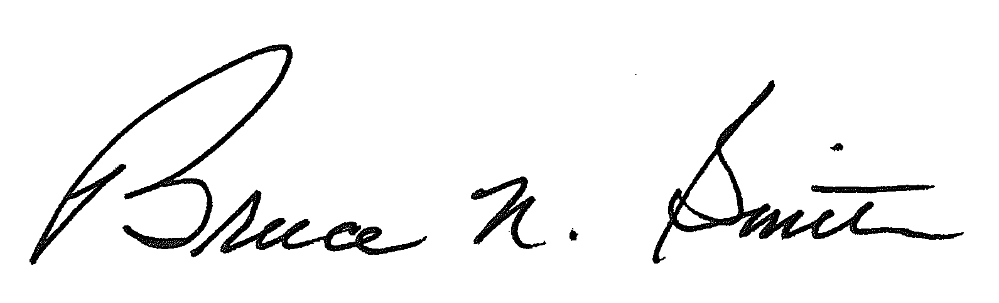
Bruce N. Smith
Director
/tmp/in/input.doc:srs

In this Order, Mr. Martinez and Mr. Noga are referred to collectively as the Intervenors; and Applicant and the Intervenors are referred to collectively as the Parties.
In addition, the Stipulation appears to exceed the scope of the Notice in that the Stipulation does not track the language of the Notice with respect to the geographic area to be served by Applicant. As written, the Stipulation does not state clearly that the transportation to be provided must originate or terminate in one of the six listed counties. At the least, the language is ambiguous. This needs to be addressed if there is a new stipulation.
If the Intervenors wish to agree that, under certain conditions, they will not contest a specific application (e.g., for authority to provide scheduled service or chartered service) that Applicant might file in the future, they are free to do so. Nothing in this Order limits the scope of such an agreement. This Order determines only that the Parties may not expand the scope of the present proceeding through the Stipulation.
The ALJ is not available on January 2, 7, 21, and 22, 2004. The proposed dates should be Tuesdays, Wednesdays, and/or Thursdays.
The ALJ expects the parties to cooperate in this matter.

