Decision No. R03-1289-I
BEFORE THE PUBLIC UTILITIES COMMISSION OF THE STATE OF COLORADO
DOCKET NO. 03A-095T
in the matter of the application of ntch-colorado, inc., doing business as clear talk, for designation as an eligible telecommunications carrier.
interim order of
administrative law judge
MANA L. JENNINGS-FADER
denying motion to vacate
procedural schedule
Mailed Date: November 14, 2003

statement
- On March 12, 2003, NTCH-Colorado, Inc., doing business as Clear Talk (Applicant), filed its Application for Designation as an Eligible Telecommunications Carrier.
- On June 13, 2003, by Decision No. R03-0666-I, the undersigned Administrative Law Judge (ALJ) established a procedural schedule and hearing date in this proceeding.
- On July 1, 2003, Applicant filed its direct testimony and exhibits.
- On July 25, 2003, Staff of the Commission (Staff) filed its answer testimony and exhibits. On July 30, 2003, the Colorado Telecommunications Association, Inc. (CTA), filed its answer testimony and exhibits. On July 30, 2003, the Colorado Office of Consumer Counsel (OCC) filed its answer testimony and exhibits.
- On August 4, 2003, Applicant filed its Notice of Waiver of Statutory Time Limit for Commission Decision (under § 40-6-109.5, C.R.S.) and Motion to Vacate Current Procedural Schedule. On August 5, 2003, by Decision No. R03-0871-I, the ALJ granted that motion and vacated the procedural schedule and hearing dates.
- On August 29, 2003, Applicant filed a Proposed New Procedural Schedule. On September 2, 2003, by Decision No. R03-0997-I, the ALJ modified and, as modified, adopted the proposed procedural schedule.
- Pursuant to the procedural schedule, rebuttal testimony and exhibits and cross-answer testimony and exhibits are to be filed on or before November 14, 2003. Prehearing motions are to be filed on or before November 19, 2003. A prehearing conference is scheduled for November 24, 2003, on which date the parties are also to file corrections to their testimony and exhibits. Hearing in this matter is scheduled for December 3 and 4, 2003. See Decision No. R03-0997-I at ¶ 9.
- On November 4, 2003, Staff filed a Motion to Vacate Procedural Schedule and to Shorten Response Time. Staff represents that OCC does not oppose, and CTA supports, the relief sought. Motion at ¶ 12.
- By Decision No. R03-1244-I, the ALJ shortened the response time to the Motion to Vacate Procedural Schedule (Motion) to November 14, 2003, at noon.
- On November 14, 2003, Applicant filed its Response to Staff’s Motion to Vacate Procedural Schedule (Response). Applicant opposes the Motion.
- In the Motion Staff asserts that the Commission’s decision in Docket No. 03A-061T, In the Matter of the Application of Western Wireless Holding Co., Inc., for Designation as an Eligible Telecommunications Carrier, “will embrace several important issues that directly affect matters presented in [the present docket], including but not limited to (a) whether it is in the public interest to allow redefinition of an incumbent local exchange provider’s service area to a level smaller than a wire center boundary, thus allowing competitive eligible telecommunications carriers (ETC) the ability to serve only partial wire centers; and (b) whether and to what extent the Commission will regulate wireless telecommunications providers that the Commission designates as ETCs.” Motion at ¶ 8. Staff further asserts that the “Commission’s decision in Docket No. 03A-061T will narrow the issues for hearing in [the instant proceeding] by setting forth and clarifying Commission policies regarding ETC designation and the Commission’s regulation of wireless telecommunications carriers that have been granted ETC designation or seek ETC designation,” such as Applicant here. Id. at ¶ 10. Finally, Staff states that, “until the Commission’s standards and guidelines on these issues are known with certainty, it will be impossible to guarantee that the decision in this Docket will be consistent with the Commission’s policies.” Id.
- The Commission’s deliberations in Docket No. 03A-061T occurred on November 5, 2003. Staff believes that “the Commission is unlikely to issue” a written decision in that docket before the December 3 and 4, 2003, hearing in this proceeding. Motion at ¶ 9. Thus, to conserve the resources of the Commission and of the parties and to help assure that the decision in this proceeding is consistent with Commission policies, Staff requests that the procedural schedule be vacated. Staff does not offer a suggested alternative procedural schedule or suggested hearing dates.
- In its Response, Applicant states its opposition to the Motion. Applicant first notes that, although it waived the provisions of § 40-6-109.5, C.R.S., it “did not intend to extend this matter indefinitely.” Response at ¶ 2. Applicant then states that the Commission, at the November 5, 2003, deliberations in Docket No. 03A-095T, “announced fairly clearly what [the] decisions will be. In essence, the Commissioners announced that they will rule that the Commission has the jurisdiction, power and authority to impose quality of service standards and affordability standards on BUS service offered by a wireless ETC applicant. … [E]veryone now knows, at least in a general sense, what the Commission decision will be.” Applicant argues that, while a written decision would be “somewhat helpful, it will not be so helpful as to require further delay in the disposition of this docket.” Id. at ¶ 3.
- The Motion will be denied. As noted by Applicant, the Commission decision in Docket No. 03A-061T is known to the parties. To the extent the Commission addressed in its deliberations any or all of the issues identified by Staff in its Motion, the parties can use that information during the course of this proceeding. In addition, Staff did not explain in its Motion what specific factor or factors differentiate this situation from the many other similar situations encountered by ALJs during the course of their work (i.e., a matter pending before the Commission for decision involves, or may involve, one or more issues in a case pending before an ALJ). Absent a clearly articulated and controlling differentiating factor, it is unfair to an applicant (such as NTCH-Colorado, Inc., here) to delay consideration of an application for an unspecified period of time because a Commission decision in a pending matter might narrow the issues or might provide Commission guidance on an issue. Finally, the Commission may issue
- its decision in Docket No. 03A-061T before the hearing in this matter. If that is the case, a party may seek permission to supplement testimony at the time of the hearing if it believes supplementation is necessary.
- The procedural schedule, the scheduled prehearing conference, and the scheduled hearing will proceed as set out in Decision No. R03-0997-I.
- On November 14, 2003, a copy of this decision was sent by electronic mail to counsel for the parties in this matter.

order

It Is Ordered That:
- The Motion to Vacate Procedural Schedule is denied.
- The procedural schedule and filing requirements established in Decision No. R03-0997-I and in Decision No. R03-0666-I remain in effect.
- The prehearing conference and the hearing will take place as scheduled.
- This Order shall be effective immediately.

THE PUBLIC UTILITIES COMMISSION
OF THE STATE OF COLORADO
MANA L. JENNINGS-FADER
________________________________
Administrative Law Judge
(S E A L)

ATTEST: A TRUE COPY
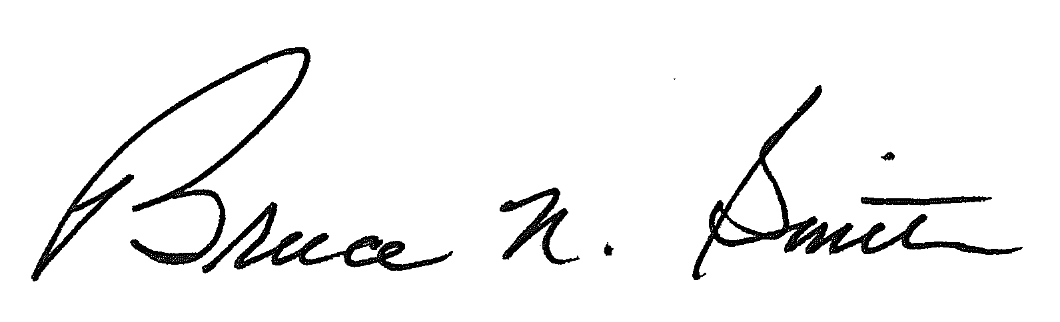
Bruce N. Smith
Director
/tmp/in/input.doc:srs

The ALJ assumes that the parties in this proceeding attended the Commission’s deliberations in Docket No. 02A-061T if, as the Staff states, the issues raised in that docket are also issues in this proceeding.
In this regard, the ALJ notes that, in her opinion, it is not possible “to guarantee that [a recommended decision] will be consistent with the Commission’s policies.” Motion at ¶ 10 (emphasis supplied). An Administrative Law Judge applies and interprets the law and Commission policy as they exist at the time of a decision and as the judge understands them. In its review of a recommended decision, based on the record and given its discretion to articulate policy and its responsibility to interpret the law, the Commission may or may not agree with the judge’s application and analysis.

