Decision No. R03-1288-I
BEFORE THE PUBLIC UTILITIES COMMISSION OF THE STATE OF COLORADO
DOCKET NO. 02I-572T
in the matter of the investigation into unfiled agreements executed by qwest Corporation.
interim order of
administrative Law Judge
william j. fritzel
granting joint motion
to modify procedural
schedule and scheduling
status conference
Mailed Date: November 14, 2003

statement
- On October 14, 2003, Qwest Corporation (Qwest), the Staff of the Colorado Public Utilities Commission (Staff), and the Colorado Office of Consumer Counsel (OCC) filed a Joint Motion to Modify Procedural Schedule. Qwest, Staff and OCC requested a 30-day extension of time for all of the parties to file comments and reply comments. No party objected to the motion.
- Qwest, Staff, and OCC state in support of the motion that “…the Parties have continued to participate in settlement negotiations, and have compiled and exchanged information necessary to negotiate a settlement.”
- The motion was orally granted.
- The parties have filed similar joint motions on a monthly basis, all of which have been granted. Since this matter has been pending for some time, with no settlement filed with the Commission, it is appropriate to schedule a status conference for a report on the progress of settlement negotiations and to consider alternatives, including a hearing if a settlement is unlikely. If necessary, new dates for the filing of comments and any other necessary modifications to the procedural schedule will be established at the status conference

ORDER

It Is Ordered That:
- The joint motion of Qwest Corporation, Staff of the Colorado Public Utilities Commission, and Colorado Office of Consumer Counsel to modify procedural schedule is granted.
- A status conference is scheduled a follows:
DATE: January 15, 2004
TIME: 9:00AM
PLACE: Commission Hearing Room
1580 Logan Street, OL2
Denver, Colorado
- This Order is effective immediately.

THE PUBLIC UTILITIES COMMISSION
OF THE STATE OF COLORADO
WILLIAM J. FRITZEL
________________________________
Administrative Law Judge
(S E A L)

ATTEST: A TRUE COPY
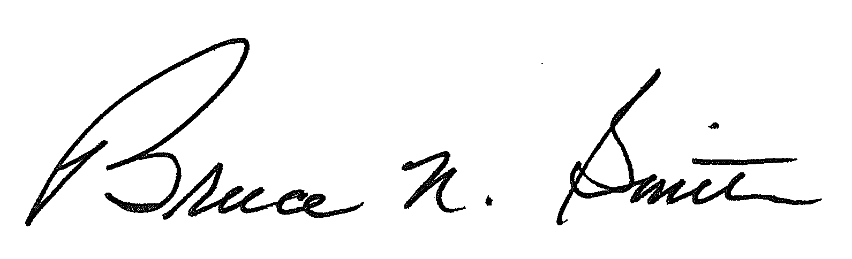
Bruce N. Smith
Director
/tmp/in/input.doc:srs

