Decision No. R03-1267
BEFORE THE PUBLIC UTILITIES COMMISSION OF THE STATE OF COLORADO
DOCKET NO. 03V-336T
in the matter of the petition by qwest corporation for waiver of rule 4 ccr 723-2-24 relating to availability of service.
RECOMMENDED DECISION OF
ADMINISTRATIVE LAW JUDGE
mana l. jennings-fader
granting motion to dismiss,
dismissing petition without
prejudice, vacating hearing
and procedural schedule,
waiving response time,
and CLOSING DOCKET
Mailed Date: November 12, 2003

STATEMENT, findings, and conclusion
- On July 31, 2003, Qwest Corporation (Qwest) filed its Petition for Waiver (Petition). Qwest seeks a waiver of Rule 4 Code of Colorado Regulations (CCR) 723-2-24.4 and of Rule 4 CCR 723-2-24.5 for the “Jasper, Colorado vicinity where [commercial] electric power is currently unavailable.” Petition at ¶ 6. If granted in the form sought by Qwest, the waiver would be temporary and would continue “until such time as [commercial] electric power becomes available in the Jasper, Colorado area.” Id. at ¶ 7. The Petition commenced this proceeding.
- On August 1, 2003, the Commission gave public notice of the Petition. See Notice of Petition Filed (Notice), dated August 1, 2003. In that Notice, the Commission established an intervention period and a procedural schedule.
- On September 2, 2003, the Colorado Office of Consumer Counsel (OCC) filed its Response to Qwest’s Petition for Waiver and its Request for Hearing, Notice of Intervention of Right and Entry of Appearance in this matter. On September 8, 2003, Qwest filed its Response to the OCC Notice of Intervention and Request for Hearing.
- By minute order dated September 10, 2003, the Commission deemed the Petition complete as of September 17, 2003, and referred this matter to be heard by an Administrative Law Judge (ALJ). The undersigned ALJ was assigned to hear this matter.
- On September 25, 2003, Staff of the Commission (Staff) intervened of right; filed its Rule 4 CCR 723-1-9(d) and Rule 4 CCR 723-1-24 notice; and requested a hearing in this docket.
- On September 30, 2003, by Decision No. R03-1117-I, the ALJ vacated the hearing and the procedural schedule set out in the Notice.
- Following a prehearing conference, the ALJ set a hearing date in this matter for January 14 and 15, 2004, and established a procedural schedule. See Decision No. R03-1172-I.
- On November 7, 2003, Qwest filed a Motion to Dismiss (Motion) in which it asks the Commission to dismiss the Petition without prejudice. In the Motion Qwest states that it no longer needs the requested waiver as it has been able to procure the equipment necessary for it to provide service in Jasper, Colorado. Qwest further represents that Staff and OCC, the only other parties in this case, do not oppose the Motion.
- The ALJ finds and concludes that the Motion states good cause and that granting the unopposed Motion will not prejudice any party. The Motion should be, and will be, granted. The Petition will be dismissed without prejudice. The hearing scheduled for January 14 and 15, 2004, will be vacated. The procedural schedule established by Decision No. R03-1172-I will be vacated. Docket No. 03V-336T will be closed.
- The Motion seeks dismissal of the Petition. No party opposes the Motion. In view of these facts, the time for response will be waived.
- In accordance with § 40-6-109, C.R.S., the ALJ recommends that the Commission enter the following order.

ORDER

The Commission Orders That:
- The Motion to Dismiss filed by Qwest Corporation is granted.
- The Petition for Waiver is dismissed without prejudice.
- The hearing scheduled for January 14 and 15, 2004, is vacated.
- The procedural schedule established by Decision No. R03-1172-I is vacated.
- Response time to the Motion to Dismiss is waived.
- Docket No. 03V-336T is closed.
- This Recommended Decision shall be effective on the day it becomes the Decision of the Commission, if that is the case, and is entered as of the date above.
- As provided by § 40-6-106, C.R.S., copies of this Recommended Decision shall be served upon the parties, who may file exceptions to it.
- If no exceptions are filed within 20 days after service or within any extended period of time authorized, or unless the recommended decision is stayed by the Commission upon its own motion, the recommended decision shall become the decision of the Commission and subject to the provisions of § 40-6-114, C.R.S.
- If a party seeks to amend, modify, annul, or reverse a basic finding of fact in its exceptions, that party must request and pay for a transcript to be filed, or the parties may stipulate to portions of the transcript according to the procedure stated in § 40-6-113, C.R.S. If no transcript or stipulation is filed, the Commission is bound by the facts set out by the administrative law judge; and the parties cannot challenge these facts. This will limit what the Commission can review if exceptions are filed.
- If exceptions to this Recommended Decision are filed, they shall not exceed 30 pages in length, unless the Commission for good cause shown permits this limit to be exceeded.

THE PUBLIC UTILITIES COMMISSION
OF THE STATE OF COLORADO
MANA L. JENNINGS-FADER
________________________________
Administrative Law Judge
(S E A L)

ATTEST: A TRUE COPY
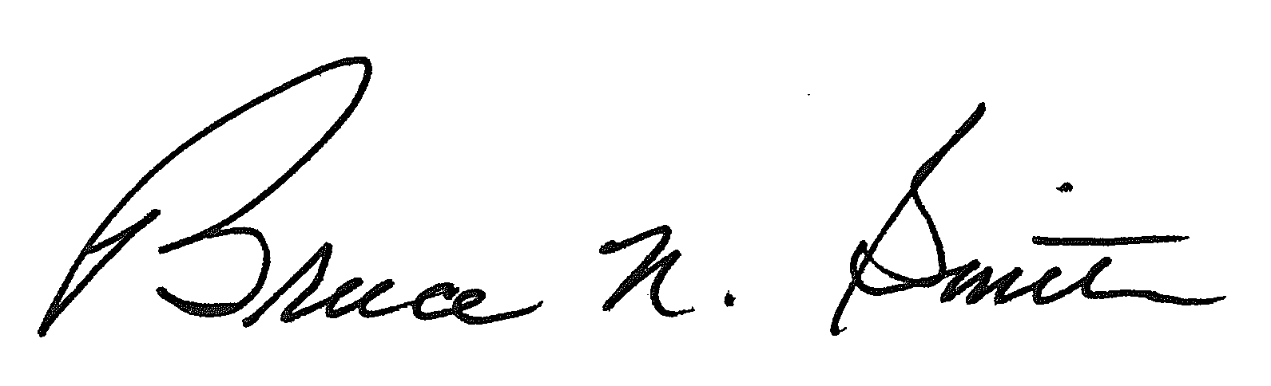
Bruce N. Smith
Director
/tmp/in/input.doc:srs

