Decision No. R03-1263-I
BEFORE THE PUBLIC UTILITIES COMMISSION OF THE STATE OF COLORADO
DOCKET NO. 03A-434CP
IN THE MATTER OF THE APPLICATION OF silverpick tours l.l.c. for a certificate of public convenience and necessity to operate as a common carrier by motor vehicle for hire.
interim order of
administrative law judge
MANA L. JENNINGS-FADER
vacating hearing date
and requiring filing
Mailed Date: November 10, 2003

statement
- On September 29, 2003, Silverpick Tours L.L.C. (Applicant), filed its Application for a Certificate of Public Convenience and Necessity to Operate as a Common Carrier by Motor Vehicle for Hire (Application). That Application commenced this docket.
- On October 6, 2003, the Commission gave public notice of the Application in the Notice of Applications Filed (Notice). See Notice of Applications Filed, dated October 6, 2003, at 2. The Notice also established a 30-day intervention period, established a procedural schedule, and scheduled the hearing in this matter for December 10, 2003.
- On October 15, 2003, San Miguel Mountain Ventures, LLC, doing business as Telluride Express (Telluride Express), filed an intervention of right in this matter.
- On October 23, 2003, Durango Transportation, Inc. (Durango), filed an intervention of right in this matter.
- On November 5, 2003, the intervention period closed. Telluride Express and Durango are the only intervenors in this matter. As both oppose the Application, this docket is contested and requires a hearing.
- This matter is assigned to the undersigned Administrative Law Judge (ALJ). She is unavailable for the hearing scheduled for December 10, 2003. It is necessary, therefore, to vacate the December 10, 2003, hearing, and to schedule a new hearing date. It is also necessary to determine whether the hearing should be held in Denver or in some other location (e.g., in San Miguel County or Ouray County).
- Applicant will be ordered to file, on or before November 21, 2003, a list of three proposed hearing dates in January or February 2004 and the city in which the hearing should be held. This filing must be based on discussions held with the intervenors and must reflect dates and a location acceptable to all parties. If possible, the ALJ will select a date and arrange a hearing location based on this filing. If the parties are unable to agree on proposed dates and/or a location for the hearing, Applicant shall make a filing, on or before November 21, 2003, which informs the ALJ of this fact. In that event, the ALJ will select the hearing date and location.
- Vacating the hearing date does not change the procedural schedule established by the Notice and set out in this Order. Absent further Order, Applicant must file with the Commission (and serve on all parties) its list of witnesses and copies of its exhibits on or before November 17, 2003. Each intervenor must file with the Commission (and serve on all parties) its list of witnesses and copies of its exhibits on or before November 25, 2003.
- No witness will be permitted to testify, except in rebuttal, unless identified as provided in ¶ 8, supra. No exhibit will be received in evidence, expect in rebuttal, unless filed and served as provided in ¶ 8, supra.
- If a party does not meet the requirements of this Order and/or the procedural schedule, the Application may be dismissed or an intervention may be dismissed unless good cause is shown for the failure to meet the requirements. The dismissal may occur upon the motion of any party or upon the Commission’s own motion.
- Parties are reminded that they are responsible for reviewing the Commission’s file to be sure that they have the names and addresses of all other parties, including counsel, so that service of filings can be made on all parties and counsel in this proceeding.
- The parties are advised to obtain a copy of, and to be familiar with, the Rules of Practice and Procedure, 4 Code of Colorado Regulations 723-1. These rules are available on the Commission’s website and from the Commission.

order

It Is Ordered That:
- The hearing scheduled for December 10, 2003, is vacated.
- On or before November 21, 2003, Applicant Silverpick Tours L.L.C. shall make a filing in accordance with ¶ 7, supra.
- The procedural schedule established in the Notice of Applications Filed, dated October 6, 2003, and contained in ¶ 8, supra, is in effect absent further order.
- The parties shall make the filings and follow the procedures set out above.
- This Order shall be effective immediately.

THE PUBLIC UTILITIES COMMISSION
OF THE STATE OF COLORADO
MANA L. JENNINGS-FADER
________________________________
Administrative Law Judge
(S E A L)

ATTEST: A TRUE COPY
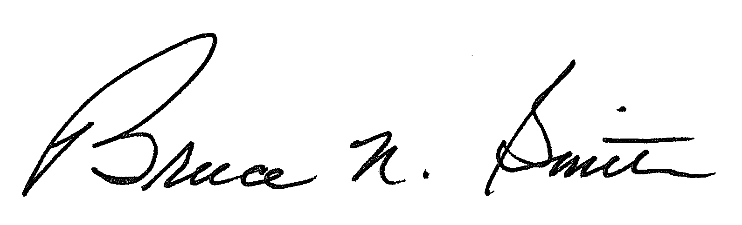
Bruce N. Smith
Director
/tmp/in/input.doc:srs

The ALJ is not available on January 2, 14, 15, 21, and 22, 2004.
The ALJ expects the parties to cooperate in this matter.

