Decision No. C03-1389
BEFORE THE PUBLIC UTILITIES COMMISSION OF THE STATE OF COLORADO
DOCKET NO. 03A-479T
IN THE MATTER OF THE APPLICATION OF verizon avenue corp. for grant of certificates of public convenience and necessity and letter of registration, and for the transfer of the existing certifications of one point communications – colorado, llc to its parent company, verizon avenue corp.
Order granting application
Mailed Date: December 12, 2003
Adopted Date: December 10, 2003

BY THE COMMISSION

Statement
- On October 30, 2003, OnePoint Communications - Colorado, LLC, doing business as OnePoint Communications (OPC) and its parent company Verizon Avenue Corp. (VAC) filed an application to execute a transfer whereby OPC will transfer its telecommunications authorities issued by this Commission to VAC. In addition, the application requests that VAC receive a Certificate of Public Convenience and Necessity (CPCN) and a Letter of Registration to provide regulated telecommunications services in its own name. 4 Code of Colorado Regulations (CCR) 723-25-8 and 4 CCR 723-25-4.
- OPC was granted a Certificate to Provide Local Exchange Telecommunications Services, a CPCN to provide Local Exchange and Emerging Competitive Services, and a Letter of Registration to provide non-optional operator services in Commission Decision Nos. C97-1078 and C99-1017. In Commission Decision No. C00-1204, the Commission granted a transfer of control of OPC to Verizon Communications, Inc. (VCI), the existing parent of both OPC and VAC.
- OPC is a wholly-owned subsidiary of VAC, which is a wholly-owned subsidiary of VCI. As a result of the transaction, VAC intends to obtain the existing operating authorities held by OPC.
- On November 13, 2003, in response to a letter sent by Staff of the Public Utilities Commission, VAC filed a letter that included a cancellation of its original request to obtain separate telecommunications authorities issued in its name. The joint application to transfer the authorities held by OPC to VAC remains.
- The application contains information for the Commission to consider a grant of authority to VAC, as required in 4 CCR 723-25-8 of a transferee that does not have a CPCN of its own, as is the case with VAC.
- Notice of the application was posted on the Commission's web site on November 3, 2003. Interventions were due on or before December 3, 2003. None were filed.

Discussion
- The application is unopposed and may be considered without a hearing. § 40-6-109(5), C.R.S.
- The Commission finds that the proposed transfer of authorities is not contrary to the public interest.

ORDER

The Commission Orders That:
- The application by OnePoint Communications (OPC) and Verizon Avenue Corp. (VAC) is deemed complete.
- VAC is issued a grant of authority to effectuate the transfer of authorities issued by this Commission and held by OPC.
- The application to approve the transfer of authorities held by OPC to VAC is granted.
- The obligation of OPC to file an annual report with the Commission and contribute to all applicable Colorado funds for the period prior to the effective date of this Order remains. These funds include the Public Utilities Commission's Fixed Utilities Fund, the Colorado High Cost Administration Fund, the Telecommunications Relay Services for the Disabled Telephone Users Program, and the Emergency Telephone Access Act Program.
- VAC is authorized to file for adoption of OPC’s tariffs currently on file with the Commission on one day’s notice.
- This Order is effective on its Mailed Date.

ADOPTED IN COMMISSIONERS’ WEEKLY MEETING
December 10, 2003.

THE PUBLIC UTILITIES COMMISSION
OF THE STATE OF COLORADO
GREGORY E. SOPKIN
________________________________
POLLY PAGE
________________________________
JIM DYER
________________________________
Commissioners
(S E A L)


ATTEST: A TRUE COPY
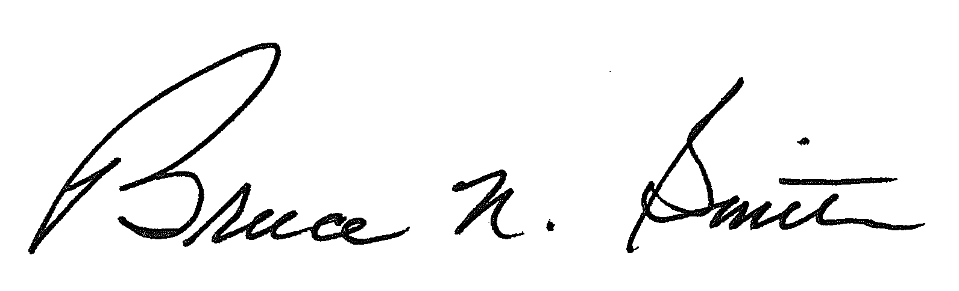
Bruce N. Smith
Director
/tmp/in/input.doc

