Decision No. C03-1280
BEFORE THE PUBLIC UTILITIES COMMISSION OF THE STATE OF COLORADO
DOCKET NO. 00D-261G
IN THE MATTER OF THE PETITION OF K N WATTENBERG TRANSMISSION, LLC, FOR A DECLARATORY ORDER THAT THE COLORADO PUBLIC UTILITIES COMMISSION HAS NO JURISDICTION OVER ITS DELIVERY LATERAL WHICH INTERCONNECTS WITH THE TRANSMISSION LINE OF COLORADO INTERSTATE GAS COMPANY AND IS USED TO DELIVER GAS TO TWO INDUSTRIAL USERS FOR WHOM THE LATERAL WAS BUILT.
DOCKET NO. 00A-635G
IN THE MATTER OF THE APPLICATION OF K N WATTENBERG TRANSMISSION LIMITED LIABILITY COMPANY FOR SUCH AUTHORITY AS MAY BE NECESSARY FOR THE COMMISSION TO ASSUME THE EXERCISE OF REGULATORY SUPERVISION OVER THE TRANSPORTATION OF INTERSTATE GAS THROUGH A FIVE-MILE LATERAL FROM AN INTERCONNECTION WITH THE TRANSMISSION PIPELINE OF COLORADO INTERSTATE GAS COMPANY TO TWO INDUSTRIAL CUSTOMERS LOCATED ON THE OUTSKIRTS OF THE CITY OF FORT MORGAN, COLORADO, INCLUDING: 1) A CERTIFICATE OF PUBLIC CONVENIENCE AND NECESSITY, 2) AUTHORIZATION TO PROVIDE SUCH SERVICE IN ACCORDANCE WITH EXISTING CONTRACT TERMS, CONDITIONS AND RATES, AND/OR 3) SUCH OTHER AUTHORITY AS THE COMMISSION MAY FIND TO BE NECESSARY OR DESIRABLE.
notice of intent to participate
Mailed Date: November 12, 2003
Adopted Date: November 12, 2003

BY THE COMMISSION

Statement
- On September 9, 2003, the Commission issued Decision No. C03-1024, which indicated that Chairman Sopkin recused himself in this matter. Chairman Sopkin recused himself because of his previous involvement in cases related to issues raised in the present dockets. However, Chairman Sopkin’s involvement in these prior cases was limited to representing the Commission itself.
- As an Assistant Attorney General, Chairman Sopkin represented the Commission in Docket No. CPCN98-49-004 before the Federal Energy Regulatory Commission, which addressed an application filed by K N Wattenberg Transmission, LLC’s (KNW) for a Certificate of Public Convenience and Necessity. Chairman Sopkin also represented the Commission in Case No. 00CV61 before Morgan County District Court, which addressed a complaint against KNW by the City of Fort Morgan. In each of these cases Chairman Sopkin represented the Commission itself, and did not represent Commission Staff or any other party. Therefore, upon further consideration, Chairman Sopkin believes that his past involvement does not warrant his recusal in this matter.
- The parties are now notified that Chairman Sopkin intends to participate in these dockets. Any party may file an objection to Chairman Sopkin's participation in this matter on or before November 24, 2003.

ORDER

The Commission Orders That:
- Any party objecting to Chairman Sopkin's participation in this matter shall file such objection on or before November 24, 2003.
- This Order is effective on its Mailed Date.

ADOPTED IN COMMISSIONERS’ WEEKLY MEETING
November 12, 2003.

THE PUBLIC UTILITIES COMMISSION
OF THE STATE OF COLORADO
GREGORY E. SOPKIN
________________________________
POLLY PAGE
________________________________
JIM DYER
________________________________
Commissioners
(S E A L)


ATTEST: A TRUE COPY
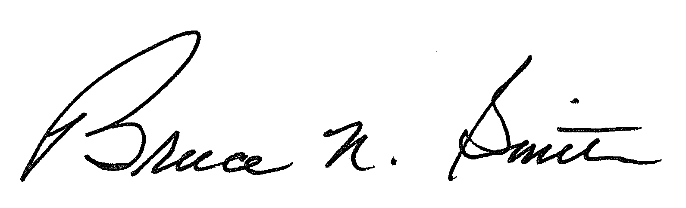
Bruce N. Smith
Director
/tmp/in/input.doc:srs

