Decision No. C03-1277
BEFORE THE PUBLIC UTILITIES COMMISSION OF THE STATE OF COLORADO
DOCKET NO. 03T-370
IN THE MATTER OF THE APPLICATION FOR APPROVAL OF WIRELESS INTERCONNECTION AGREEMENT BETWEEN QWEST CORPORATION AND COMMNET WIRELESS, INC.
DECISION DENYING WIRELESS
INTERCONNECTION AGREEMENT
Mailed Date: November 13, 2003
Adopted Date: November 12, 2003

BY THE COMMISSION

Statement
- This matter comes before the Colorado Public Utilities Commission (Commission) for consideration of a Joint Application (Application) for approval of a wireless interconnection agreement (Agreement) filed by Qwest Corporation (Qwest) and Commnet Wireless, Inc. (Commnet), pursuant to Commission Rule 4 Code of Colorado Regulations (CCR) 723-44 et seq.
- The Parties filed this Application on August 26, 2003. Commnet and Qwest have voluntarily negotiated the terms of the Agreement, and included the Agreement as part of their application. Commnet is an Illinois based corporation.
- The Parties have complied with the requirements of 4 CCR 723-44 et seq. for the submission for approval of interconnection agreements except that the parties have not furnished Commnet’s certificate of authority to do business in the State of Colorado as required by 4 CCR 723-44-5.1.4.1. The parties have sought a waiver of the requirements of 4 CCR 723-44-5.1.4.1 in their application. Commission Staff has notified the parties that the application is incomplete, and has attempted to procure the missing documentation.
- Pursuant to 4 CCR 723-44-11, the Commission may permit variance from its rules for good cause shown when it finds compliance to be impossible, impracticable, or unreasonable. It has therefore delayed issuing a decision on this application even though 4 CCR 723-44-5.5 provides that:
In the event an Application or Motion for Approval of an Amendment is made pursuant to this Rule 5 which the Commission determines does not include the above required submittal information, the Commission shall, by an order, reject the Application or Motion for Approval of an Amendment within (15) calendar days from the date of the submittal, with written findings as to the deficiencies in the information submitted. The Parties may then correct and resubmit the agreement or amendment for approval.
- The Commission believed it reasonable to delay consideration of this application to allow the parties time to submit the required information.
- Section 47 U.S.C. § 251 et seq. of the Act requires that the Commission review and approve or reject interconnection agreements involving incumbent local exchange carriers like Qwest. To comply with the Act, rates in negotiated agreements must be just and reasonable, nondiscriminatory, and based on the cost of providing the interconnection or network element. 47 U.S.C. § 252(e). In reviewing agreements or portions thereof, the Commission, generally, is guided by 47 U.S.C. § 252(e)(2), requiring that interconnection agreements not discriminate against non-parties and be consistent with the public interest, convenience, and necessity.
- The Commission has allowed the parties enough time to complete their application, and now rejects the application, including the application for waiver of 4-CCR 723-44-5.1.4.1, because they have not complied with the requirements of 4 CCR 723-44-5.1.4.1.

ORDER

The Commission Orders That:
- The joint filing of a Report of Adoption by Qwest Corporation and Commnet Wireless, Inc., to adopt Qwest Corporation’s Ninth Revised Statement of Generally Available Terms and Conditions for Interconnection, Unbundled Network Elements, Ancillary Services, and Resale of Telecommunication Services is denied because the parties have failed to submit the required information pursuant to 4-Code of Colorado Regulations (CCR) 723-44-5.1.4.1.
- The parties’ application for waiver of 4 CCR 723-44-5.1.4.1 is denied.
- This denial is without prejudice, and the parties may resubmit the application as set forth in 4 CCR 723-44-5.5.
- This Order is effective on its Mailed Date.

ADOPTED IN COMMISSIONERS’ WEEKLY MEETING
November 12, 2003.

THE PUBLIC UTILITIES COMMISSION
OF THE STATE OF COLORADO
GREGORY E. SOPKIN
________________________________
POLLY PAGE
________________________________
JIM DYER
________________________________
Commissioners
(S E A L)

ATTEST: A TRUE COPY
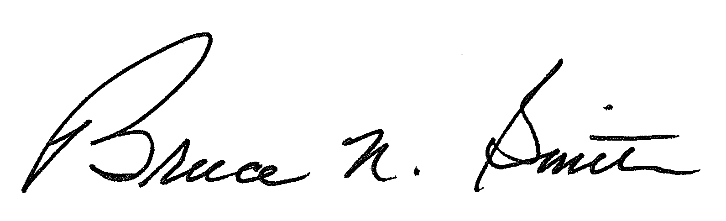
Bruce N. Smith
Director
/tmp/in/input.doc

