Decision No. C03-1274
BEFORE THE PUBLIC UTILITIES COMMISSION OF THE STATE OF COLORADO
DOCKET NO. 03T-423
IN THE MATTER OF THE APPLICATION FOR APPROVAL OF INTERCONNECTION AGREEMENT BETWEEN QWEST CORPORATION AND VI LATA COMMUNICATIONS, LLC.
DECISION GRANTING JOINT MOTION
FOR APPROVAL OF AMENDMENT TO THE INTERCONNECTION AGREEMENT
Mailed Date: November 13, 2003
Adopted Date: November 12, 2003

BY THE COMMISSION

Statement
- This matter comes before the Commission on the joint motion of Qwest Corporation (Qwest) and Vi Lata Communications, LLC (Vi Lata) for approval of an Amendment to their Interconnection Agreement (Agreement), pursuant to Commission Rule 4 Code of Colorado Regulations (CCR) 723-44 et seq. The Agreement was initially approved in Decision No. C03-1217 issued November 3, 2003, as amended.
- The Parties filed this Amendment on October 3, 2003, pursuant to 4 CCR 723-44-4. The Parties have decided to amend the Agreement by adding terms and conditions for a Bill and Keep mechanism for Internet Service Provider bound traffic. They are also amending the Agreement by adding terms and conditions for Cageless Physical Collocation. The terms of both amendments are unique to the parties. This is consistent with prior Commission decisions. Rates will be as per Statement of Generally Available Terms and Conditions (SGAT) Exhibit A for these services.
- Under the terms of 47 U.S.C. § 252(i), the “pick and choose” provision of the Telecommunications Act of 1996 (the Act), Vi Lata may at some future date opt into the rates, terms, and conditions of Commission approved and currently effective agreements, amendments, SGATs, or tariffs:
[a] local exchange carrier shall make available any interconnection, service, or network element provided under an agreement approved under this section to which it is a party to any other requesting telecommunications carrier upon the same terms and conditions as those provided in the agreement.
- Section 47 U.S.C. § 251 et seq. requires that the Commission review and approve or reject interconnection agreements involving incumbent local exchange carriers like Qwest. To comply with the Act, rates in negotiated agreements must be just and reasonable, nondiscriminatory, and based on the cost of providing the interconnection or network element. 47 U.S.C. § 252(e). In reviewing agreements (or portions thereof) the Commission, generally, is guided by 47 U.S.C. § 252(e)(2), requiring that interconnection agreements not discriminate against non-parties and be consistent with the public interest, convenience, and necessity.
- We find it consistent with the directives of the Act, and our own interconnection agreement rules to approve the present terms and conditions subject to our own rules and general ratemaking proceedings.

ORDER

The Commission Orders That:
- The joint motion of Qwest Corporation and Vi Lata Communications, LLC to amend their Interconnection Agreement is granted.
- This Order is effective on its Mailed Date.

ADOPTED IN COMMISSIONERS’ WEEKLY MEETING
November 12, 2003.

THE PUBLIC UTILITIES COMMISSION
OF THE STATE OF COLORADO
GREGORY E. SOPKIN
________________________________
POLLY PAGE
________________________________
JIM DYER
________________________________
Commissioners
(S E A L)

ATTEST: A TRUE COPY
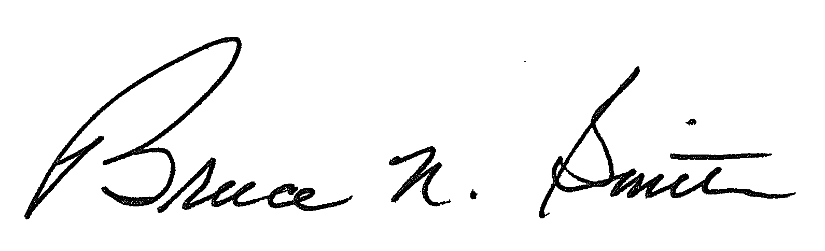
Bruce N. Smith
Director
/tmp/in/input.doc

