Decision No. C03-1273
BEFORE THE PUBLIC UTILITIES COMMISSION OF THE STATE OF COLORADO
DOCKET NO. 03V-424T
IN THE MATTER OF THE APPLICATION OF MCIMETRO ACCESS TRANSMISSION SERVICES L.L.C. FOR A VARIANCE FROM RULE 4 CCR 723-2-10.1.1.
decision granting application for variance
Mailed Date: November 13, 2003
Adopted Date: November 12, 2003

BY THE COMMISSION

Statement
- This matter comes before the Commission for consideration of MCImetro Access Transmission Services, L.L.C.'s (MCImetro) application for extension of a temporary variance from 4 Code of Colorado Regulations 723-2-10.1.1 (Rule 10). Rule 10 requires local exchange carriers to type or machine print their monthly bills to consumers. MCImetro asks to be allowed to continue to provide electronic billing (e-billing) for the period of one year or until the Commission addresses rule revisions that may modify Rule 10.
- In Decision No. C02-1455, the Commission granted MCImetro a variance of Rule 10 until December 31, 2003.
- Notice of the application was posted on the Commission's web site on October 2, 2003. Interventions were due on or before November 3, 2003. None were filed.
- We have previously stated that it is our intention to initiate a rulemaking proceeding to revise our telephone rules (Decision No. C02-902). At that time, revisions to Rule 10.1.1, which would allow all local exchange carriers (LECs) to use e-billing will likely be considered. Therefore, we grant MCImetro's request for an extension of its variance until Rule 10.1.1 is revised to allow e-billing by LECs in general, but, in any event, the variance shall not continue beyond December 31, 2004.

ORDER

The Commission Orders That:
- The application by MCImetro Access Transmission Services, L.L.C. is deemed complete.
- MCImetro Access Transmission Services, L.L.C.'s application for an extension of variance from 4 Code of Colorado Regulations 723-2-10.1.1 is granted. The variance shall continue until that rule is revised in the Commission rulemaking docket but, in no event shall this variance continue beyond December 31, 2004.
- This Order is effective on its Mailed Date.

ADOPTED IN COMMISSIONERS’ WEEKLY MEETING
November 12, 2003.

THE PUBLIC UTILITIES COMMISSION
OF THE STATE OF COLORADO
GREGORY E. SOPKIN
________________________________
POLLY PAGE
________________________________
JIM DYER
________________________________
Commissioners
(S E A L)


ATTEST: A TRUE COPY
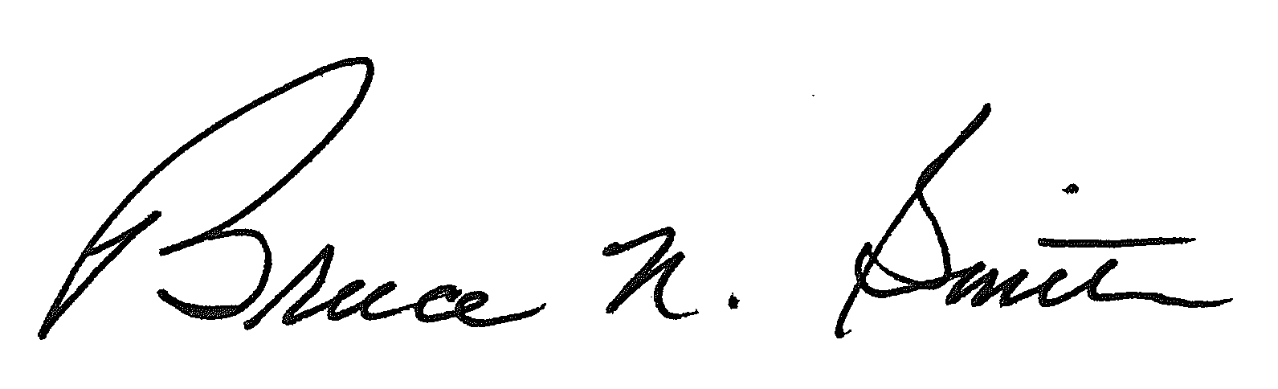
Bruce N. Smith
Director
/tmp/in/input.doc

