Decision No. C03-1272
BEFORE THE PUBLIC UTILITIES COMMISSION OF THE STATE OF COLORADO
DOCKET NO. 03M-481T
IN THE MATTER OF THE VERIFIED PETITION OF DELTA COUNTY TELE-COMM, INC. FOR VARIANCE OF COMMISSION RULE 4 CCR 723-1-10 REGARDING ELECTRONIC BILLING.
decision granting application for variance
Mailed Date: November 13, 2003
Adopted Date: November 12, 2003

BY THE COMMISSION

Statement
- This matter comes before the Commission for consideration of Delta County Tele-Comm, Inc.'s (DCTC) application for a temporary variance from 4 Code of Colorado Regulations 723-2-10.1.1 (Rule 10). Rule 10 requires local exchange carriers to type or machine print their monthly bills to consumers. DCTC requests the granting of a permanent waiver of Rule 10 to be allowed to provide electronic billing (e-billing), for the period until the Commission modifies its rules to allow e-billing.
- In Decision No. C02-1455, the Commission granted MCImetro Access Transmission Services a temporary variance of Rule 10. Likewise, Qwest Corporation in Decision No. C02-902 was granted a temporary variance of Rule 10.
- Notice of the application was posted on the Commission's web site on November 4, 2003. No interventions were filed.
- We have previously stated that it is our intention to initiate a rulemaking proceeding to revise our telephone rules (Decision No. C02-902). At that time, revisions to Rule 10.1.1, which would allow all local exchange carriers (LECs) to use e-billing will likely be considered. Therefore, we grant DCTC's request for a variance until Rule 10.1.1 is revised to allow e-billing by LECs in general, but, in any event, the variance shall not continue beyond December 31, 2004.

ORDER

The Commission Orders That:
- The application by Delta County Tele-Comm, Inc., is deemed complete.
- Delta County Tele-Comm, Inc.'s application for a variance from 4 Code of Colorado Regulations 723-2-10.1.1 is granted. The variance shall continue until that rule is revised in the Commission rulemaking docket but, in no event shall this variance continue beyond December 31, 2004.
- Delta County Tele-Comm, Inc., shall file an Advice Letter with the Commission having an effective date of no less than 14 days from the date of filing to implement optional e-billing for its customers. The tariff sheets shall include an expiration date of December 31, 2004, and the Number of this Decision as the authority that grants the ability to make the filing.
- This Order is effective on its Mailed Date.

ADOPTED IN COMMISSIONERS’ WEEKLY MEETING
November 12, 2003.

THE PUBLIC UTILITIES COMMISSION
OF THE STATE OF COLORADO
GREGORY E. SOPKIN
________________________________
POLLY PAGE
________________________________
JIM DYER
________________________________
Commissioners
(S E A L)


ATTEST: A TRUE COPY
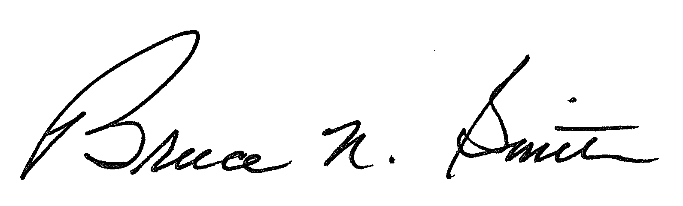
Bruce N. Smith
Director
/tmp/in/input.doc

