Decision No. C03-1269
BEFORE THE PUBLIC UTILITIES COMMISSION OF THE STATE OF COLORADO
DOCKET NO. 03A-437T
IN THE MATTER OF THE JOINT APPLICATION OF WILLIAMS LOCAL NETWORK, LLC AND LEUCADIA NATIONAL CORPORATION TO EXECUTE A TRANSFER.
Order granting application
Mailed Date: November 13, 2003
Adopted Date: November 12, 2003

BY THE COMMISSION

Statement
- On October 6, 2003, Williams Local Networks, LLC (WLN) and Leucadia National Corporation (Leucadia) filed an application to execute a transfer whereby WilTel Communications Group, Inc. (WilTel), will transfer ultimate ownership of WLN to Leucadia, pursuant to 4 Code of Colorado Regulations 723-25-8.
- WLN was granted a Certificate to Provide Local Exchange Telecommunications Services and a Certificate of Public Convenience and Necessity to provide private line service in Commission Decision No. C00-137.
- WLN is a wholly owned subsidiary of Williams Communications, LLC which is a wholly owned subsidiary of WilTel. Leucadia currently owns approximately 47.7 percent of WilTel. As a result of the transaction Leucadia will be the 100 percent owner of WilTel.
- On February 28, 2001, WLN withdrew its tariffs on file with the Commission.
- Notice of the application was posted on the Commission's web site on October 8, 2003. Interventions were due on or before November 7, 2003. None were filed.

Discussion
- The application is unopposed and may be considered without a hearing. § 40-6-109(5), C.R.S.
- The Commission finds that the proposed transfer of assets is not contrary to the public interest.

ORDER

The Commission Orders That:
- The application by Williams Local Network, LLC and Leucadia National Corporation is deemed complete.
- The application to approve the transfer of Williams Local Network, LLC is granted.
- The obligation of Williams Local Network, LLC to file an annual report with the Commission and contribute to all applicable Colorado funds for the period prior to the effective date of this Order remains. These funds include the Public Utilities Commission's Fixed Utilities Fund, the Colorado High Cost Administration Fund, the Telecommunications Relay Services for the Disabled Telephone Users Program, and the Emergency Telephone Access Act Program.
- This Order is effective on its Mailed Date.

ADOPTED IN COMMISSIONERS’ WEEKLY MEETING
November 12, 2003.

THE PUBLIC UTILITIES COMMISSION
OF THE STATE OF COLORADO
GREGORY E. SOPKIN
________________________________
POLLY PAGE
________________________________
JIM DYER
________________________________
Commissioners
(S E A L)


ATTEST: A TRUE COPY
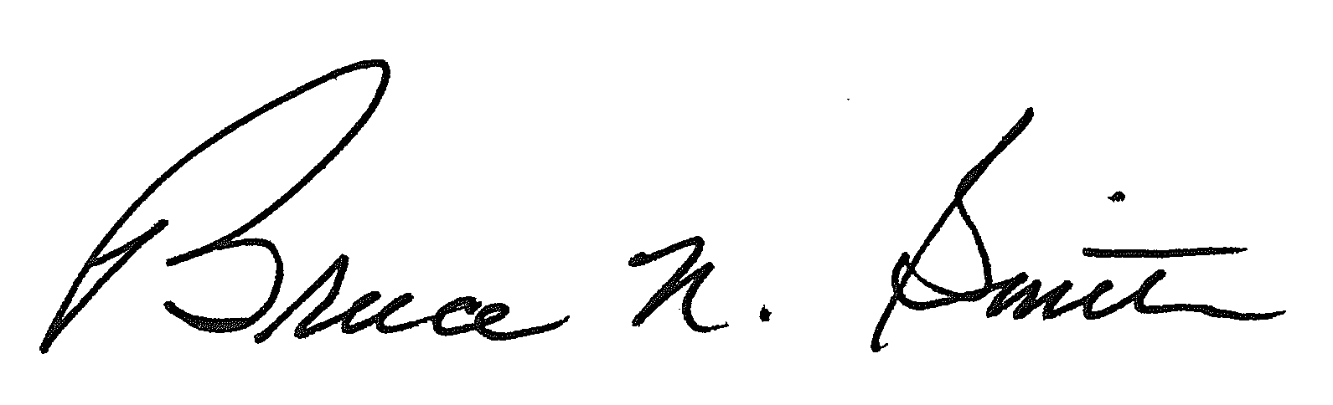
Bruce N. Smith
Director
/tmp/in/input.doc

