Decision No. C03-1255
BEFORE THE PUBLIC UTILITIES COMMISSION OF THE STATE OF COLORADO
DOCKET NO. 98A-511E
in the matter of the application of public service company of colorado for an air quality improvement rider to recover the costs of voluntary emission reductions in three metro area power plants.
ORDER Granting motion for extension of time
Mailed Date: November 10, 2003
Adopted Date: November 5, 2003

BY THE COMMISSION

Statement, Findings, and Conclusions
- On October 27, 2003, Public Service Company of Colorado (Public Service or Company) filed a Motion for Thirty Day Extension of Time to File Updated Class Allocations (Motion for Extension). Public Service states that under the settlement agreement reached in this case and approved in Decision No. R99-678, the Company is required to file annually on November 1, the class allocations used to design the Air Quality Improvement Rider (AQIR) scheduled to be effective January 1 of each year, or in this case January 1, 2004.
- The settlement agreement also required the Company to seek Federal Energy Regulatory Commission (FERC) approval to collect a portion of the AQIR costs from its wholesale customers. Public Service did apply to the FERC for such cost recovery in FERC Docket ER03-971-000. Within the Motion for Extension, the Company states it is hopeful that a settlement can be reached in this FERC docket during November 2003. If a settlement is reached, it is likely that the AQIR rate for retail customers will be reduced and Public Service wishes to take this reduction into account in proposing the 2004 AQIR rates.
- Public Service states that it has served the motion on all persons on the Company’s service lists for both of the AQIR dockets, Docket Nos. 98A-511E and 02S-485E. The Commission waives the remaining response time to the Motion for Extension in order to timely address the merits of the motion.
- The Commissions finds that good cause has been shown to grant the Motion for Extension. In particular, a possible reduction in the AQIR rate for retail customers (as a result of a settlement in the FERC proceeding) states good cause.

order

The Commission Orders That:
- The Commission waives the remaining response time to the Motion for Thirty Day Extension of Time to File Updated Class Allocations.
- The Motion for Thirty Day Extension of Time to File Updated Class Allocations filed by Public Service Company of Colorado is granted.
- This Order is effective on its Mailed Date.

ADOPTED IN COMMISSIONERS’ WEEKLY MEETING
November 5, 2003

THE PUBLIC UTILITIES COMMISSION
OF THE STATE OF COLORADO
GREGORY E. SOPKIN
________________________________
POLLY PAGE
________________________________
JIM DYER
________________________________
Commissioners
(S E A L)


ATTEST: A TRUE COPY
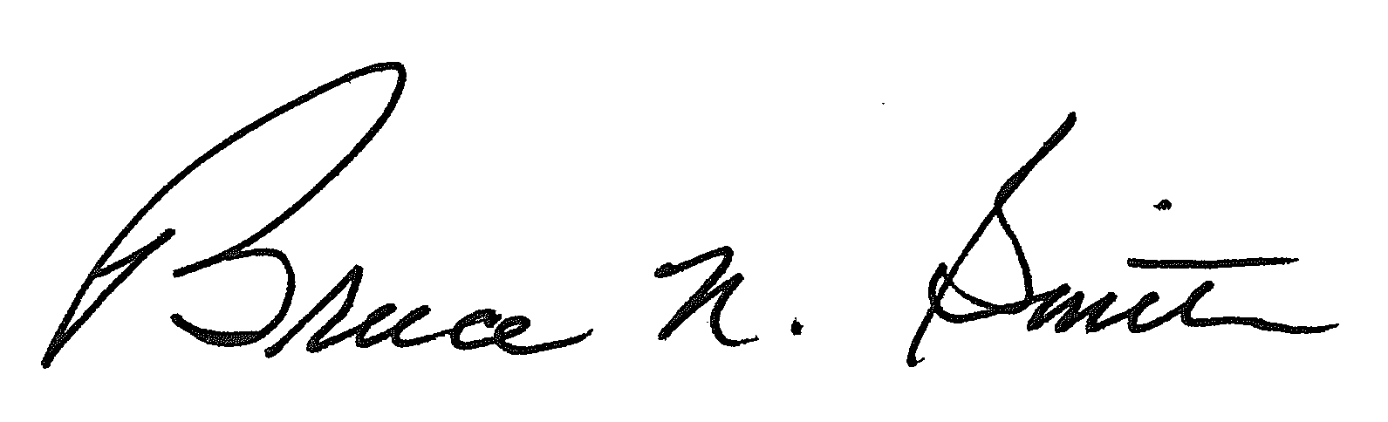
Bruce N. Smith
Director
/tmp/in/input.doc:srs

