Decision No. C02-0426-E
BEFORE THE PUBLIC UTILITIES COMMISSION OF THE STATE OF COLORADO
DOCKET NO. 02M-149EC incorrectly referred to as 02A-149EC
THE APPLICATION OF admiral moving and storage, inc. FOR An order of the commission authorizing a waiver of the rules and regulations governing MOTOR vehicle carriers exempt from regulation as public utilities.
ERRATA NOTICE
Decision No. C02-0426
Mailed Date: April 18, 2002
Adopted Date: April 10, 2002
Errata Mailed Date: May 9, 2002

Decision No. C02-0426, mailed April 18, 2002, included an incorrect Docket Number of 02A—149EC. The Docket Number should have read 02M-149EC.

BEFORE THE PUBLIC UTILITIES COMMISSION
THE PUBLIC UTILITIES COMMISSION
OF THE STATE OF COLORADO
________________________________
BRUCE N. SMITH
Director
Dated at Denver, Colorado this
9th day of May, 2002.

OF THE STATE OF COLORADO

CERTIFICATE OF SERVICE

DOCKET NO. 02A-149EC
DECISION NO. C02-0426
(Page 1 of 1 Page)

I, Bruce N. Smith, Director of the Public Utilities Commission of the State of Colorado, certify that I served a true and correct copy of the above Commission Decision -- entered in the above numbered matter of record -- upon each of the persons whose names and addresses appear below, by mailing the same in sealed envelopes properly addressed, with sufficient postage prepaid to carry the same to its destination to the following:

APPLICANT:
Admiral Moving and Storage, Inc.
10900 West 120th Avenue
Broomfield, CO 80021

ROUTE:
6, 60, all other PUC staff including staff that may be listed as parties, received this decision electronically.

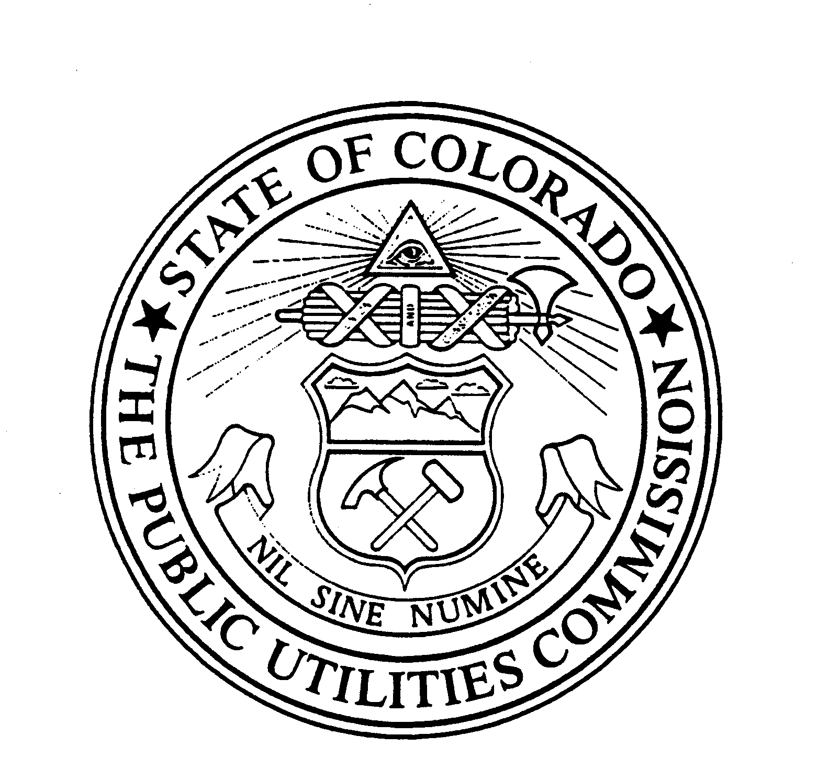 | WITNESS MY HAND AND THE SEAL OF THE PUBLIC UTILITIES COMMISSION OF THE STATE OF COLORADO    Director

