Decision No. C01-1271
BEFORE THE PUBLIC UTILITIES COMMISSION OF THE STATE OF COLORADO
DOCKET NO. 01M-569CP
IN THE MATTER OF THE TARIFF FILING OF GISDHO Shuttle, Inc., doing business as American Spirit Shuttle proposed increases in their PASSENGER TARIFF, colorado pUC no. 5, TO BECOME EFFECTIVE ON December 15, 2001.
COMMISSION ORDER REJECTING TARIFF CHANGES
Mailed Date: December 13, 2001
Adopted Date: December 12, 2001

BY THE COMMISSION

Statement, Findings, and Conclusion:

    - On November 13, 2001, GISDHO Shuttle, Inc., doing business as American Spirit Shuttle (“GISDHO”) filed Passenger Tariff, Colorado PUC No. 5, to become effective December 15, 2001. GISDHO provides sightseeing service between points in Mesa County and points in Delta, Garfield, Moffat, Ouray, Rio Blanco, San Miguel, Gunnison, Pitkin, LaPlata, San Juan, Montrose, Dolores, and Montezuma under Certificate of Public Convenience and Necessity PUC No. 53828.
    - Passenger Tariff, Colorado PUC No. 5, proposes to increase sightseeing rates for tours in Colorado National Mountain, Black Canyon National Monument, and Grand Mesa. Proposed Passenger Tariff, Colorado PUC No. 5, increases rates up to 15.4 percent.
    - Rule 31(g) of the Commission’s Rules of Practice and Procedure, 4 Colorado Code of Regulations (“CCR”) 723-1, requires that a common carrier to provide justification in support of the proposed changes to a tariff. Rule 31(j), of the Commission’s Rules of Practice and Procedure, 4 CCR 723-1, requires a common carrier filing to increase rates publish notice of the increase in a local newspaper.
    - Review of the tariff filing indicates that no justification in support of the increase has been submitted by GISDHO as required by Rule 31(g). The notice was not published as required by Rule 31(j).
    - The Commission finds that Passenger Tariff, Colorado PUC No. 5, should be rejected for violations of Rule 31(g) and Rule 31(j) of the Commission’s Rules of Practice and Procedure, 4 CCR 723-1.

ORDER

The Commission Orders That:

    - Passenger Tariff, Colorado PUC No. 5, as filed by GISDHO Shuttle, Inc., doing business as American Spirit Shuttle is rejected.
    - This Order is effective on its Mailed Date.

ADOPTED IN COMMISSIONERS’ WEEKLY MEETING December 12, 2001.

APPLICANT:
THE PUBLIC UTILITIES COMMISSION
OF THE STATE OF COLORADO
RAYMOND L. GIFFORD
________________________________
POLLY PAGE
________________________________
JIM DYER
________________________________
Commissioners

(S E A L)


ATTEST: A TRUE COPY


Bruce N. Smith
Director
/tmp/in/input.doc

GISDHO Shuttle, Inc., dba
American Spirit Shuttle
204 4th Street
Clifton, CO 81520

ROUTE:
60; 6; all PUC staff, including staff that may be listed as parties, received this decision electronically.

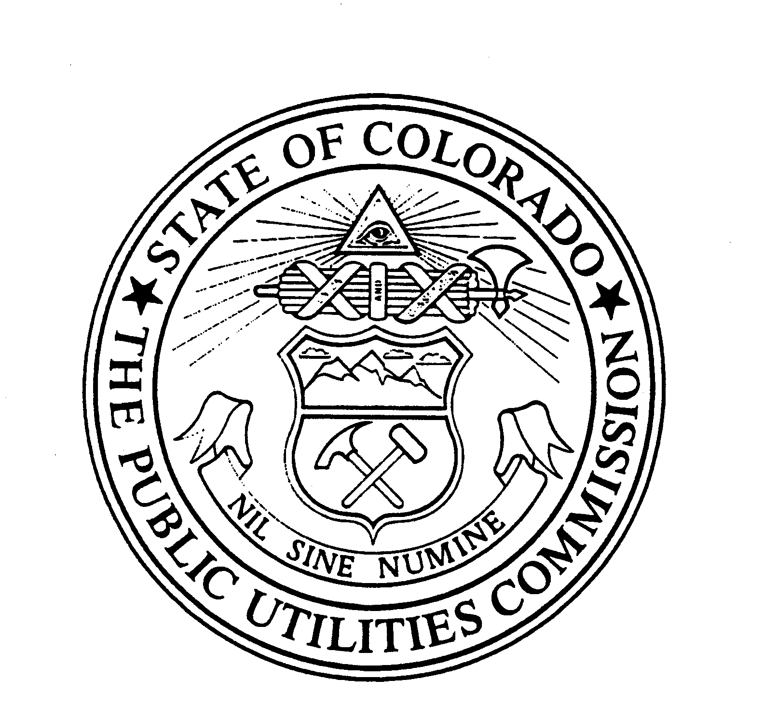 | WITNESS MY HAND AND THE SEAL OF THE PUBLIC UTILITIES COMMISSION OF THE STATE OF COLORADO  Director

