Decision No. C01-1227
BEFORE THE PUBLIC UTILITIES COMMISSION OF THE STATE OF COLORADO
DOCKET NO. 01A-488CP-TA
THE APPLICATION OF Park Taxi, LLC FOR TEMPORARY AUTHORITY TO CONDUCT OPERATIONS AS A COMMON CARRIER BY MOTOR VEHICLE FOR HIRE.
COMMISSION ORDER GRANTING
TEMPORARY AUTHORITY
Mailed Date: November 30, 2001
Adopted Date: November 28, 2001

BY THE COMMISSION:

Statement

    - On October 23, 2001, Park Taxi, LLC ("Park Taxi"), filed an application for temporary authority to conduct operations as a common carrier by motor vehicle for hire as follows: Transportation of passengers and their baggage in taxi service between all points within an 18-mile radius of the intersection of U. S. Highway 34 and U. S. Highway 36 in Estes Park, Colorado, and between said points, on the one hand, and Denver International Airport, on the other hand.
    - The Commission gave notice of the application on November 5, 2001.
    - Odd Lyngholm, doing business as Estes Park Shuttle & Mountain Tours, filed an intervention opposing the grant of this application.
    - Pursuant to § 40-6-120(1), C.R.S., the Commission is authorized to grant temporary authority when "there appears to be an immediate and urgent need to any point or within a territory having no carrier service capable of meeting such need."
    - Park Taxi must meet a two-fold test: first, that there is an immediate and urgent need for the transportation services, and second, that there is no existing carrier capable of meeting the need. If Park Taxi fails to meet either test, the application must be denied.

Findings of Fact

    - The support filed on behalf of this application consists of ten letters from residents of, or employees of businesses in the Estes Park area. The authors of these letters express the need for a reliable and dependable taxi service on the Estes Park area.
    - As of the date of this decision, there is no carrier with authority from this Commission currently providing taxi service in the Estes Park area .
    - Odd Lyngholm, doing business as Estes Park Shuttle & Mountain Tours has authority under CPCN 54696 to provide charter and sightseeing service in the Estes Park area and scheduled service between Estes Park and Denver, Colorado. Odd Lyngholm, doing business as Estes Park Shuttle & Mountain Tour does not have the authority to provide any taxi service under CPCN 54696.

Conclusions

    - An immediate and urgent need for the requested transportation services exists, and no other carrier has been shown to be capable of providing the service.
    - Park Taxi has adequate equipment and financial resources to begin immediate service within the scope of the authority sought.
    - This application for temporary authority is in the public interest.
    - Park Taxi is advised that the grant of a temporary authority creates no presumption that a permanent authority will be granted.

ORDER

The Commission Orders That:

    - Park Taxi, LLC is granted temporary authority to conduct operations as a common carrier by motor vehicle for hire for a period of 180 days commencing from the Mailed Date of this Order, with authority as set forth in the Appendix.
    - Park Taxi, LLC shall operate in accordance with all applicable Commission rules and regulations.
    - Park Taxi, LLC shall not commence operation until it has filed with the Commission the proper insurance as required by Commission rules. Park Taxi, LLC shall also file the proper tariff and pay the required vehicle identification fee. Park Taxi, LLC may not begin operations until these requirements have been met and writen notification has been received from the Commission stating it is in compliance and may begin service.
    - If Park Taxi, LLC does not comply with the requirements of this Order within 30 days of its effective date, then the temporary authority shall be void. For good cause shown, the Commission may grant additional time for compliance if the request for additional time is filed within the 30 days.
    - The twenty day time period provided by § 40-6-114(1), C.R.S., to file an application for rehearing, reargument, or reconsideration shall begin on the first day after the Commission mails or serves this Order.
    - This Order is effective on its Mailed Date.

ADOPTED IN THE COMMISSIONERS' WEEKLY MEETING November 28, 2001.

Appendix
THE PUBLIC UTILITIES COMMISSION
OF THE STATE OF COLORADO
RAYMOND L. GIFFORD
________________________________
POLLY PAGE
________________________________
JIM DYER
________________________________
Commissioners

(S E A L)


ATTEST: A TRUE COPY

Bruce N. Smith
Director
i:\trans\orders\01A-488CP-TA.DOC

Page 1 of 1 Page

Docket No. 01A-488CP-TA

Decision No. C01-1227
November 28, 2001

Transportation of passengers and their baggage in taxi service between all points within an 18-mile radius of the intersection of U. S. Highway 34 and U. S. Highway 36 in Estes Park, Colorado, and between said points, on the one hand, and Denver International Airport, on the other hand.

APPLICANT:
Park Taxi, LLC
1690 Brook Court
Estes Park, CO 80517

INTERVENOR:
Odd Lyngholm
dba Estes Park Shuttle & Mountain Tours
481 West Elkhorn Avenue
Estes Park, CO 80517

INTERVENOR'S ATTORNEY:
Charles M. Williams
CHARLES M. WILLIAMS, P.C.
303 E. 17th Ave., Suite No. 888
Denver, CO 80203

ROUTE:
All PUC staff, including staff that may be listed as parties, received this decision electronically.

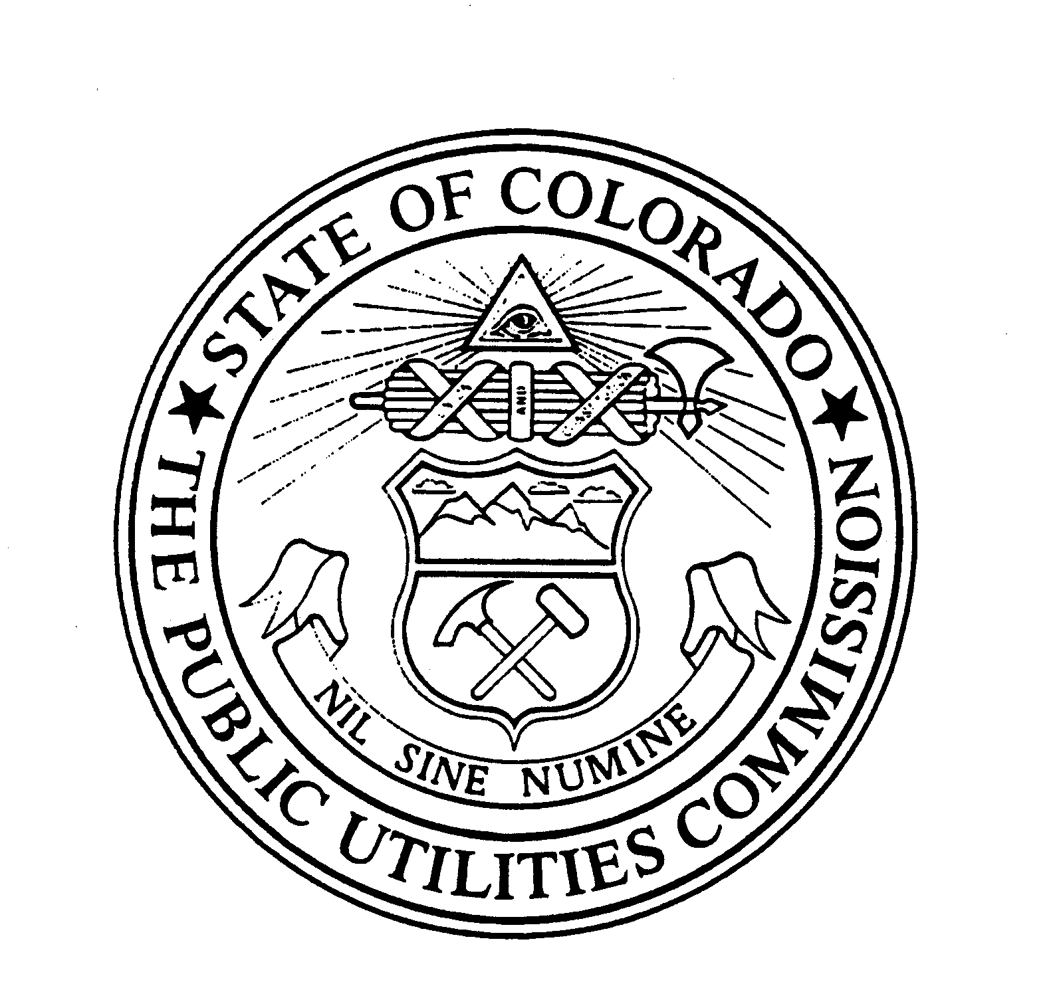 | WITNESS MY HAND AND THE SEAL OF THE PUBLIC UTILITIES COMMISSION OF THE STATE OF COLORADO  Director

