Decision No. C01-1226
BEFORE THE PUBLIC UTILITIES COMMISSION OF THE STATE OF COLORADO
DOCKET NO. 01A-462CP-Encumbrance
THE APPLICATION OF Shamrock Taxi of Fort Collins, Inc., DOING BUSINESS AS Shamrock Shuttle, FOR AUTHORITY TO ENCUMBER CERTIFICATE OF PUBLIC CONVENIENCE AND NECESSITY PUC NO. 49759 IN FAVOR OF 5800 Corporation.
COMMISSION ORDER
GRANTING ENCUMBRANCE
Mailed Date: November 30, 2001
Adopted Date: November 28, 2001

BY THE COMMISSION:

Statement, Findings and Conclusions

    - On October 1, 2001, Shamrock Taxi of Fort Collins, Inc., doing business as Shamrock Shuttle filed an application for authority to encumber Certificate of Public Convenience and Necessity ("CPCN") PUC No. 49759 in favor of 5800 Corporation. Shamrock Taxi of Fort Collins, Inc., doing business as Shamrock Shuttle, seeks to encumber CPCN PUC No. 49759 as security for indebtedness in the principal sum of $500,000 in accordance with the terms and conditions set forth in the “Security Agreement and Financing Statement” executed by the parties, dated September 28, 2001, and properly filed with the Commission.
    - The Commission noticed this application to all interested persons, firms, and corporations pursuant to § 40-6-108(2), C.R.S., on October 9, 2001. The Commission set this matter for hearing on December 21, 2001.
    - No petition to intervene or otherwise participate in this proceeding has been filed. This proceeding is noncontested. Under § 40-6-109(5), C.R.S., this matter may be determined without a hearing.
    - The submitted evidence warrants the grant of the requested encumbrance of CPCN PUC No. 49759.
    - This application for authority to encumber CPCN PUC No. 49759 is in the public interest.

ORDER

The Commission Orders That

    - The hearing set for December 21, 2001, is vacated.
    - This application was deemed complete on November 15, 2001, within the meaning of § 40-6-109.5, C.R.S.
    - Shamrock Taxi of Fort Collins, Inc., doing business as Shamrock Shuttle is authorized to encumber all right, title, and interest in Certificate of Public Convenience and Necessity PUC No. 49759 in favor of 5800 Corporation. The encumbrance is authorized to secure payment of indebtedness in the principal sum of $500,000 in accordance with the terms and conditions of the “Security Agreement and Financing Statement” executed by the parties, dated September 28, 2001, and properly filed with the Commission.
    - Shamrock Taxi of Fort Collins, Inc., doing business as Shamrock Shuttle and 5800 Corporation shall notify the Commission, in writing, of the full satisfaction of the indebtedness and release of the authorized encumbrance. This notice shall be filed no more than 10 days after the full satisfaction of the indebtedness.
    - This Order is effective on its Mailed Date.

ADOPTED IN THE COMMISSIONERS' WEEKLY MEETING November 28, 2001

THE PUBLIC UTILITIES COMMISSION
OF THE STATE OF COLORADO
RAYMOND L. GIFFORD
________________________________
POLLY PAGE
________________________________
JIM DYER
________________________________
Commissioners

(S E A L)


ATTEST: A TRUE COPY

Bruce N. Smith
Director
i:\trans\orders\01A-462CP

APPLICANT:
Shamrock Taxi of Fort Collins, Inc.
dba Shamrock Shuttle
P.O. Box 88
Windsor, CO 80550

CREDITOR:
5800 Corporation
521 North Link Lane
Fort Collins, CO 80524

CREDITOR'S ATTORNEY:
Mark L. Korb
Frey, Korb, Haggerty & Michaels, P.C.
318 Canyon Avenue
Suite No. 200
Fort Collins, CO 80550

ROUTE:
All PUC staff, including staff that may be listed as parties, received this decision electronically.

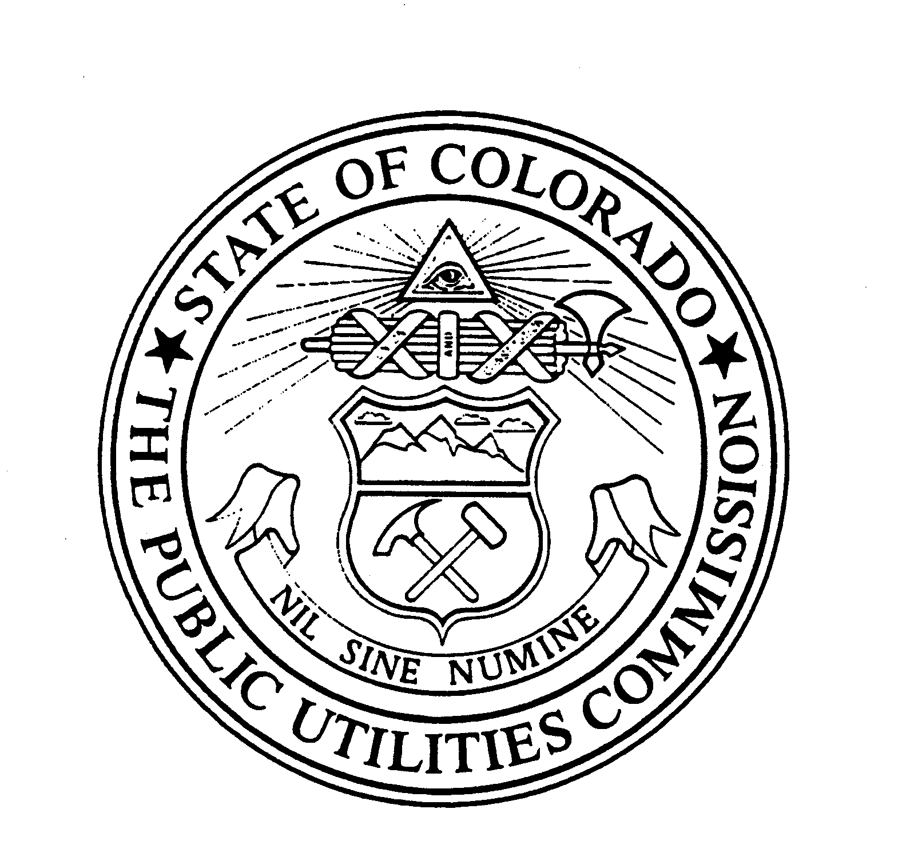 | WITNESS MY HAND AND THE SEAL OF THE PUBLIC UTILITIES COMMISSION OF THE STATE OF COLORADO  Director

