Decision No. C97-366-E
BEFORE THE PUBLIC UTILITIES COMMISSION OF THE STATE OF COLORADO
DOCKET NO. 96S-331T
Re: The Investigation and suspension of tariff sheets filed by U S WEST Communications, Inc., with Advice Letter No. 2617, regarding tariffs for interconnection, local termination, unbundling, and resale of services.
Order: Granting Joint Petition
for Reconsideration, In Part; Denying
Late-Filed Motion For Intervention; Granting
Motion To Strike; And Ruling On Motions For
Protective Orders
Decision No. C97-366
Mailed Date: April 4, 1997
Adopted Date: April 2, 1997
Errata Mailed Date: April 14, 1997

Correct the caption of this Decision to show the Adopted Date as April 2, 1997.
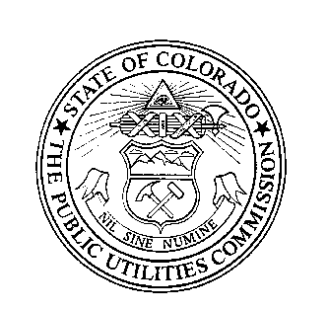 | THE PUBLIC UTILITIES COMMISSION  OF THE STATE OF COLORADO  _____________________________  BRUCE N. SMITH  Director  Dated at Denver, Colorado this  14th day of April, 1997.

