BEFORE THE PUBLIC UTILITIES COMMISSION
OF THE STATE OF COLORADO

* * * * *

RE: THE TARIFF SHEETS FILED BY PUBLIC SERVICE COMPANY OF  COLORADO WITH ADVICE LETTER  NO. 1495 – ELECTRIC | )  )  )  ) | DOCKET NO. 07S-521E

Supplemental Answer Testimony of

Kathryn Iverson

On behalf of

Colorado Energy Consumers

Project 8964
April 15, 2008

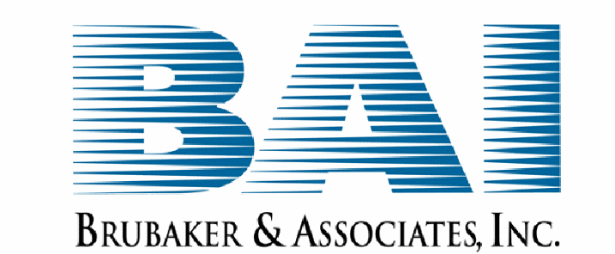
St. Louis, MO 63141-2000

BEFORE THE PUBLIC UTILITIES COMMISSION
OF THE STATE OF COLORADO
* * * * *

RE: THE TARIFF SHEETS FILED BY PUBLIC SERVICE COMPANY OF  COLORADO WITH ADVICE LETTER  NO. 1495 – ELECTRIC | )  )  )  ) | DOCKET NO. 07S-521E

Supplemental Answer Testimony of Kathryn Iverson

Q PLEASE STATE YOUR NAME AND BUSINESS ADDRESS.
A My name is Kathryn E. Iverson; 17244 W. Cordova Court; Surprise, Arizona 85387.

Q ARE YOU THE SAME KATHRYN IVERSON WHO previously FILED answer testimony regarding the interruptible service option credit (“ISOC”) PROGRAM on behalf of the colorado energy consumers?
A Yes.

Q what issues are you addressing in your supplemental answer testimony?
A As a result of Commission Decision No. C08-0369 in Docket No. 07A-469E, the ALJ has ordered that supplemental answer testimony be filed in this case addressing Commission-identified issues from Docket No. 07A-469E. The first Commission-identified issue to be addressed is “what additional incentives, if any, are necessary to encourage Public Service customers to take service pursuant to Public Service’s interruptible tariffs.”

Q DO YOU HAVE ANY COMMENTS AS TO WHAT ADDITIONAL INCENTIVES ARE NECESSARY TO ENCOURAGE Customers to participate in the ISOC PROGRAM?
A Yes. As I pointed out in my Answer Testimony of March 24, 2008, being an interruptible customer can have significant cost and operational implications. The choice to be an interruptible customer can entail logistical and staffing challenges associated with managing interruptions that will last several hours, as well as investments in equipment in order to bring about interruptions in a timely and controlled manner. The costs to the interruptible customer in terms of lost production and added wear and tear on equipment must be weighed against the savings in electricity bills. Therefore, as I discussed in my Answer Testimony, a robust incentive mechanism is necessary and appropriate to compensate customers who take on these burdens for the benefit of the other PSCo customers.
Having said that, one issue I didn’t highlight in my original Answer Testimony is the importance of stability, specifically as to methodology for determining the credits.

Q WHAT DO YOU MEAN BY “STABILITY”?
A While it makes sense to periodically update the avoided costs used to develop the credits paid under the ISOC program, the Commission should strive to retain the fundamental methodology and assumptions used in determining the interruptible credits. This would provide interruptible customers with the benefit of knowing they will not need to constantly battle against unwarranted changes in the equation. Without stability of the methodology used to calculate the interruptible credit, customers may be hesitant to make the investments in equipment, maintenance and operational system changes necessary to allow that customer to handle the challenges of being interruptible.

Q WOULD A STABLE METHODOLOGY ALSO ASSIST IN THE DEVELOPMENT OF THIRD-PARTY DEMAND RESPONSE AGGREGATION?
A Yes, it should. In order to adequately develop a business plan, a third-party demand response aggregator would also need assurance of a stable methodology used for the determination of interruptible credits. If fundamental components of the avoided cost methodology are subject to debate every time avoided cost inputs are updated, then this will place additional risk into a customer’s analysis of whether or not to participate. This additional risk would most likely also impact how willing third-party demand response aggregators would be to contract with PSCo and the price demanded by the third-party.

Q DOES THIS CONCLUDE YOUR SUPPLEMENTAL ANSWER TESTIMONY?
A Yes.

